A sensitive spectrophotometer method for the determination of 4-aminoantipyrine as a Schiff base complicated with Cr (III),
Ni (II) &Cu (II) transition elements and its preparation.

Ahmed H.Ismail,Jwan A.Abdul-sattar.

Department of Chemistry, College of Science, University of Al-Musansiriya Baghadad, Iraq.

Abstract

A sensitive spectrophotometer method for the determination of 4-aminoantipyrine in pure as well as in pharmaceutical dosage form is reported, based on the preparation of Schiff base as a chalet ligand by condensation reaction of 4-aminoantipyrine with Isatin to give (1-phenyl-2,3dimethyl-4Isatidine-5-oxopyrazole) followed by the preparation of three new complexes for this ligand with Cr(III),Ni(II),and Cu(II) in alcoholic media. These prepared complexes were characterized by C.H.N.,F.T.I.R.,electronic spectra,molar conductivity,magnetic sensitivity and measurements of metal ratio by flame atomic absorption technique.Beer's law was obeyed in the concentration ranges (5-400) µg.ml⁻¹,(7-300) µg.ml⁻¹&(10-250) µg.ml⁻¹ with a detection limit(D.L) of (0.18) µg.ml⁻¹,(0.25) µg.ml⁻¹&(0.33) µg.ml⁻¹ for Cr(III),Ni(II) & Cu(II)
respectively. The method was successfully applied for the assay of pharmaceutical tables (Ampyrone).

الخلاصة

في هذا البحث تم استخدام طريقة طيفية لتقدير(4-aminoantipyrine)كمادة نقية وكذلك في المستحضر الصيدلاني،مبنية على تحضير قواعد شيف كليكاند مخلبي وذلك بتكاثف (1- فنيل-2،3داي مثيل-4ايساتيدين-5-اوكسوبايرازول)ومن ثم تحضيرثلاث معقدات تناسقية لهذا الليكاند مع ايونات العناصر[الكروم(III)النيكل(II) والنحاس[(II) في وسط كحولي.وقد تم تشخيص هذه المعقدات بواسطة اجهزة التحليل الدقيق للعناصر(C.H.N.)،طيف الاشعة تحت الحمراء المعززة بتغيرات فورير،الاطياف الالكترونية،التوصيلية الكهربائية المولارية،الحساسية المغناطيسية وقياس نسبة الفلز بواسطة تقنية الامتصاص الذري اللهبي.ان مدى التراكيز التي تطيع قانون بيرهي (400-5)مايكروغرام.مل⁻¹(300-7)، مايكروغرام.مل⁻¹و(250-10) مايكروغرام.مل⁻¹مع حدود كشف (0.18)مايكروغرام.مل⁻¹(0.25)،مايكروغرام. مل⁻¹و(0.33)مايكروغرام.مل⁻¹على التوالي،ولقد تم تطبيق هذه الطريقة بنجاح لتقدير العقار الصيدلاني(Ampyrone).

1. Introduction

Pyrazolone is a five-membered lactam ring compound containing two nitrogen and ketone in the same molecule.Lactam structure is an active nucleuses in pharmacological activity also lactam have big demand in artificial fibre industry, Pyrazolone is an active moiety as a pharmaceutical ingredient, especially in the class of nonsteroidal anti-inflammatory agents (NSAI) used in the treatment of arthritis and other musculoskeletal and joint disorders⁽¹⁾.
Antipyrine (also called phenazone) is a pyrazolone class analgesic agent in otic solutions in combination with other analgesic such as benzocaine, and phenylephrine.4-aminoantipyrine (4-AAP) (4-Amino-2,3-dimethyl-1-phenyl-3-pyrazolin-5-one) is a metabolite of aminopyrine with an analgesic, anti-inflamatory, and antipyretic properties, it can be used as an intermediate for the synthesis of pharmaceuticals especially antipyretic and analgesic drugs. It is also used in the colorimetric determination of phenols⁽²⁾ (Fig.1).


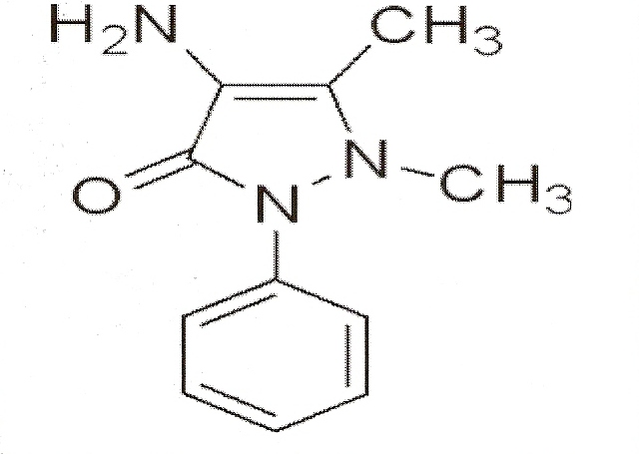

Fig (1).Chemical structure of (4-aminoantipyrine (4-AAP))

Analytical methods are useful in the determination of 4-AAP in pure and pharmaceutical dosage forms. Owing to the widespread use of UV-Visible Spectrophotometer in the routine analysis, it is important that good colorimetric methods are developed and that these are thoroughly validated ^{(3,4,5)}.
The proposed spectrophotometer method had sufficiently good accuracy, precision and permitted time-and money-saving assay of (Ampyrone).

2. Experimental

2-1 Apparatus and Reagents
Elemental microanalysis was carried out using C.H.N. elemental analyzer model Perkins-Elmer B240.Infra red spectra of the samples were recorded on F.T.I.R. 830 Shimadzu spectrophotometer using cesium iodide disc in the rang(200-400)cm⁻¹.The U.V.-Visible 160A-Ultra-Violet spectrophotometer in the rang 200-800nm.conductivity measurement were carried out by using SIMENS Digital Conductivity meter. Magnetic susceptibility measurements for the prepared complexes were obtained at room temperature using(magnetic susceptibility Balance) Johnson Mattey catalytic system division. Flame Atomic Absorption was obtained by using Shimadzu AA-670.Melting points of the prepared compounds were determined by using a calibrated meter F.B.S. Melting apparatus.
All chemicals used in this study were analat grad (Merk &Fluka).

2-2 Preparation of the Ligand (L)
An ethanolic solution of (20ml) 0f 4-amino antipyrine (0.01mole,
2.3gm) was added to a solution of (0.01mole, 1.47gm) Isatin dissolved in (20ml) of ethanol. The mixture was refluxed on water bath and a red solid compound was separated as shown in scheme (1).

2-3 General Procedure
2-3-1 Preparation of calibration curve
A stock solution of the ligand was prepared by dissolving (0.05gm) in (50ml) volumetric flask, this solution was used to prepare the working standard solutions for different concentration between (5-400)µg.ml⁻¹then add (100) µg.ml⁻¹ of CrCl₃.6H₂O,NiCl₂.4H₂O&CuCl₂.2H₂O separately, complete to the mark. The absorbance was measured at (532,410 and 460) nm respectively.

2-3-2 Assay Procedure
A specific amount of powdered tables of(Ampyrone) equivalent to one table contain undergo condensing reaction with Isatin,react with CrCl₃.6H₂O,NiCl₂.4H₂O&CuCl₂.2H₂O respectively, then transfer into (25ml) volumetric flask and raise up to the mark. The drug concentration was determined from the calibration curve.

3. Result and Discussion

3-1 Physical and Analytical data
The physical and analytical data of the ligand and its metal complexes are given in table (1).Results obtained from elemental analysis are in satisfactory agreement with the calculated values.
3-2 Infra-red Spectra
The characteristic stretching vibration modes concerning ligand and its metal complexes were described in table(2).The IR spectrum of the ligand exhibited two distinct bands located at(1705 and 1630)cm⁻¹ which are assigned to carbonyl group and isomethine group ν_{C=N} stretching respectively^{(6,7)}.
A comparison of the IR spectrum of the free ligand and its metal complexes reveres that all complexes show the characteristic bands table (2).Coordination of the metal ion with nitrogen isomethine group ν_{C=N} is indicated by negative shift of ν_{C=N} by (15-20) cm⁻¹.Metal-nitrogen band ν_{M→N} is further confirmed by the presence of the band around (470-480) cm⁻¹.As well as the negative shift of carbonyl group vibration in all the prepared complexes table (2). Support the participation of oxygen atom of carbonyl group to coordinate with the metal ion ⁽⁸⁾.
New bands observed around the region (250-480) cm⁻¹ were assigned to ν_{M→N}, ν_{M→O}, and ν_{M→Cl} ⁽⁹⁾ modes table (2).
3-3 Electronic spectra, Molar conductance and Magnetic properties:
The UV spectrum of the ligand showed two bands at (245,and 341)nm that may be attributed to π→π* and n→π* respectively⁽¹⁰⁾ Fig(2).

3-3-1 Cr (III) complex
The bands at (13.135, 16.558 and 22.511) cm⁻¹ in the Cr(III) complex assigned to the transitions (⁴A_{2g}^{F}→⁴T_{2g}^{F}),(⁴A_{2g}^{F}→⁴T_{1g}^{F}) and (⁴A_{2g}^{F}→¹T_{1g}^{P}) respectively in an octahedral field ^{(1,2)} Fig(3).
The value of magnetic moment (µ_{eff}=3.68 B.M.) showed that the complex expect to be high spin, the molar conductance of Cr (III) complex indicate the non electrolytic behavior table(3).

3-3-2 Ni (II) complex
The visible spectrum of the Ni (II) complex show multiple peak lie at (12.821, 17.458 and 27.155) cm⁻¹ which are attributed to (¹A_{1g}→¹A_{2g}),
(¹A_{1g}→¹B_{1g}) and (¹A_{1g}→¹E_{g}) respectively of square planar symmetry^{(3,4)} Fig(4),the value of magnetic moment(µ_{eff}= 0 B.M.) showed that the complex expected to be diamagnetic table(3),the molar conductance in DMF solvent indicate the electrolyte behavior in 1:1 ratio.

Table (1).Physical properties and C.H.N.M. elemental analysis of prepared compounds.
% C.H.N.M.  Calculated,(Found) |  |  |  | m.p C° | Formula | Symb.
%M | %N | %H | %C
------ | 16.8  (16.34) | 4.81  (4.25) | 68.67  (68.33) | 168-170 | C₁₉H₁₆N₄O₂ | L
10.6  (9.87) | 11.41  (10.85) | 3.26  (3.11) | 46.48  (46.05) | 233* | [Cr(C₁₉H₁₆N₄O₂)Cl₃] | C₁
12.7  (11.82) | 12.12  (11.57) | 3.46  (3.21) | 49.38  (48.8) | 198* | [Ni(C₁₉H₁₆N₄O₂)Cl]Cl | C₂
 | 11.55  (10.92) | 3.71  (3.51) | 47.05  (46.25) | 220* | [Cu(C₁₉H₁₆N₄O₂)Cl₂.(H₂O)] | C₃

*it means the decomption of compound.

Table (2).Infrared spectra of the ligand and its Metal complexes.
ν_{M-Cl} | ν_{M-O} | ν_{M-N} | ν_{C=O} | ν_{C=N} | Compound
------- | ------- | ------ | 1705(s) | 1630(s) | Ligand(L)
290(w) | 390 | 480 | 1690(m) | 1610(m) | [Cr(L)Cl₃]
250(m) | 390 | 470 | 1695(m) | 1615 (m) | [Ni(L)Cl]Cl
270(w) | 385 | 470 | 1700 (m) | 1610 (w) | [Cu(L)Cl₂(H₂O)]

*Where s=strong, w=weak, m=medium

Scheme (1): preparation of ligand (L).

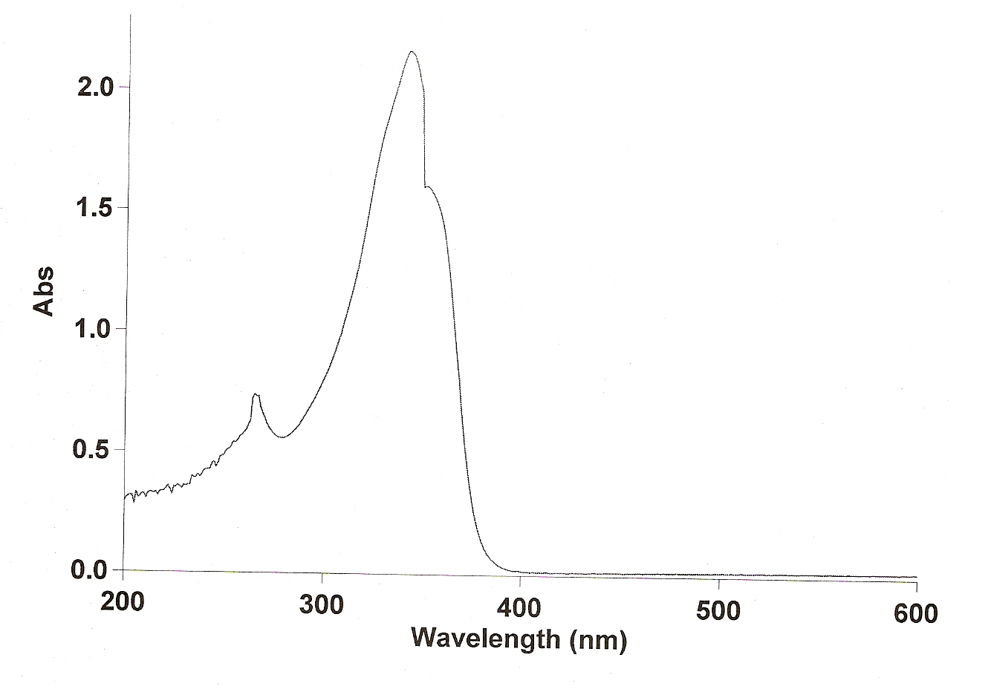
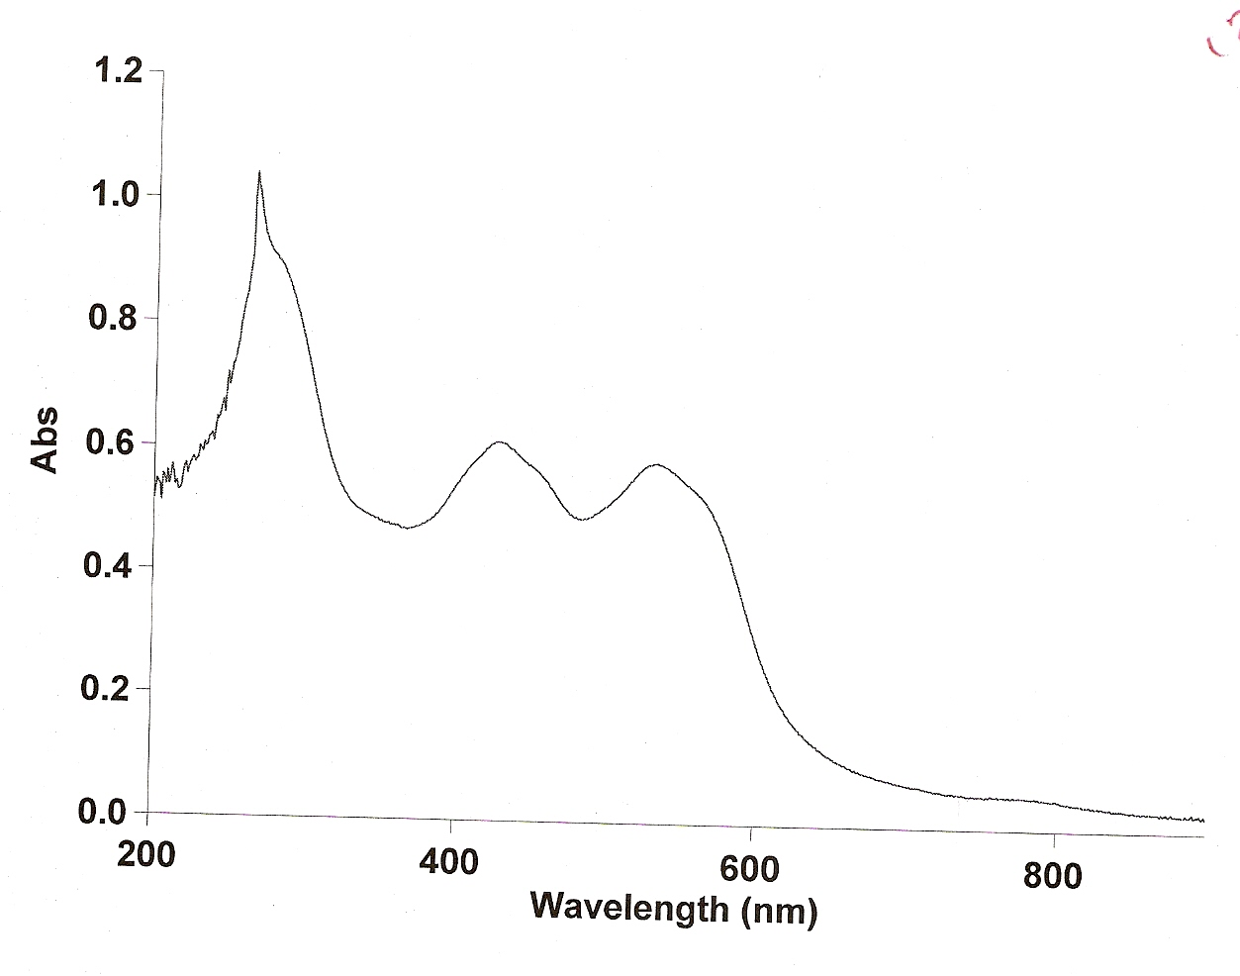
Fig (2): UV-Visible for ligand. Fig (3): UV-Visible for C₁
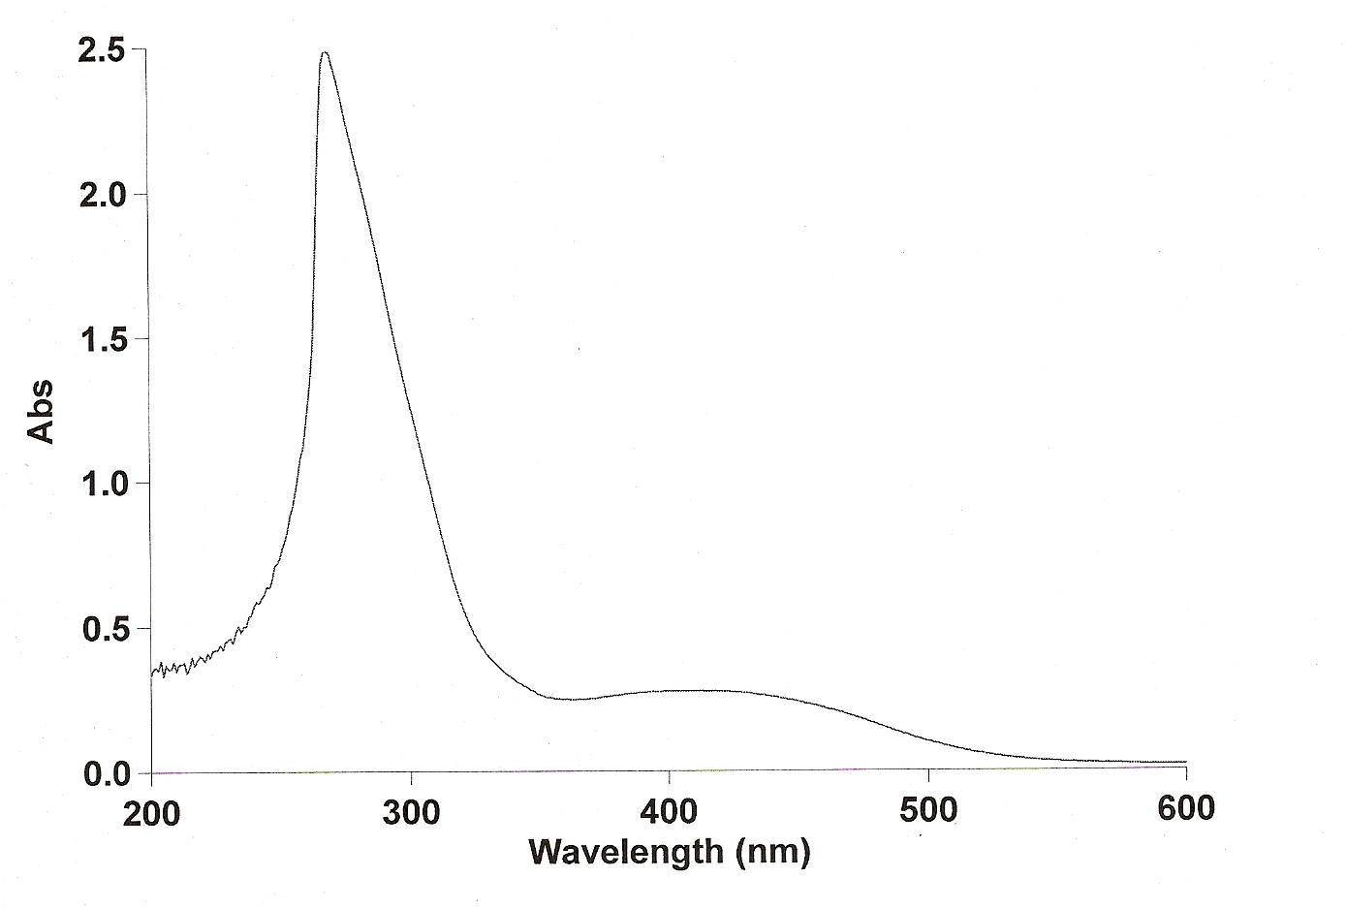
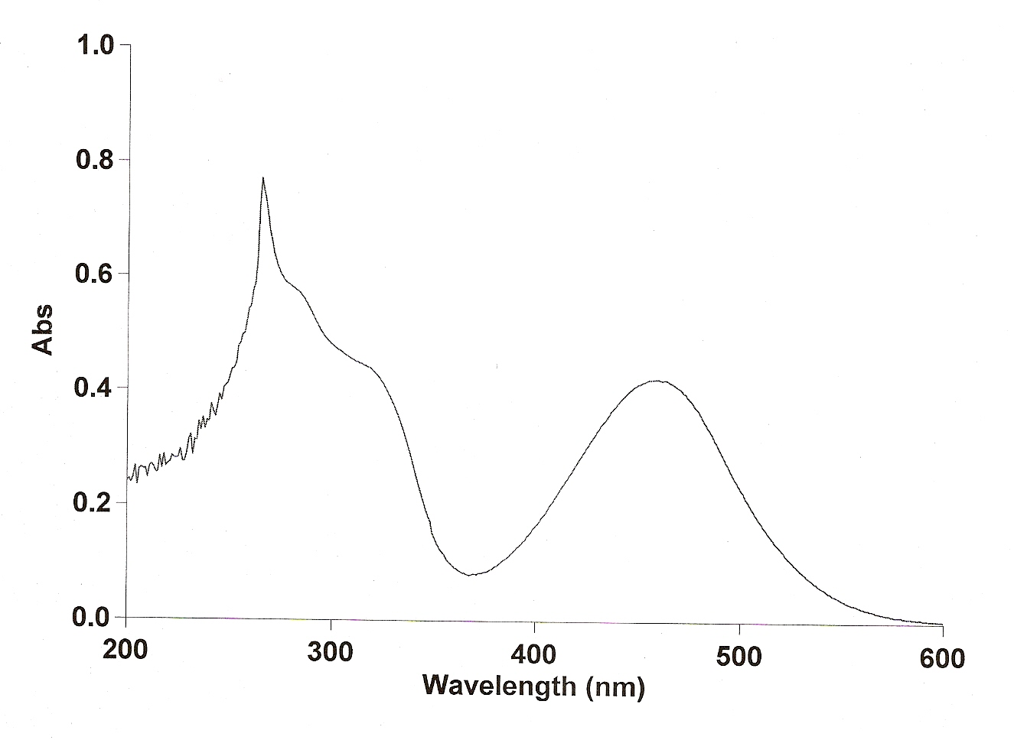
Fig (4): UV-Visible for C₂ Fig (5): UV-Visible for C₃

Table (3).Electronic spectra data, Conductivity, Magnetic moment (B.M.)

Comp. | Electronic spectral peak  (cm⁻¹). | Tentative assignments | Λ_{m}  Ohm⁻¹cm².mole⁻¹ | µ  B.M.
L
C₁ | 13.135 | ⁴A_{2g}^{F}→⁴T_{2g}^{F} | 3.2 | 3.68
 | 16.558 | ⁴A_{2g}^{F}→⁴T_{1g}^{F}
 | 22.511 | ⁴A_{2g}^{F}→¹T_{1g}^{P}
C₂ | 12.821 | ¹A_{1g}→¹A_{2g} | 58.2 | Diamagnetic
 | 17458 | ¹A_{1g}→¹B_{1g}
 | 27155 | ¹A_{1g}→¹E_{g}
C₃ | 15.332 | ²E_{g}→²T_{2g} | 15 | 1.68
3-3-3 Cu (II) complex:
The visible spectrum of Cu(II) complex show a broad band in the region(15.332)cm⁻¹ due to(²E_{g}→²T_{2g}) of distorted octahedral complexes⁽⁵⁾ Fig(5).Conductivity value (Λ_{m})in DMF showed that the complex was non-electrolyte, and the magnetic moment was(1.68)B.M. table(3).
According to the mentioned results, the suggested structure of the prepared complexes may be illustrated as follows:

Fig (6): Facial (1-phenyl-2,3dimethyl-4Isatidine-5-oxo pyrazole tri chloro-chromium (III)).

Fig (7):1-phenyl-2,3dimethyl-4Isatidine-5-oxopyrazole Nickel (II)
chloride.

Fig (8):1-phenyl-2,3dimethyl-4Isatidine-5-oxopyrazole di chloro aqua cupper (II).
3.4 Optical characteristics and validation of the method
The proposed procedure is validated by determining various optical parameters, which are listed in table(4).The linearity, slope and intercept have been calculated using the regression equation y=ax+b.The values of detection limit (D.L.), relative standard deviation (R.S.D.), confidence levels of con.and absor.,sandell's sensitivity(S),and molar absorptive coefficient(ε).

Table (4).Validation and sensitivity of the proposed method.

C₃[Cu(L)Cl₂(H₂O)] | C₂[Ni(L)Cl]Cl | C₁[Cr(L)Cl₃] | Parameters
brownish | brownish | green | Color
460 | 410 | 532 | λmax
y=0.0057x+0.06 | y=0.0054x+0.087 | y=0.0017x+0.02 | Regre.Eq.  Y=ax+b
0.9997 | 0.9994 | 0.9999 | Corr.coef.(r)
2.776 | 2.571 | 3.182 | Tabulated t-test  two tailed (n-2)  95% C.I.
0.0057±0.0019 | 0.0054±0.00061 | 0.0017±0.00016 | Conf.Limit for slop b±ts_{b}
0.06±0.36 | 0.087±0.24 | 0.02±0.096 | Conf.Limit for  intercept a±ts_{a}
0.33 | 0.25 | 0.18 | D.L. µg.ml⁻¹  n=14
0.1 | 0.05 | 0.075 | Erel. %
1.18 | 2.02 | 1.15 | RSD%
99.9±1.2 | 199.9±0.9 | 399.7±0.94 | Conf.Limit conc.  µg.ml⁻¹ 95%C.I.
0.557±0.002 | 1.08±0.004 | 0.699±0.0017 | Conf.Limit abs.  95%C.I.
0.16 | 0.179 | 0.1 | S µg.cm⁻²
1.19*10³ | 1.13*10³ | 2.8*10³ | ε L.mol⁻¹.cm⁻¹

4. Applicability of the method

The applicability of the suggested method for the assay of (Ampyrone) was examined. The results of the assay of tables were given in table (5) for all complexes.

Table (5).Determination of 4-AAP in pharmaceutical preparation.

C3[Cu(L)Cl2(H2O)] | C2[Ni(L)Cl]Cl | C₁[Cr(L)Cl₃] | Label claim(mg) | Commercial formulation analyzed
24.9 | 24.975 | 24.937 | 25 | Ampyrone

Table (6).Recovery results of the proposed method.

complexes | C₁[Cr(L)Cl₃] | C₂[Ni(L)Cl]Cl | C₃[Cu(L)Cl₂(H₂O)]
Recovery % | 99.75 | 99.9 | 99.6

5. Interferences

To study the potential interference from the commonly used excipients and other additives such as starch, talc, magnesium stearate, and glucose, under the experimental conditions employed in this paper.
Recovery studies were carried out and the results of the recovery analysis, table (6) showed no interference with the assay.

6. Conclusion

The objective of the investigation reported in this paper was to evaluate a spectrophotometer method for the determination of 4-aminoantipyrine in pharmaceutical dosage form, based on the synthesis of the new shiff base (1-phenyl-2,3dimethyl-4Isatidine-5-oxopyrazole) with some metal complexes.
This method was found to be reliable, accurate, and more sensitive than most of the analytical methods reported.
References

1-A. Burcinova, and M. Tichy, J.Chromatogr., 25,455,420-4(1988).
2-M.Q. Al-Abchi, A.M. Al-Delami, and S. Al-Najafi, Analyst, 113(11),
1661-3(1988).
3-V.V. Zanin, E.V. Smirnov, and N.N. Papkian, Farmatsiia, 28(6), 33-7 (1988).
4-Wikipedia,the free encyclopedia (2007),Copy right by Wikimedia Foundation,Inc.,United State,on line.
5-Sigma-aldrich (2007),by Sigma-Aldrich Co.,on line.
6-M.S. Patial, and J.T. Shah, J. Indian Chem. Soc., 944, 58(1981).
7-A.B.P. Lever."Inorganic Electronic Spectroscopy" Amsterdam-London, (1968).
8-B. Singh, and H. Misra, J.Indian Chem.Soc., LX III, 692(1988).
9-P. Venkates, B. War, N. Ramaro, and V. Tyaga, Indian J. of Chem.,
25A, 482-484(1986).
10-T. Sarojini,A. Ramch,and C. Raiah,Indian J. of Chem.,35A:940-945
(1996).
11-C.B. Mahto, Indian J. of Chem.Soc., 58,935(1981).
12-V.J. Baker, D.V. Kasnis, J. Indian Chem. Soc., 58, 790(1978).
13-L. Mishra, and K. Mustafa, Indian J.of Chem., 32A, 917(1993).
14-K.Nakamato,"Infrared Spectra of Inorganic and corrdination compounds", 4th ed.Wiley,Inter scince,New Yourk(1986).
15-K.Brugger"Coordination chemistry:Expermental methods" London Butter worths,England(1973).

