Synthesis and Characterization of Novel Bidentate Ligand type NO and Its Complexes with (Co^{II} , Ni^{II} ,Cu^{II} and Zn^{II}).

Leqaa khalid Abdulkarim

Department of chemistry, College of Education, Ibn Al-Haitham, University of Baghdad,

P.O. 4150, Adhamiyah , Baghdad ,Iraq .

Abstract

The [2-aminobenzothiazole]was reacted with [2,4,6 triyhydroxy-acetophenon monohydrate] to give a new ligand [2-N-2,4,6-trihydroxyacetophenonyliden benzothiazole] [H₃L]. This ligand was reacted with metal ions ( Co^{II}, Ni^{II},Cu^{II} and Zn^{II}) in methanol as solvent with ( 1:2 ) metal : ligand ratio to give a series of new complexes with general formula [ M(H₂L)₂],(where:M= Co^{II}, Ni^{II} ,Cu^{II}and, Zn^{II}).All compounds were characterized by spectroscopic methods ( I.R , U.V – vis,HPLC) atomic absorption, along with chloride content and conductivity measurements. According to the data of these measurements we suggested a tetrahedral geometry for (Co^{II}, Ni^{II},Cu^{II}, and, Zn^{II} ) complexes.

Introduction

Thiazoles are used for manufacturing biocides,fungicides ,pharmaceuticals,and days, they are a class of organic compound related to azoles with a common thiazole functional group[1].2-aminobenzothiazole represent an important class of hetrocyclic compounds that have many applications in our life [2-5].Some of these are employed as herbicides[6]. Hetrocyclic compounds such as thiazoles are considered to be a good coordinated Ligands[7,8]. In this paper reports the synthesis and characterization of a new [2-N-2,4,6-trihydroxyacetophenonyliden benzothiazole] ligand [H₃L] which derived from the reaction of [2-aminobenzothiazole] and [2,4,6-triyhydroxy- acetophenon monohydrate] and is their metal complexes with (Co^{II}, Ni^{II}, Cu^{II}, and, Zn^{II} ).

Experimental

Reagents were purchased form Fluka and Redial – Dehenge chemical Co. I.R spectra were recorded as ( KBr ) discs using a Shimadzu 8300 FTIR spectrophotometer in the rang ( 4000 – 400 )cm⁻¹. Electronic spectra of the prepared compounds were measured in the region (200–1100) nm for 10⁻³ M solution in (methanol) at 25⁰C using a Shimadzu, 160 spectrophotometer with 1.000±0.001 cm matched quartz cell.Metal contents of the complexes were determined by atomic absorption (A.A) techniqus a Shimadzu AA 680 G atomic absorption spectrophotometer.The Chloried contents for complexes was detrmined by potentiometric titration method on (686-titro processor-665),Dosinat-metrom Swiss. The (HPLC)chromatograms the complexes were obtained by using a Shimadzu 2020. Electrical conductivity measurements of the complexes were recorded at 25⁰C in 10⁻³ M solutions of the sample in (methanol) as asolvent using a pw 9526 digital conductivity meter.

Synthesis of ligand [H₃L] :

A solution of [2,4,6 Triyhydroxy-acetophenon monohydrate]( 0.55 g,1 mmol) in (5ml) methanol and (2-4) drops of glacial acetic acid was added to a solution of [2-aminobenzothiazole] (0.45g,1 mmol) dissolved in (5ml) methanol in (100ml) round bottom flask.The mixture was allowed to refluxed for 4hrs, with stirring at room temperature. During which time a yellow solid material was collected by filtration ,dried under vacuum for 24hrs , to give [H₃L] as a yellow solid , yield (0.7g ,77%) m.p ( 136 – 138⁰C).

Synthesis of complexes:

Synthesis of [Co (H₂L)₂](1) :

In(50ml) round bottom flask (0.098g,0.41mmol)of[CoCl₂.6H₂O] was dissolved in (5ml)
mthanol .Asolution of (0.25g,0.83mmol) of [H₃L] in (5ml)and KOH (0.046g,0.83mmol) was added to the above mixture.The reaction was allowed to reflux for (2hrs).The greenish-blue precipetate formed which was filtered ,washed with (1ml) ether and dried to (0.35g,71%) of the title compound,m.p(255⁰C)dec. (Table-1).

Synthesis of [Ni (H₂L)₂] (2),[Cu(H₂L)₂] (3)and [Zn (H₂L)₂](4) Complexes:-

The method used to prepare the complexes (2),(3)and(4) was similar to that mentioned in preparation of cobalt complex(1).(Table-1) stated weight of starting materials, % yield and some physical properties of the ligand and prepared complexes.

Table (1): some physical properties of the ligand and its complexes and their reactants quantities.

Compound | M.Wt  g. mol⁻¹ | M.p⁰C (dec) | Color | Metal chloride salt | Weight of metal  Chloride |  | Weight of product (g) | Yield % | Metal content  found  (calcd.) % | chloride  content
 |  |  |  |  | g | mmole
H₃L* | 300 | 136-138 | yellow | - | - | - | 0.7 | 77 | - | -
[Co(H₂L)₂** | 655 | 255 | greenish-blue | CoCl₂.6H₂O | 0.096 | 0.41 | 0.35 | 71 | 9.96  (10.35) | nil
[Ni(H₂L)₂] | 656 | 278 | Green | NiCl₂.6H₂O | 0.097 | 0.41 | 0.31 | 63 | 9.54  (10.27) | nil
[Cu(H₂L)₂] | 661.5 | 249 | yellow | CuCl₂.2H₂O | 0.069 | 0.41 | 0.29 | 59 | 10.98  (11.36) | nil
[Zn(H₂L)₂] | 663 | 263 | Yellowish-white | ZnCl₂.2H₂O | 0.07 | 0.41 | 0.29 | 59 | 10.98  (11.36) | nil
* H₃L=C15H12N2O3S
** H₂L=C15H11N2O3S
Result and Discussion

Synthesis of Ligand

The pro–ligand[H₃L] was prepared according to the general method shown in scheme (1). The (I.R) spectrum for [H₃L] ligand Fig. (2), displayed three bands at 3529,3452 and 3319 cm ⁻¹ due to υ (O–H ) stretching frequency for the hydroxyl groups ,on the other hand,a band at 1622 cm ⁻¹ due to υ (C=N) stretching frequency for the imine groups[9],and aband at 748 cm⁻¹ assigned to υ (C –S ) stretching frequency[10].(U.V-Vis) spectrum. Fig (3), shows one peak with a high intense absorption peak at (300) nm (33333 cm⁻¹) ( ε_{max} = 2049 molar ⁻¹.cm⁻¹) which assigned to an overlap of (π →π*), (n →π*) electronic transitions[11].

Scheme (1) Synthesis route of the ligand [H₃L]

Synthesis of complexes

The synthesis of the complexes was carried out by the reaction of the ligand [H₃L] with [MCl₂.X H₂O] [where M= (Co^{II}, Ni^{II,}Cu^{II} and Zn^{II}) ,X=6 for Co^{II}, Ni^{II} and X=2 for Cu^{II} and Zn^{II}] in methanol under reflux. All complexes are stable in solution and electrolytes .The analytical and physical data (Table -1) and spectral data Table (2) and Table (3) are compatible with suggested structures Fig. (1). The (I.R) spectral data of the complexes are presented in (Table -2). In general the( I.R) spetra for all complexes revealed bands at rang (3533─3289) cm⁻¹ were attributed to υ (O–H ) stretching frequency . (I.R) spectra of the complexes (1), (2), (3) and (4) also displayed bands at 1632 cm⁻¹,1635,1630 cm⁻¹and 1636 cm⁻¹ respectively which assigned to υ (C=N) stretching for the imine groups[12].These results showed that the bands of υ (C=N) were shifted to highre frequencies in comparison with that of free ligand at 1622 cm⁻¹.These shifting can be attributed to delocalization of metal ion electronic density in to π-orbital of the ligand(π–system).Bands of υ(C–S) stretching at 748 cm⁻¹ for the free ligand did not change values that’s mean the sulfer atom did not coordinated with metal ion [13].The new bands at range(616–609)cm⁻¹and(414–420)cm⁻¹ are shown in Fig. (2a,2b,2c)and table-2 are assigned to υ(M–N) and υ(M–O) stretching respectively .These bands indicate that the nitrogen of imine group and oxygen are involved in coordination with metal ion [14-15 ].The (U.V-Vis) spectra for all complexes shown in Fig.(3a,3b and 3c).The electronic spectral data for complexes are given in (table-3). The spectra show two intense peaks in the U.V region ,the first at reang(277-300)nm and the second at range (341-343) nm for all complexes. These two peaks were assigned to ligand field and charge transfer transition respectively[16].Complex (1) exhibited peak at (833) nm which can be attributed to (d-d) electronic transition type (⁴A₂→⁴T_{1 (F)}).The weak peak in spectrum of complex (2) at (403) nm was assigned to (d-d) electronic transition type (³T₁→³T_{1(P)}).The spectrum of complexe(3) exhibited weak at (669)nm which can be attributed to (d-d) transition type (²B₂→²E).The (d-d) electronic transition for the complexes (1),(2),(3) and (4) suggest tetrahedral configuration around Co^{II}, Ni^{II}, and Cu^{II} respectively [17].The absence of absorption peak in the range(360-1000) nm for the spectrum of complexe (4) indicate no (d-d) electronic transition happened (d¹⁰-system) in visible region ,that is agood result for Zn^{II} tetrahedral complexes [ 16].The (HPLC) chromatograms for Co^{II} and Ni^{II} complexes (fig.4a,4b) (table-3) show one signal at t_{R}=11.462 and5.894min respectively, indicating the purity of the complexes and appear as a single species in solution.The molar conductances of the complexes in (methanol) solvent in 10⁻³M at 298K° (table-3) indicated non electrolytic nature [18-19] The (A.A) measurments and chloride content results for the complexes [Co(H₂L)₂], [Ni(H₂L)₂],[Cu(H₂L)₂]and [Zn (H₂L)₂],(table-1) are in a good agreement with the calculated values .

References

- A.J.Arduengo,J.R.Goerlich and W.J.Marshall."A Stable Thiazol-2-ylidene and Its Dimer ".Liebigs Annalen 1997(2):365-374.
- Ram,V.and Pandey,H.N.(1974).Chem.Pharm.Bull.22,2778.
- Parmar,S.S.;Chaudhary,S.K.;Kumar,S.Spiro,H.R.(1977)J.Pharm.Sci(7):66,971
- Mohan,J.(1983),.IndianJ.Chem.,22B270.
5. Maxwell,R.;Wasdahl,D.A.;Wolfson,A.C.;Stenberg, V.I.(1984)
J.Med.Chem.,27,1967.
6. Abdul-Rahman,S.(2000),Engineering Journal e IslamicUniversity of Gaza.(1):13p35-95.
7. Rehab,A.M.;Ayad,H.jassim and Mouayed,Q.Al-Abachi(2003),National
Journal of Chemistry,9,115-125.
8. Ahmed ,S.H;Modher,Y.M.and Salwa,A.Jabar(1999),IraqiJ.S.,40A,No.3,
9. G. Socrates " Infrared characteristic Group Frequencies " Wiley Inter science publication … ( 1980 )
10.Kumer A,Singh G,Handa RN,Dubey SN,Squattrio PJ,Synthesis and characterization of complexes of Cobalt(II),Nickel(II),Copper(II)and Zinc(II) with Schiff Bases Derived from Cinnamaldehyde and4–Amino–3– ethyl– 5–mercapto – s–triazol and 4– Amino–5–mercapto–3–N–propyl–s– iazole.Indian Journal of Chemistry.1999;38A:613.
11. W. Kemp " organic spectroscopy " 2nd Edition , ( 1987 ) , 144
12.D. Hadzi, J. Chem. Soc., 1956,15,2725.
13. Sonmez,M.and Sekerci,M.(2000).Polish-J-Chem.,76,907-914.
14. K. Nakamoto "Infrared spectra of Inorganic and coordination compounds "4th. Ed. J. Wiely and son , New York , ( 1996)
15. J. Ferraro , " Low Frequency Vibrations of Inorganic and coordination compounds " plenum , New York (1971)
16. N.N. Green wood and A.Earnshow , " chemistry of the Elements " , J .wiley and Sons Inc . New York , (1998).
17. A.B. P.Lever , "Inorganic Electronic Spectroscopy " New York , ( 1968 ).
18. W.J. Geary , Coord .Rev. ,1971, 7,81.
19. S.F.A.Kette, "Coordination Compounds Thomas nelson and sons,Londone p.165,(1975).

M=Co^{II},Ni^{II},Cu^{II} and Zn^{II}

Figure (1) The suggested structure for the complexes

Compound | υ (o-H)  phenol | υ (C = N ) | υ (C-N) | υ (C-S) | υ ( M – N) | υ ( M – O ) | Other bands  ______________
[H₃L] | 3319  3452  3529 | 1622 | 1537 | 748 | - | - | υ(C – H )aliph2987  υ (C – H)arom 3006
[Co(H₂ L)₂] | 3307 3461 3533 | 1632 | 1529 | 749 | 613 | 419 | υ(C – H )aliph 2929  υ (C – H)arom 3030
[Ni(H₂L)₂] | 3527  3456  3296 | 1635 | 1527 | 749 | 609 | 418 | υ(C – H )aliph 2964  υ (C – H)arom 3066
[Cu(H₂L)₂] | 3519  3455  3289 | 1630 | 1530 | 750 | 616 | 414 | υ(C – H )aliph 2933  υ (C – H)arom 3047
[Zn(H₂L)₂] | 3533  3460  3292 | 1636 | 1525 | 749 | 615 | 420 | υ(C – H )aliph 2918  υ (C – H)arom 3052
Table (2) I.R spectral data of the ligand and their metal complexes

Table (3) Electronic spectral data and conductance measurement of ligand and its complexes

Compound | λ nm | Wave number Cm⁻¹ | ε_{max} Molar Cm⁻¹ | Assignment | HPLC  Min | Λ  (Ω¹.cm².Mole ⁻m¹)
[ H₃L] | 300 | 33333 | 2049 | π→π*  n→π* | - | -
[Co(H₂L)₂] | 300  343  833 | 33333  29154  12004 | 2215  1981  14 | Ligand field  C.T  ⁴A₂ → ⁴T1 _{(F)} | 11.462 | 4.13
[ Ni H₂L)₂] | 300  341  403 | 33333  29325  24813 | 1520  1870  1784 | Ligand field  C.T  ³T₁→³T_{1(P)} | 5.894 | 9.6
[Cu H₂L)₂] | 277  368  669 | 36101  27173  14947 | 1285  1766  8 | Ligand field  C.T  ²B₂ →²E | - | 7.3
[Zn H₂L)₂] | 299  342 | 33444  29239 | 1954  1955 | Ligand field  C.T | - | 6.7

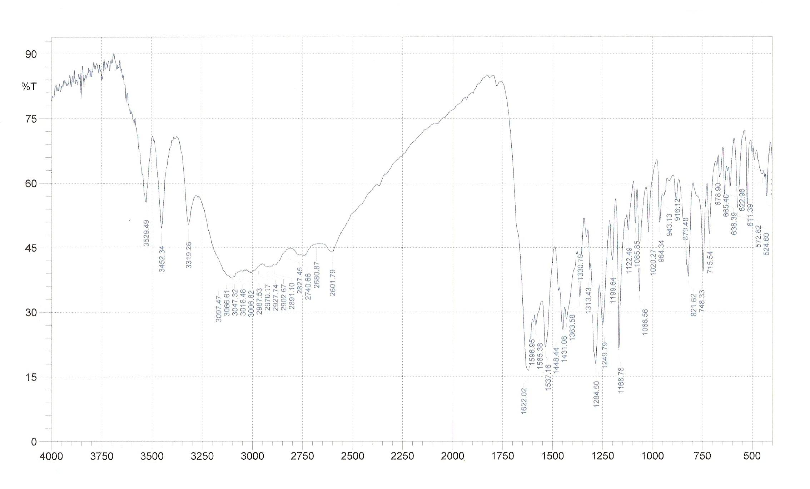

Fig.(2)The(I.R)spectrum of ligand [H3L]

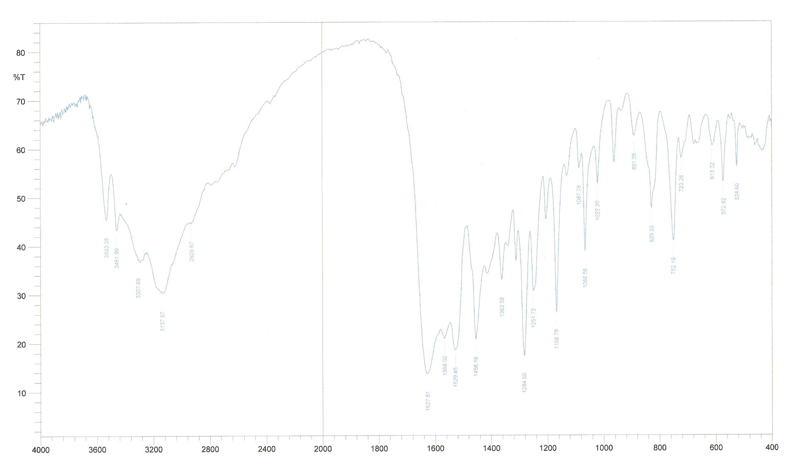
Fig.(2.a )The(I.R)spectrum of [Co(H₂L)₂]
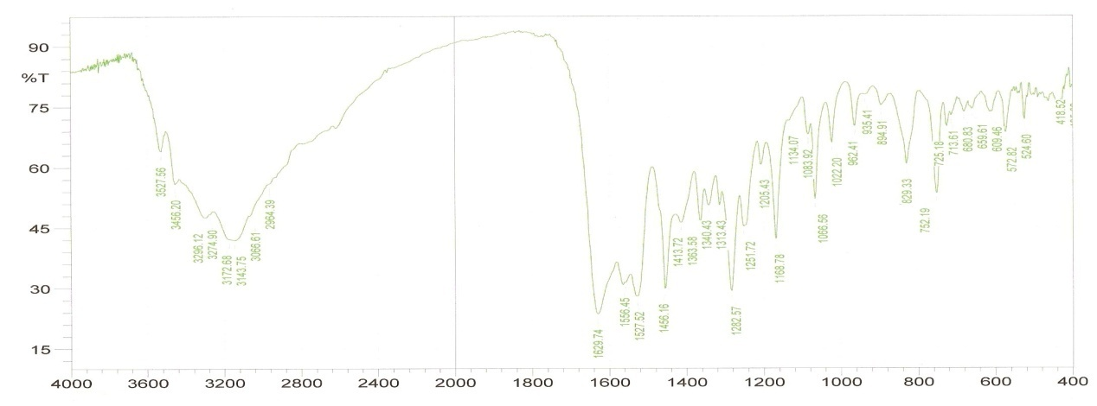

Fig.(2.b )The(I.R)spectrum of [ Ni H₂L)₂]

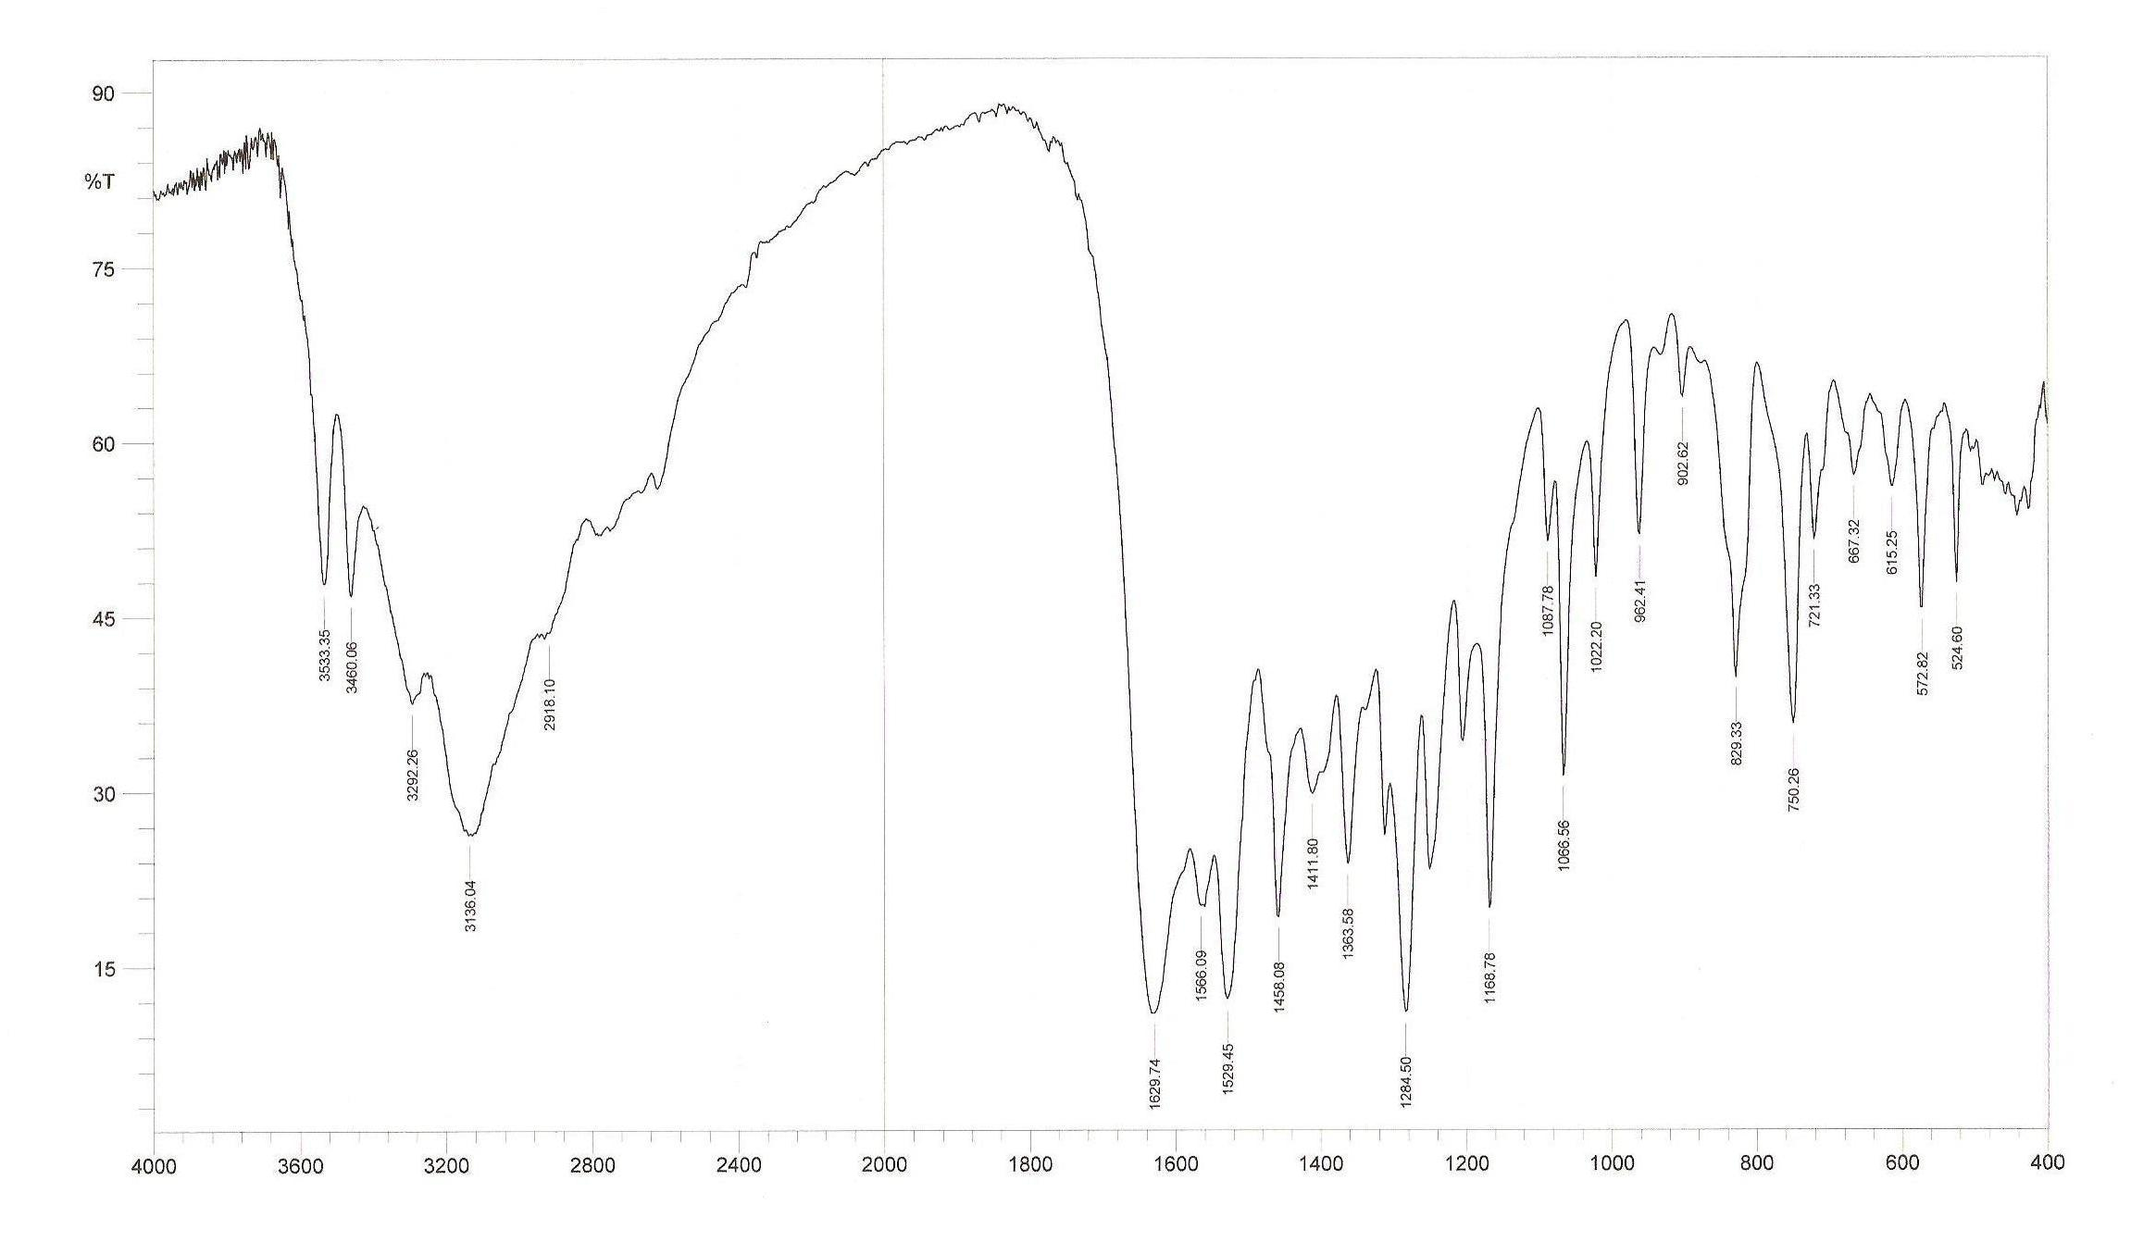
Fig.(2.C )The(I.R)spectrum of [Zn H₂L)₂]
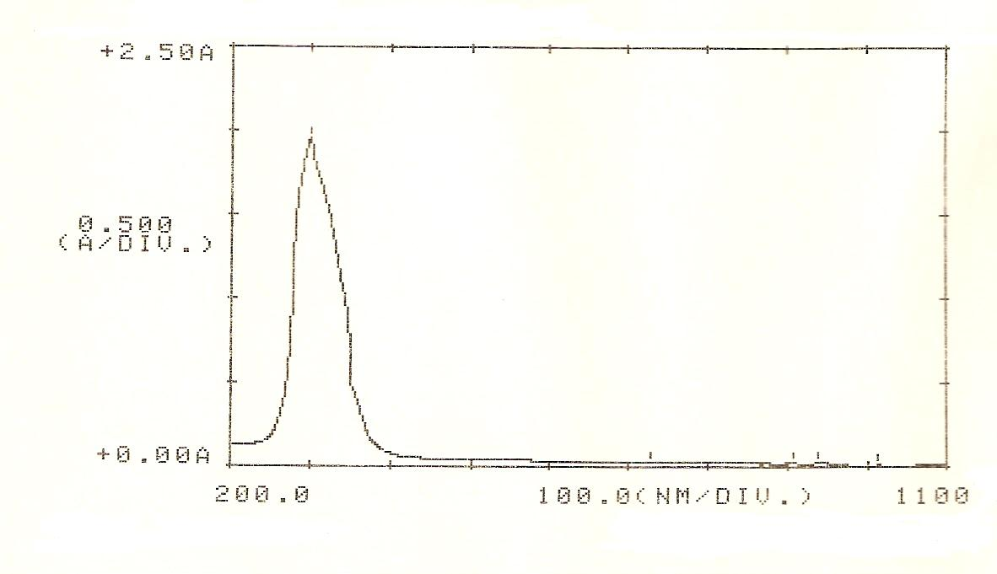

Fig.(3)The(UV - Vis) spectrum of ligand[H₃L]

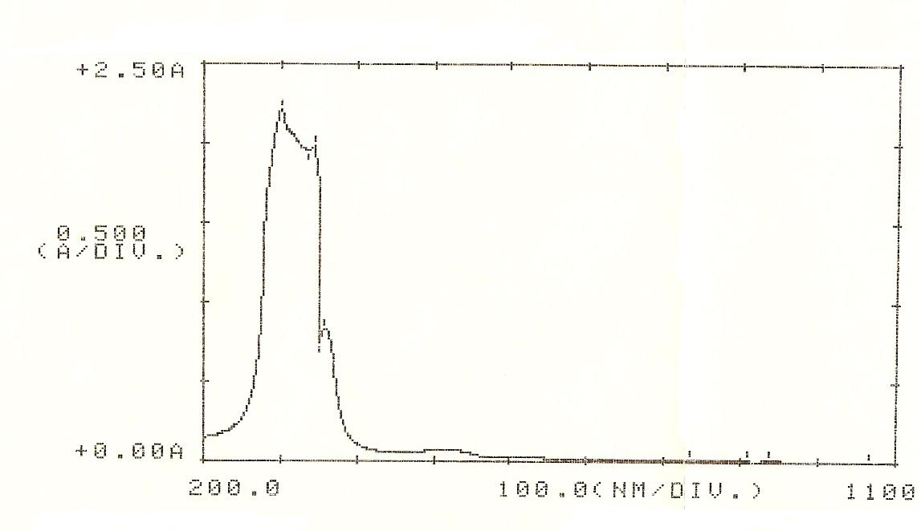

Fig.(3.a )The(UV - Vis) spectrum of [Co H₂L)₂]

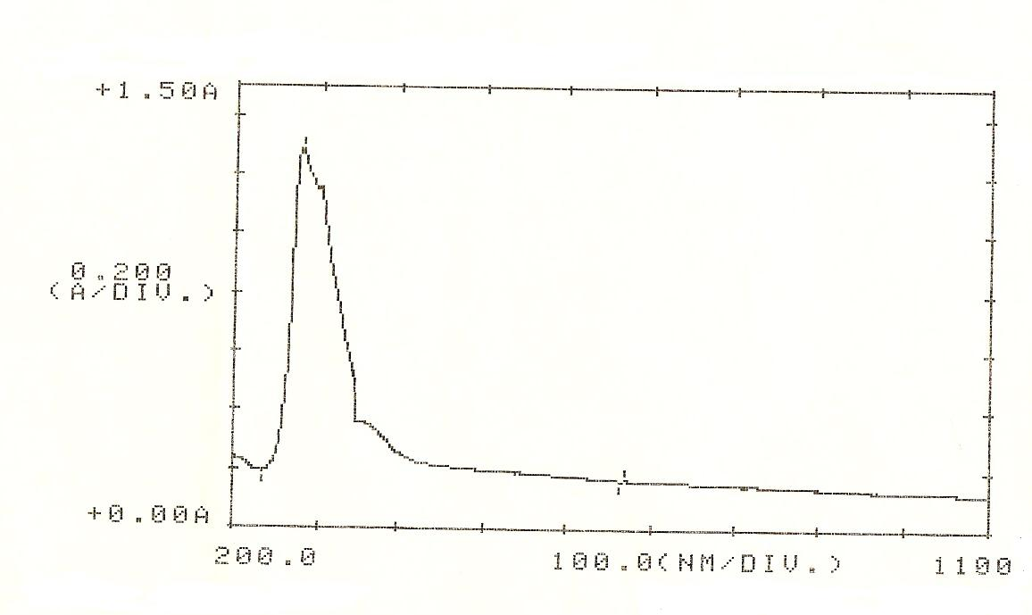

Fig.(3.b )The(UV - Vis) spectrum of [Cu H₂L)₂]

Fig.(3.C )The(UV - Vis) spectrum of [Zn H₂L)₂]

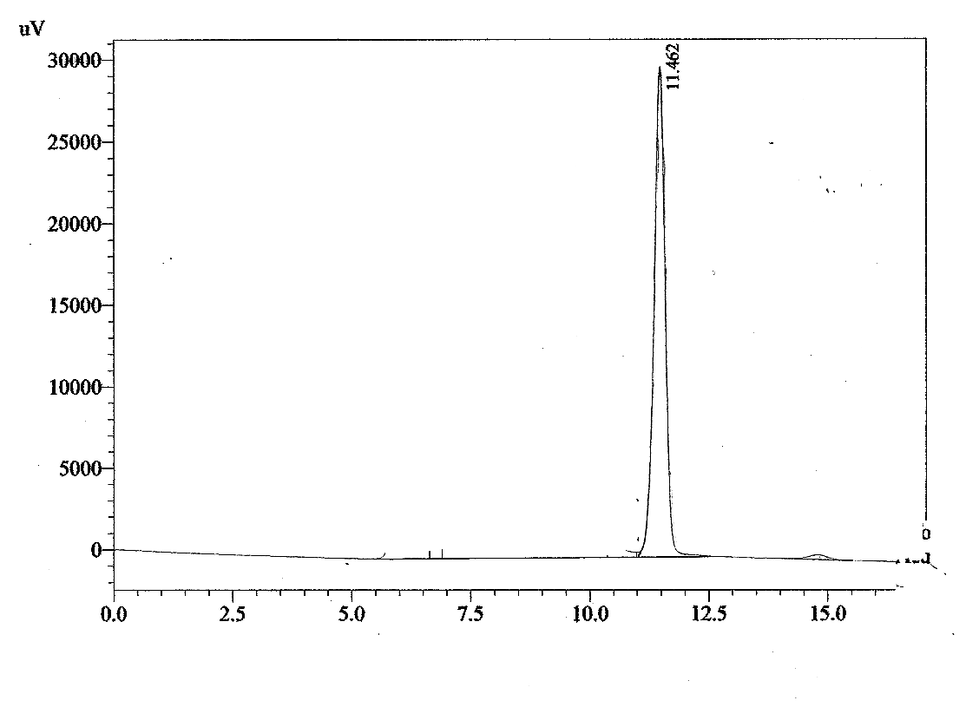

Fig (4a) .The HPLC chromatogram of the [Co (H₂L)₂]

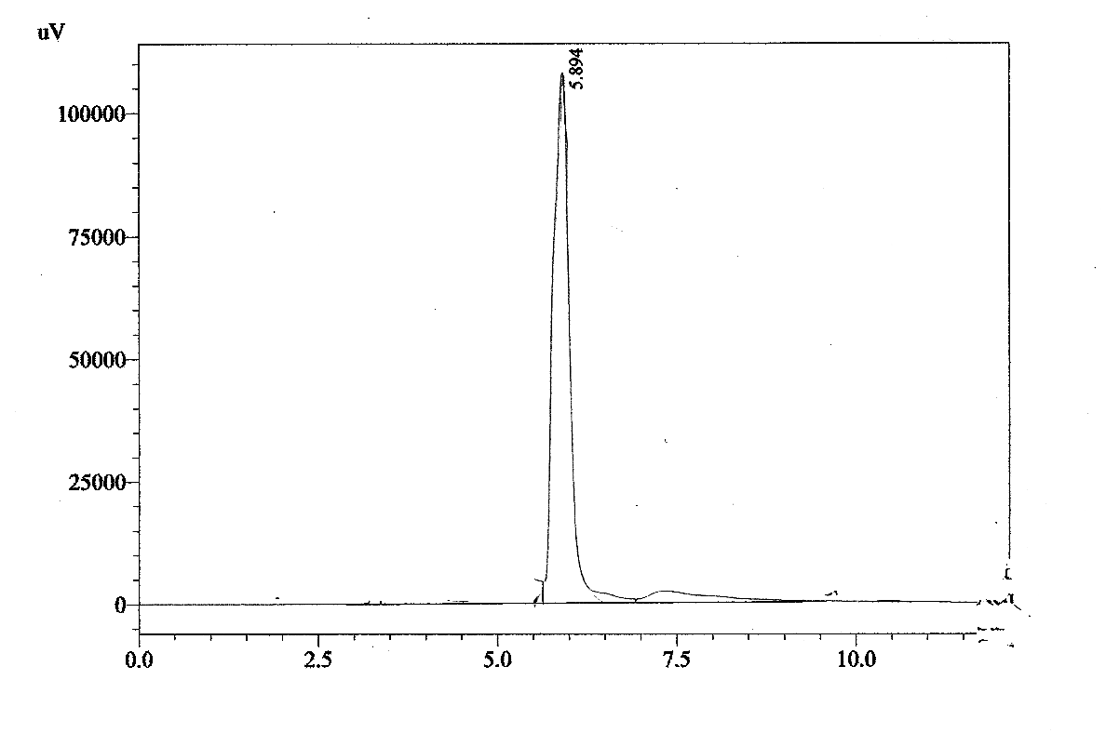

Fig (4b) .The HPLC chromatogram of the [Ni (H₂L)₂]

NO ثنائي السن جديد نوع تحضير وتشخيص ليكاند

ومعقداته مع
(Co ^{(II)}, Ni ^{(II)},Cu^{(II)} and Zn ^{(II} )

لقاء خالد عبدالكريم
جامعة بغداد

كلية التربية ابن الهيثم قسم الكيمياء

العراق – بغداد - الاعظمية P.O.4150

الخلاصة:

تضمن البحث تحضير الليكاند ثنائي السن الجديد
[H₃L] ] [2-N-2,4,6-trihydroxyacetophenonylidene-benzothiazole
وذلك من مفاعلة 2-aminobenzothiazole مع 2,4,6 triyhydroxy-acetophenon monohydrate ثم مفاعلة الليكاند مع ايونات (Co ^{(II)}, Ni ^{(II)},Cu^{(II)} and Zn ^{(II)} ) بوجود KOH باستخدام الميثانول وسطا للتفاعل وبنسبة(1:2) تكونت سلسلة من المعقدات الجديدة ذات الصيغة العامة :

[M (H₂L)₂]

حيث
M =(Co^{(II)} , Ni^{(II)} ,Cu^{(II)} and Zn^{(II)}

شخصت جميع المركبات المحضرة بوساطة الأشعة تحت الحمراء والأشعة فوق البنفسجية – المرئيةوHPLC ومطيافية الامتصاص الذري للعناصر ومحتوى الكلور ودرجات الانصهار , مع قياس التوصيلية المولارية الكهربائية من معطيات التحليل فان الشكل الفراغي لجميع المعقدات هو رباعي السطوح.

