A Survey Study of the Syllabuses of English
used in Iraq ( 1873 – 2003 A.D.)

Natiq Taha Abdul – Kareem ( M. A. )
The Directorate General of Education in Diala Governorate

1 . 0 . The Problem and Its Significance

Logically , the past is the foundation on which the present is erected. So ,it is useful to know something about the history of the English teaching materials which were used in Iraq in the previous historical eras.

This interest came from an article wrote by Al – Hamash on IDELTI Journal (4) in 1975. Al – Hamash mentions that a great deal of dissatisfaction with the result of teaching English in Iraq is attributed to the textbooks used. This article made the researcher curious and eager to know something about the syllabuses used at that time. Therefore , the efforts were made to delve deeply in the history for this purpose.

To trace the history of the Iraqi syllabuses from the year 1873 A.D. to 2003 A.D. is something uneasy nowadays due to the present situation engendering from the American occupation ; the situation is insecure which limits the action of any researcher , most of the documents were looted or burned , and the devastation is everywhere in the state institutions. All these have their impression.

Private efforts were made to obtain some documents from those who had their primary education in the 1930s and 1940s and from those who have private libraries , but most of the efforts were in vain.

So , the lack of documentation in this field constitutes the problem.

It is hoped that such a documentary work will be useful to all educationists especially the syllabus – designers , and at the same time it will fill the gap in historical documentation in this field.

1 . 1 . The Aim of the Study

The aim of this study is to enrich the Iraqi archives with valuable information of the development of the syllabuses of English used in Iraq from the year 1873 A.D. to the year 2003 A. D. .

1 .2 .What is meant by “Curriculum” and “ Syllabus” ?

Richards etal ( 1992 : 94 , 368 ) define Curriculum as an educational programme which states:

a- The educational purpose of the programme . ( the ends ).
b- The content , teaching procedures , and the teaching experiences which will be
necessary to achieve this purpose. ( the means ).
c- Some means for assessing whether or not the educational ends have been
achieved.
While a syllabus is a description of the contents of a course of instruction and the order in which they are to be taught. Language – teaching syllabuses may be based on:

- grammatical items and vocabulary ( structural syllabus )
- the language needed for different types of situations ( situational syllabus )
- the meanings and communicative functions which the learner needs to express in the target language ( notional syllabus )

White ( 1988 : 4 ) mentions that there is some confusion exists over the distinction between “syllabus” and “ curriculum”.

In Britain , ‘syllabus’ refers to the content or subject matter of an individual subject , where as “curriculum” refers to the totality of the content to be taught and aims to be realized within one year or educational system.

In U.S.A. , “Curriculum” tends to be synonymous with “Syllabus” in the British sense.
Thus , curriculum is a wider term than syllabus.
In conclusion , the common tendency is to equate the curriculum with the syllabus. ( Richmond : 1971 : 11 ) .
2 . 0 . Theoretical Background
A language – teaching syllabus is a blueprint of a very complex process. It demands the utility of a number of linguistic , psychological , sociological , pedagogical , and political principles. Brumfit and Johnson ( 1977 : 99 ) add another responsibility in which a syllabus – designer has to respond to the demand of theory.
“The development of language syllabus
responds partly to social and
political pressures as well as to the
demand of theory ”
It also requires cooperative efforts in which experienced teachers work together with specialists in the subject – matter. ( Corder : 1973 : 13 )
It is axiomatic that the design of syllabus usually begins with the analysis of learners’ needs and interests and this analysis provides a basis for setting the goals and objectives upon which the syllabus is structured.
In another words , each syllabus has objectives to be achieved , and contents to be learned and these objectives and contents change as long as our needs , demands , concepts and ideas change. Accordingly , the syllabus should change , too. i. e. It is dynamic ( Finocchiaro & Brumfit : 1983 : 207 ).
Logically , there is no specific syllabus which suit every learner or every country. It is unsatisfaction to copy exactly a syllabus that exists in another country , particularly when there are differences in religion , native language , educational and political philosophy , and the cultural and social backgrounds. ( Grayson , 1977:116 ).
In English , there are two types of syllabuses :
- ELT syllabus. ( English Language Teaching )
- ESP syllabus ( English for Specific Purposes ) which started in 1960s. It is for post graduate students specializing in various vocational disciplines , such as agriculture , industry , and commerce.
2 . 1 . ELT Syllabuses of English in Iraq
The syllabuses of English used in Iraqi schools passed in two historical phases:

- the imported syllabuses which were used during the period ( 1873 – 1970s ).
- The locally produced syllabuses which have been used since 1970s till nowadays.
2 .1 .1 . The Imported Syllabuses of English
Despite the fact that the old syllabuses have become out of date , it would be helpful to step back in time to remind ourselves of how the syllabuses of English in Iraq were.
English was taught in Iraq for the first time in the state schools in 1873. The number of schools were very few at that time.
When Iraq was mandated by Britain after the First World War , a decision was taken to expand the primary education and to confine teaching of English to the towns. English was taught as a second language beginning from the first primary year during the first year of the British occupation , but later , it was decided to teach it from the fifth primary year and its statue was changed from a second language into a foreign language. ( Al- Chalabi : 1976 : 41 )
At this era , the textbooks were imported from Egypt and they based on the Grammar – Translation Method. ( Ibid : 42 ) .
As far as this era , there is a good document which belongs to the ministerial examinations in English for the primary stage in 1938. This document ( see the appendix ) is a good proof that the syllabus was based on the Grammar – Translation method which prevailed in Europe in the nineteenth century and in the later part of the century was rapidly spread to other countries.( Rivers : 1980 : 14 / Johnson and Johnson : 1999 : 153 ).

At first glance to this document , it reveals the emphasis on written form. As Rivers ( 1980 : 17 ) points out that the pupil is often trained in artificial forms of language , the vocabulary was detailed and sometimes esoteric , communication skills were neglected and little stress was laid on accurate pronunciation.
Undoubtedly , the pupils were supplied with ready-made compositions , a pattern (s) of a letter , examples of using certain words in useful sentences and they were obliged to memorize them for examinations , i. e. , the teacher’s role was to cram his pupils for examinations.
It is also obvious that the primary skills to be developed were reading and writing. Little attention was given to speaking and listening and almost none to pronunciation. These are the main features of the Grammar – Translation Method. (Freeman : 1986 : 10 )

The earliest ELT course was followed by three series of courses which had been composed in Britain. The first series bears the name of “ The Oxford English Course “ by Oliphant , the second one bears the name “ The Oxford English Course for the Middle East” by Faucett , while the third one is entitled “ The Oxford English Course for Iraq “ by Hornby , Miller and an Iraqi expert Selim Hakim ( El-Bettar : 1965 : 2 ). The first two series had been used until the middle of the 1950s , while the third one had been used until the early of the 1970s. ( Ramadhan : 2001 : 12 ).
All the above – mentioned three series are almost identical and the material they present are the same. ( El-Bettar : 1965 : 2 ). They are vocabulary – centered and manifest a clear bias towards the Direct Method , i. e. , teaching English through reading. The books were divided into “reading texts”. This means that reading was the chief activity in those books. ( Al-Hamash : 1980 a : 6 ) , ( Al-Hamash & Younis : 1985 : 119 ).
It is obvious from the titles stated before that the first two series are not suitable for the Iraqi learners. They are for all learners who want to learn English as a second or a foreign language , while teaching a language should be practised in the social context.
Concerning the third series , it consists of ready – made materials compiled and abstracted from books and magazines , not of the basic structural patterns of the language. ( El-Bettar : 1965 : 4 ).
The main features of English learning – teaching process in Iraq during this era were the little material in English beside the prescribed books … tapes and records , were rarely used and they were limited to certain schools in large urban centres. (Al-Hamash : 1980 : 6 ).
It is worth mentioning here that most textbooks before the sixties and seventies depend on the teachers’ experience. They have enough of What to teach , but most of them take it for granted that the teacher knows the How. This means that a “Teacher’s Guide” was not existent or available ( Al-Hamash & Hammo : 1990: 7).
In short , those syllabuses did not satisfy the learners’ needs and interests and at the same time , they did not submit to the sociological , religious and political factors of the Iraqi society. Richmond ( 1971 : 6 ) stresses this point
“ a curriculum ought to be built around the great issues , principles , and values that society deems worthy of the continual concern of
its members”.
Moreover , the Ministry of Al-Maarif ( Education ) had no right to revise and modify those syllabuses because they are the property of the authors , not of the Ministry. ( Al-Hamash : 1977 : 1-2 ).
Matter of course , the authority which was in charge of education had to look into these aspects thoughtfully and deeply in order to improve that situation. Hence , the establishment of the Foreign Languages Department at the Higher Teachers Training College in Baghdad ( in the 4th decade of the 20th century ) marks a new era in English language teaching in Iraq on the way of improving the foresaid situation. (El-Bettar : 1965 : 2 ).
Concerning a literary reader , to the best knowledge of the researcher , teaching a literary reader began from the intermediate stage , not from the preparatory stage as it is now. For instance , in 1966 – 1967* , pupils at the first grade of the intermediate stage had a short story entitled “ Carel and Tom “. This short story suited the learners’ age ; therefore , it was very interesting for them. Furthermore , it was taught separately , i. e. once a week.
2 . 1 . 2 . The locally produced syllabus of English
“The Oxford English Course for Iraq “ was used until the early 1970s when book -1- of the New English Course for Iraq ( NECI , for short ) was first put in use at that time to be taught for the pupils of the Primary Fifth Grade , and every year a new book of the NECI series began to replace its counterpart of the old series regularly.
In point of fact , a new era in the history of the Iraqi educational sector in authorship began and it can be called “The Era of the Nationalizing the Syllabuses of English in Iraq” , because all the authors of this series and the advisory board are Iraqi.
In May , 1970 , the Ministry of Education formed a committee to draw up the objectives of a new English programme in Iraq. The committee specified the objectives and the main features of the programme. It stressed that the items in the textbooks should be graded in terms of value and difficulty : value should be come first and difficulty to be decided in terms of the possibility of interference from the Native language , as well as the degree of deviation from the established patterns of English. In the same year , another committee was formed to re-examine the situation and it submitted its recommendation about the new syllabus to the Education Board which endorsed them before 1972 , i. e. , the official approval (Al-Hamash : 1973 : 19-20 / 1980 a : 7 ).
The new series which consists of eight books been the name “ The New English Course For Iraq “. It is designed on the structural approach and a new method of teaching “ The Audiolingual Method” is recommended for teaching this programme. ( Al-Jumaily , 2002 : 30 ).
Teaching this syllabus starts in the fifth year in all primary schools. The syllabus should be applied experimentally in all schools and then modified after being practically applied. As result , the NECI was adopted after being proved efficient in comparison with the old textbooks. ( Ramadhan : 2001 : 14 ).
Starting with the year 1973 , the books have bears introduced to schools at the rate of one book per year. The last of the books ( Book 8 ) is intended to be in the
hands of the teachers and the pupils at the beginning of the academic year 1980-1981. This series include a total of (22) books for both pupils and teachers as follows:

__________________________________________________________________
* The researcher was a pupil in Al-Kindi Intermediate School for Boys (Al-Muqdadia – Diala )

- 8 language books for pupils
- 8 teacher’s guides
- 3 handwriting manuals for the fifth and sixth primary grades and the first intermediate grade
- 3 literary readers for the three grades of the preparatory stage.
( Al- Hamash , 1980 a : 8 , 9 )
The authors of this series and the advisory board are Iraqi. They are :
1. Khalil I. Al-Hamash , Ph. D College of Arts
2. Abdul-Kader Al-Bettar , Ed. D = =
3. Latif Hassan Ali , Ph. D = =
4. Adnan J. Radhi , M. A = =
5. Ra’ad Ahmed , M. A IDELTI
6. Aziz Yousif , M. A College of Arts
7. Samir Abdul-Rahim , M. Ed IDELTI
8. Khudheyer S. Ali , Dip. Ministry of Education
9. Badeel Hammo , B. A = =
This step is considered as a great exploit for the Iraqi specialists in ELT and pride for the Iraqi Ministry of Education. To the best knowledge of the researcher , the authors of the English syllabuses in most of the Arab countries are foreigners. This historic chance opened wide for the Iraqi team in ELT to prove their ability in the field of authorship in English.
Locally produced textbooks have a great characteristic. They are the property of the Iraqi Ministry of Education and this characteristic gives the curriculum authorities in this country the right and the freedom to revise and modify the books whenever they find it appropriate to do so. (Al-Hamash : 1977 : 1 ).
On October 1st , 1970 , “ The Institute for the Development of English Language Learning in Iraq ( henceforth IDELTI ) had been established by the Ministry of Education and opened in 1972 ( Al-Hamash 1973 : 9 / 1980a : 4 ). One of its main functions is to assist in improving the textbooks of English in Iraq. There was a standing committee which held its meeting regularly to look into the suggestions for revisions and modification. ( Al-Hamash : 1977 : 2 ). This institute also issued the IDELTI Journal No. (1) in 1973. This journal , which deals with English language teaching in Iraq , came out quarterly. All the editorial board were Iraqi except Mr. R. E. Underwood.
NECI series are not readers ( not readers – centred ) as the previous syllabuses. Reading is just one of the activities that the books include. The activities in a reader are usually limited to reading and answering written questions , while in a language book of NECI , there are a lot of activities such as dialogues , oral practice , pronunciation , reading , spelling , punctuation , writing a paragraph or a composition and written work. ( Al-Hamash , 1977 , 2 ).
Standard British English is used throughout the series. It is known as the speech of educated people ( Ibid : 8 ).
In NECI series , it has been found out that teachers need guidance and instructions for teaching English ; therefore , a teacher’s guide is designed with each book of the series ( Al-Hamash and Hammo : 1990 : 7 ).
During the first half of the year 1980 , the Directorate of Curricula and Textbooks opened wider discussions on school textbooks in all specialties including English. Therefore , a questionnaire and a critique of the textbooks of English were distributed to more than fifty scholars.
There were lengthy discussions of the pros and cons of the NECI textbooks and the suggested alternatives. ( Al-Hamash : 1980 b : 4 ).
In the wake of that meeting , a small committee of eight specialists was formed to formulate a definite opinion. The committee found it necessary to retain the NECI set of textbooks and to attempt to improve them in two separate ways :
a. constant revision and enrichment.
b.experimenting with a new different set of textbooks to be compiled by a special
committee for that purpose. ( Ibid : 6 , 7 ).
As for the item (b) , the committee submitted the items of the new syllabus , but they were rejected. ( Al-Jumaily : Personal Communication* ).

NECI series was retained , but it witnessed some modifications of errors. It was subject to modification on the basis of feedback from all those concerned ,i. e. it was just a “patching up” operation. ( Al-Hamash : 1980a : 40 ).
In 1980s , Iraq participated with Arab Gulf States in the work of unifying the English language curriculum in the seven states including Iraq. ( Education Development in Iraq , June , 1990 : 98 )** and it was decided to discuss this project finally in a meeting in Kuwait on the 1st of Jan. , 1990
____________________________________________________________________
* In the late 1980s ,Dr. Abdullatif Alwan Al-Jumaily was the specialist in charge of the ELT unit at the Directorate General of Curriculum and Textbooks at the Ministry of Education. He was also vice
- chairman and the chairman of the Iraqi National Committee for ELT.
** The Ministry of Education , The Iraqi national Commission for Education , Science and Culture.
In late March , 1990 the decision to adopt the syllabus and to start the process was taken in a conference held in Kuwait chaired by Dr. Abdullatif Al-Jumaily , Iraq, and also attended by Khudhair S. Al-Khazraji. The conference also appointed Al-Jumaily General Consultant for the course. ( Al-Jumaily : Personal Communication ).
Unfortunately , this effort ended in vain due to the political and military situation in the region arising from the Kuwaiti – Iraqi conflict.
In 2001 , the Ministry of Education formed a committee of Iraqi specialists in ELT curriculum. This committee consists of :
- Dr. Abdul – Jabbar Ali Darwesh ( Ph. D ) College of Teachers.
- Hisham Ibrahim Abdullah ( M. A ) Ministry of Education.
- Khudhair S. Al-Khazraji ( Dip. ) Ministry of Education.
The Advisory Board consists of :
- Ayif Habeeb ( M. A. ) College of Education , Baghdad University.
- Firas Awad Maroof ( M. A. ) = =
- Lamia A. Al-Ani ( M. A. ) = =
- Nejat A. Al-Juboury ( M. A. ) College of Education for Women.
The committee decided that the new syllabus which bears the name “Rafidain English Course for Iraq“ ( henceforth RECI ) to be designed on the communicative approach and it succeeded in putting Book -1- in use in the academic year ( 2002 –
2003 ) in spite of a lot of difficulties arising from the economic sanctions and embargo imposed on Iraq at that time. Some of the difficulties were the need for a foreign expert in ELT to read and comment on the manuscripts of the new series , and the need for native speakers to record the material , especially the songs on cassettes ( Al-Khazraji * : Personal Communication ).
Pupil’s Book -1- of RECI starts with “introductory Unit” in which the teacher takes three or four weeks to present some commends verbally and the pupils respond physically and also to teach them the English alphabet.( Darwesh etal , 2002 : 41,42). The aim is to train the pupils’ ears to accurate pronunciation of some words and also to realize their meaning., i. e. to develop the listening skill.
In addition to the Introduction Unit , it consist of fifteen units. Each unit is composed of several linguistic activities such as short conversations , games , songs and rhymes. Each fifth unit reviews the four previous ones. So , the units five , ten and fifteen are “ Riview Units “.
____________________________________________________________________
* Al-Khazraji , K. S. is one of the three authors of RECI series.

Pupil’s Book -1- ( 11 X 8 inches ) which is colourful is accompanied by two books :
a – Teacher’s Guide -1-
b – WorkBook & Manual -1- ( 11 X 8 inches).
These two books are not colourful. The Teacher’s Guide is written in Arabic to ensure the full benefit from the instructions and information on the part of the teachers.
3 – Conclusions and Recommendations
- It has been found out that because NECI textbooks are heavily politicized , they were subject to continual modification , omission and addition due to the political changes.
Consequently , syllabuses should not be used as instruments for political ends.
- From the survey of the construction of the Iraqi syllabuses , it is obvious that NECI series has been applied in teaching English for over thirty years.
This is illogical due to the developments in linguistics and ELT methodology and also due to the fact of the changing needs and wishes* of the learners. Assuredly , what was acceptable in 1970s , it is unacceptable in 2000s. Therefore , the syllabus must be continuously reviewed making use of the teachers’ and learners’ feedback. In deed , this is not preferable because it is a “patching - up” operation.
Accordingly , it is preferable that each new syllabus should not be used more than ten years to leave the door wide open for other Iraqi specialists to think of constructing another series taken the continuous changing conditions in all fields of life into consideration.
___________________________________________________________
* “needs” are externally imposed , while “wishes” are internally generated. Yalden Janice (1983 : 91) The communicative Syllabus : Evaluation , Design and implementation. Exeter : A. Wheaton Co. Ltd.
4 . Appendix
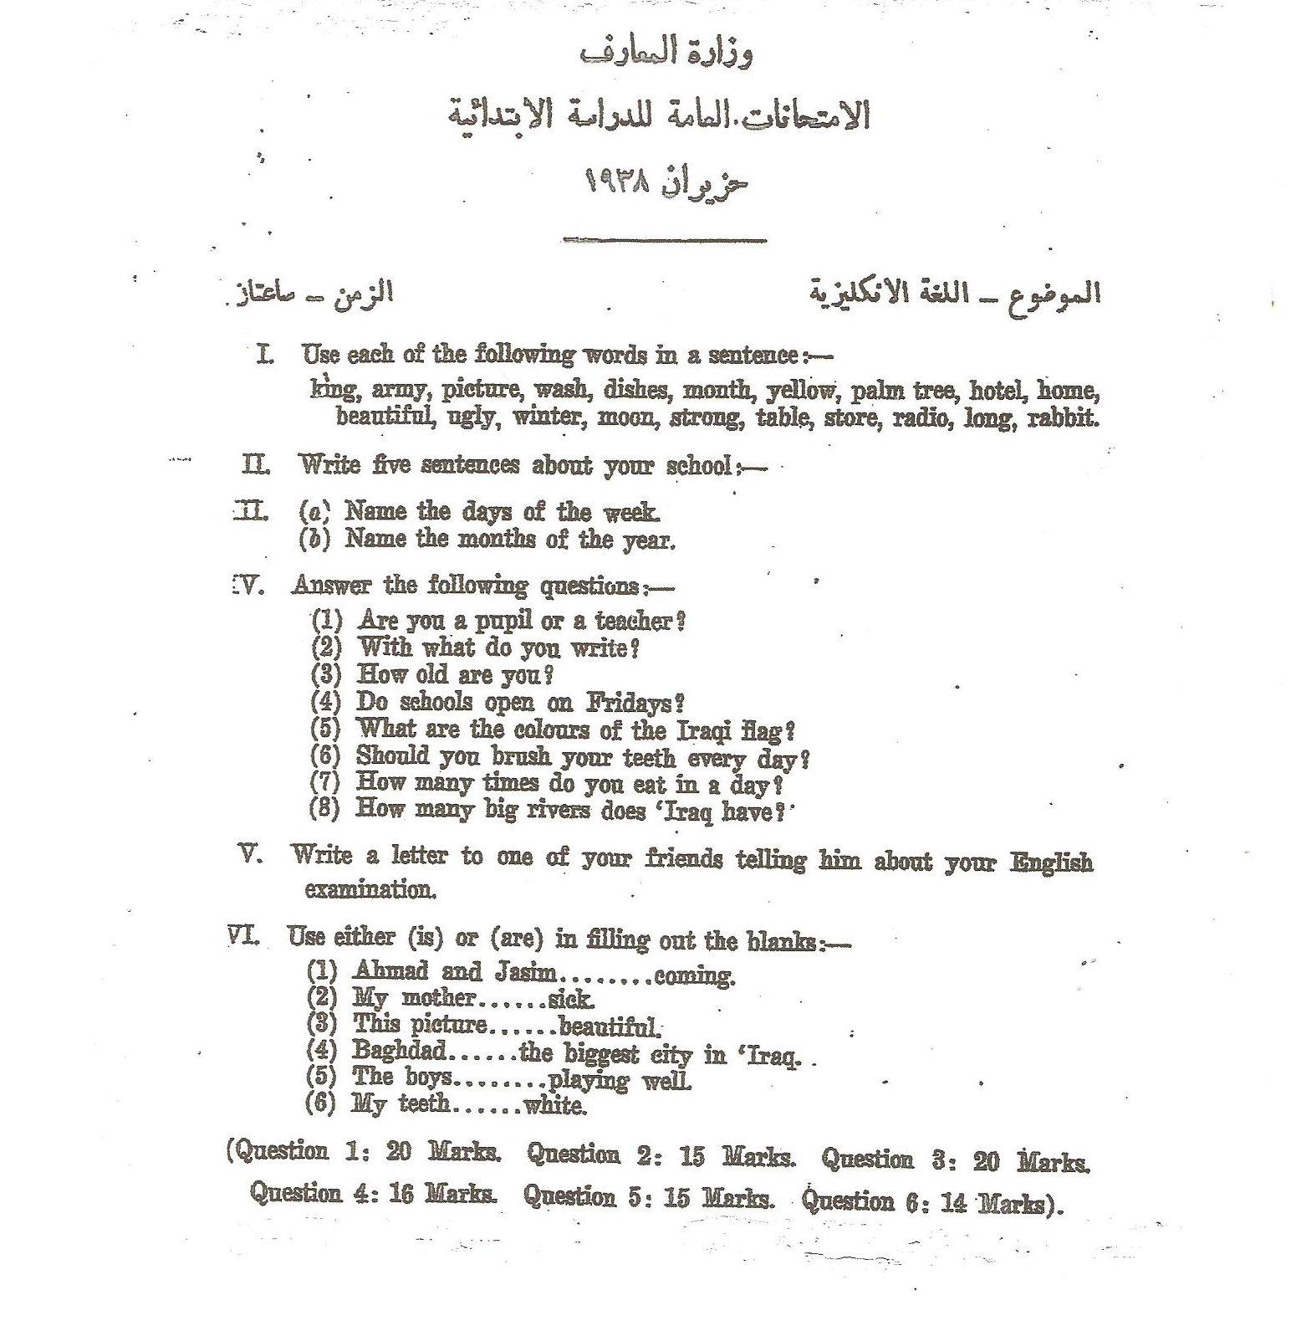

Bibliography

- Al- Bettar , Abdul-Kadir ( 1965 ) Method of Teaching English , Old and New.
Baghdad : Al – Sha’ab Press.

- Brumfit , C. J. and K. Johnson ( 1978 ) The Communicative Approach to Language
Teaching. Oxford University Press.

- Al-Chalabi , Samir Abdul-Rahim ( 1976 ) Teaching English as a Foreign Language
In Iraq with Emphasis on the in – Service Training of Secondary
Schools Teachers of English. Baghdad : Dar Al-Jahidh Press.

- Corder , S. Pit ( 1973 ) Introducing Applied Linguistics. London : Penguin
Education.

- Darwesh , Abdul-Jabbar Ali , Hisham I. Abdullah and Khudair S. Ali ( 2002 )
Teacher’s Guide –1 for Fifth Grade of the Primary Education Stage.
Baghdad : Ministry of Education.

- Finocchiaro , Mary and Christopher Brumfit ( 1983 ) The Functional – Notional
Approach , From Theory to Practice. Oxford : Oxford University Press.

- Grayson , Lawrence P. ( 1977 ) The Design of Engineering Curriculum. Unesco.

- Al- Hamash , I. Khalil (1973 ) Observations on the Success and Failure of Teaching
English in Iraq. Baghdad : IDELTI Journal -1- .

- = = = ( 1975 ) The New Primary Texts and Handwriting Materials.
Baghdad : IDELTI Journal -4-.
- = = = ( 1977 ) Features of the New English Textbooks of Iraq.
Baghdad : IDELTI Journal -9-.

- = = = ( 1980 a ) The New English Course for Iraq : The Basic Tasks
For The Future. Baghdad : IDELTI Journal -15-.

- = = = ( 1980 b ) The New English Course for Iraq : Future
Orientation. Baghdad : IDELTI Journal –17-.

- Al-Hamash , I. Khalil and Hamdi Younis ( 1985 ) Principles and Techniques of
Teaching English as a Second Language. Baghdad : IDELTI.

- Al-Hamash , I. Khalil and Badeel Hammo ( 1990 ) Teacher’s Guide of Book -1-
(NECI). Baghdad : Iraqi Technical Printing Co. Ltd.

- Johnson , Keith and Helen Johnson ( 1999 ) Encyclopedic Dictionary of Applied
Linguistics. Oxford : Blackwell Publisher Ltd.

- Al-Jumaily , Abdullatif A. ( 2002 ) The ELT Syllabus In Iraq : problems and
Solutions. Baghdad : Al-Adab Journal No. –61-.

- Larsen – Freeman , Diana ( 1986 ) Techniques and Principles In Language
Teaching. New York : OUP.

- Ramadhan , Khadija Yassin ( 2001 ) Evaluation The Efficiency of ELT
Methodology Syllabus For TTIS in The light of the Primary School
(EFL) Objectives Unpublished Ph. D. Dissertation. Baghdad : The
College of Education . ( Ibn Rushd ).

- Richards , Jack C. , John Platt and Heidi Platt ( 1992 ). Longman Dictionary of
Language Teaching and Applied Linguistics. ( 2nd Edition ) Bungay :
Richard Clau PLC.

- Richmond , W. Kenneth ( 1971 ). The School Curriculum. Norwich : Fletcher &
Son Ltd.

- Rivers , Wilga M. ( 1980 ) Teachers Foreign – Language Skills. Chicago : The
University of Chicago Press.

- White , V. Ronald ( 1988 ) The ELT Curriculum , Design , Innovation , and
Management. Oxford : Blackwell Publisher Ltd.

