The study of chromosomal aberrations in mice infested with radiated and non-radiated protoscolices of Echinococcus granulosus .

Asst.Dr.Samer Hussein Al-Samarrae. Diyala University, College of Veterinary Medicine, Dept. Public health.
Asst.Dr.Ahamed Jassim Mohamed Al-Bayaati .Diyala University , College of Veterinary Medicine, Dept. Pathology.
Asst.Instructor.Shehab Ahmed Lafi Al-Anbar , College of Medicine , Dept. Microbiology.
Abstract

The mitotic index (MI) and the chromosomal aberration in cells have been studied in white bulb mice subjected to radiated and non-radiated protosolices of E. granulosis . In this experimental infestation , gamma ray of 81.58416 × 10³ wave length have been used. The protoscolices were subjected to a high degree of 25 Gy and low degree of 5 Gy. The results revealed no significant variation in both MI and chromosomal aberration were found in bone marrow cells of infested mice in comparison to control.

الخلاصة

تم خلال هذا البحث ايجاد معامل الانقسام الخلوي MI ودراسة التغيرات الكروموسومية في خلايا نقي العظم لفئران بيضاء حقنت برؤيسات وأكياس لطفيلي المشوكات الحبيبية مشععة بدرجة 5 كري و 25 كري باشعة كاما ذات طول موجي 81,55416×10³ . وأظهرت النتائج وجود فرق بسيط في معامل الانقسام الخلوي لحيوانات التجربة المحقونة بالرؤيسات والأكياس المشععة مقارنة بنفس النوع من الخلايا في حيوانات السيطرة الموجبة والسالبة ، كما ظهرت تغيرات كروموسومية بسيطة ، لذلك ليس هنالك تأثير للرؤيسات المشععة على كروموسومات المعاملات.

Introduction

The exposure of living cells to mutagenic and carcinogenic factors may lead to chromosomal and chromatid changes (Evans & Orriodan , 1975). Chromosomal aberration in the cells of living organisms could be raised after exposure of such cells to different chemical and physical factors. These factors may cause damage in the cellular chromosomes . Abnormal repair for these nicks may confirm the ability of these factors to cause changes in the DNA molecules ( Wolff,1981).

There are many tests can be used to investigate the ability of chemical and physical factors to induce changes in the genetic materials. Microorganisms were used widely to detect and identify the carcinogenic chemicals . Most of these tests depend on the detection of changes induced by such chemicals in the DNA molecules of bacteria ( Ames, et. al. 1975) fungi ( Zimmerman , et. al. 1975) and insects ( Tease,1982).

The use of very sensitive bacterial strains to many carcinogenic and mutagenic chemicals to study the changes in the DNA molecules failed to explain the same changes in highly developed primates. Accordingly , many other biological systems closely to humans were used such as mice and rats ( Huong, et. al. 1990 ; Tice, et. al. 1989).

Some other investigators found that tissue culture can be used to effect of carcinogenic chemicals such as human lymphoid cells (Lamberti, et. al. 1983) and hamster lung cells (Boys, et al. 1990). In the present study we used mice as a model to investigate the chromosomal aberration due to Gamma radiation.

Material and Methods

120 white bulb mice (Al-Razi Research Centre) of 28-35 days old were used. The mice were randomly divided into six groups. Each group contains 20 mice kept in cages with optimal feeding and environment. Fertile of Echinococcus granulosus were isolated from hydatid cyst of liver and lung of sheep origin. The viability of protoscolices were cheched and found to be 90%.

The hydatid cyst and protoscolices were subjected gamma rays Co 60 with varying dose of 5 Gy and 25 Gy for 1.2 and 6 minutes respectively. According to the method described by Smyth & Davies,1974 two groups of mice were infested intra-peritoneally with irradiated hydatid cysts of 5 Gy and 25 Gy respectively and another two groups were infested intra-peritoneally with irradiated protoscolices of 5 Gy and 25 Gy respectively. The other two groups were used as positive and negative controls. Mice of positive control group were inoculated with non-irradiated protoscolices of the same dose. The negative control mice group was inoculated with sterile normal physiological saline.

One month later all the groups were challenged with the dose of 2000 protoscolex/animal intraperitoneally. Five mice from each group were killed after 2 , 4 , 8 and 12 weeks post challenge and tissue samples were collected and examined grossly and microscopically to investigate the macro and micro changes from cytological and genetic points of view in comparison to positive and negative controls.

Bone marrow samples were collected from femur of mice and processed according to Cook & Pallister, 2000. Processed cells were allowed to grow for 24 hours, collected by precipitated by centrifugation. The precipitated cells were fixed on microscopical slides and stained with Giemza for 5-7 minutes. The mitotic index (MI) was calculated according to the following equation (Ghosh, et. al. 1991) :-
Number of cell division
MI = ------------------------------- × 100
Number of total cell
The chromosomal aberration was estimated according to Bauchiger et. al. 1983 by calculation of the ratio of chromosomal changes in each 100 cells selected randomly in first metaphase stage of division.

Results and Discussion

The results revealed the MI of cells was decreased in mice infested with 5 Gy and 25 Gy irradiated protoscolices in comparison to positive control (Table 1) while it was increased in bone marrow cells of mice infested with 5Gy and 25 Gy irradiated hydatid cyst. Such increase or decrease was found to be low and not significant.

grouping | MI
Control (-) | 10.8
Control (+) | 11.3
5 gray cyst | 11.6
5 gray fluid | 10.3
5 gray cyst | 11
25 gray fluid | 10.5

The estimated chromosomal aberration of studied cells (Table 2) was found to be very little and not significant ( figures 2,4, and 5) in comparison to control (Figures 1,3,and 6)

grouping | Total  count | Gap  chromosome | Break  chromosome | Gap  chromatide | Break  chromatide | Ring  chromosome | Diecentric  chromosome | Acentric  chromosome
Control(-) | 0.9 | 0.3 | 0.1 | 0.4 | 0.1 | - | - | -
Control(+) | 1.2 | 0.5 | 0.1 | 0.3 | 0.3 | - | - | -
5 gray cyst  radiation | 1.3 | 0.4 | 0.2 | 0.3 | 0.4 | - | - | -
5gray fluid  Radiation | 1 | 0.3 | 0.1 | 0.4 | 0.2 | - | - | -
25 gray cyst  Radiation | 1.6 | 0.3 | 0.2 | 0.6 | 0.5 | - | - | -
25 gray fluid  Radiation | 1.5 | 0.2 | 0.2 | 0.7 | 0.4 | - | - | -

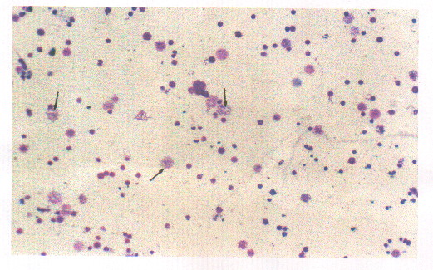
Figure (1) mitotic index bone morrow control positive.

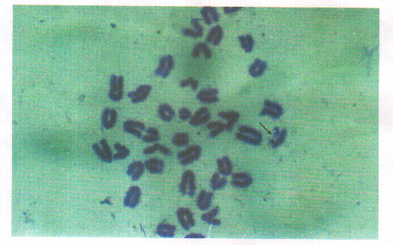

Figure (2) chromosome aberration type Gap chromatid in the bone morrow of experimental mice 5 gray cyst.

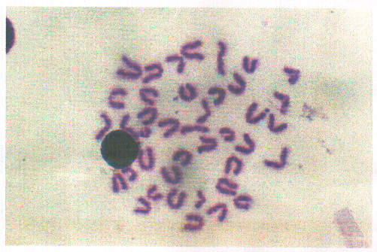

Figure (3) chromosome in the meta phase stage in bone morrow of mice which control negative.

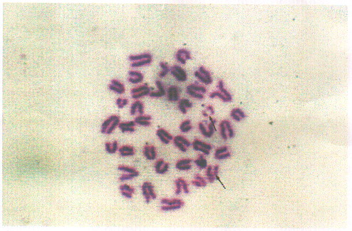

Figure (4) chromosomal aberration type Gap chromatide in bone morrow in the mice in group 25 gray fluid.

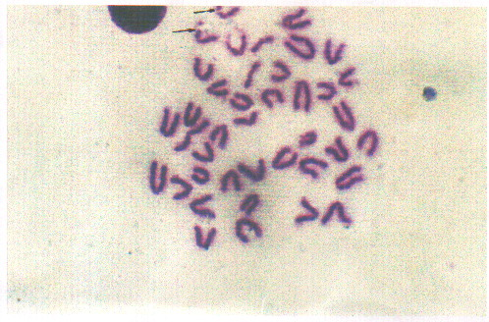
Figure (5) chromosomal aberration type Gap chromatid in the bone morrow in the mice in group 5 gray fluid.

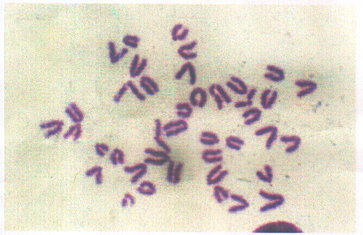

Figure (6) chromosome in the meta phase stage in the bone morrow of the mice which control positive.

The MI test was used by many investigators to evaluate the chromosomal changes in cells subjected to irradiation. Chemical and physical factors like irradiation can effect the time required for cell division to normal and not irradiated cells. Chromosomal aberration can be used as a marker to indicate the effect of such factors on normal cells (Mahli & Crover,1987). In the present study, little chromosomal aberration was observed in mice cells. Such change can be attributed to the effect of radiation from irradiated protoscolices that used in this experiment. The changes in MI of affected cells and the little chromosomal aberration were found to not significant in this study. This means that 5 Gy and 25 Gy radiations of irradiated protoscolices have little or no effect on bone marrow cells of infested mice.

References

- Ames,B.N.; MC Cann,J., and Yamasak, E. (1975). Method for detecting carcinogens and mutagens with the Salmonella in mammation microsome muagenicity mut Res, 31: 247-364.
- Balasem,A.N. and Ali, A.S.(1991). Establishment of dose-response relationship between doses of 5-137 x-ray and frequencies of micronuclei in human peripheral blood lymphocytes , Mut. Res. 259:133-138.
- Bauchinger , M. ; Schmid, E. and Dresp, J.(1993).Quantitative analysis of chromosome damage at first division of human lymphocytes after radiation. Radi.Envi.Biophys. 22:225-229.
- Boyes, B.G.; Rogers, C.G. ; Karpinsky, K. and Stapely, R.(1990). A statistical evaluation of the reproducibility of micronucleus , sister chromatid exchange , thioguanine-resistance assay in V 79 cell exposed to ethyl methane sulfonate and 7,12-dimethyl-benz (a) anthracene . Mut.Res.234:81-89.
- Bowman, D.D. and Lynn, R.C. (2000). Parasitology of Veterinarians.6th ed. W.B. Saunders Company, London, Toronto, Montreal, Sydney, Tokyo.
- Cook, D.J. and Pallister, C.J. (2000). Cellular Pathology. 2nd ed. U.K.
- Eckert, J. ; Conraths, D.J. and Tackman, K. (2000). Echinococcosis an emerging or re-emerging zoonosis. Int. J. Parasitol. 30:1283-1294.
- Evans, H.J. and O'Riordan, M.L. (1975). Human peripheral blood lymphocytes for the analysis of chromosome aberrations in mutagen test. Mutat.Res.31:135-148.
- Ghosh, B. ; Taluker,G. and Shorma, A. (1991). Effect of culture media on spontaneous incidence of mitotic index , chromosomal aberration, SEC,and cell cycle in peripheral blood lymphocytes of male and female donors. Cytobios. 67:71-75.
- Lamberti, L. ; Ponzetto, P. and Aditie, G. (1983). Cell kinetic and sister chromatid exchange frequency in human lymphocytes .Mut.Res.120:193-199.
- Obe, G. ;Vogt, M. ; Madel, S. and Meller, W. (1982). Double blind study on the effect of cigarette smoking. Mut.Res.92:309-319.
- Rauch, R.L. (1997).Echinococcus granulosus : Biology and ecology in compendium on cystic echinococcosis in Africa and in Middle Eastern countries with special reference to Morocco (Anderson, L.F. ; Ouhell, H. and Kachani, M. eds) Brigham young university Print services, Pravo,Utah, USA. 18-46.
- Schantz. P.M. (1999). Echinococcus ,In; infectious disease principles, Pathogens and Practice (Guerrant, R.L. ; Walker, D.H. and weller,P. eds) Churchill Livingstone Harcourt Broce and Company, London, Toronto, Tokyo. 1005-1025.
- Smyth, J.D. and Davies, Z. (1974). Occurrence of physiological strains of Echinococcus granulosus demonstrated by invitro culture of protoscolices from sheep and horse hydatid cysts. Int.J.Parasitol.4:443-445.
- Stich, M. and San, C. (1981). Topics in environmental physiology and medicine in short term tests for chemical carcinogens. Springer Vering, New York.
- Teas, C.(1982). Sister chromatide exchange analysis of somatic and germ line cell insect. In Sister chromatide exchange.Sandberg A.S. ed ARL. Inc.235-247.
- Wolff, S.(1981). The sister chromatide exchange test. In short term test for chemical carcinogens .238-242.
- Zimmermann, F.K. ; Kern, R. and Rasenberger, H. (1975). A yeast strain for simultaneous deletion of induced mitotic crossing over, mitotic gene conversion and reverse. Mut.Res. 28:381-388.

