Synthesis and Spectral Analysis of VO(II),Cr (III) , Zn(II),Cd(II),Hg(II)and UO₂(II) Complexes with Mixed Ligands of Bipyridyl and Novl Schiff Base

Asst.Dr.Abbas Ali Salih Al-hamdani*,Asst.Dr.Amer JabbarJarad**,Asst.Instructor.Sargol Abd-AlGhani AL-Atrakchi***
Department of chemistry, College of Science for wamen ,University of Baghdad
Department of chemistry, Ibn-Al-Haithem College ,University of Baghdad
The Central Laibrary, University of Baghdad

Abstract

Salicylaldehyde was react with 4-amino-2,3-dimethyl-1-phenyl-3-Pyrazoline-5-on to produce the novel Schiff base ligand 2,3-dimethyl-1-phenyl-4-salicylidene-3-pyrazoline-5-on (HL). A new complexes of VO(II), Cr(Ш), Zn(II), Cd(II), Hg(II) and UO₂(II) with mixed ligands of bipyridyl and new shiff base ( 2,3-dimethyl-1-phenyl-4-salicylidene-3-pyrazoline-5-on) (HL) were prepared . All prepared compounds were identified by atomic absorption, FT.IR , UV-Visable spectra and molar conductivity. From the above data, the proposed molecular structure for VO(II) complex is squre pyramidal while (Zn(II), Cd(II), Hg(II)) and ( UO₂(II),Cr(III)) complexes are forming tetrahedral and octahedral geometry respectively.

Introduction

Synthesis of transition–metal complexes with schiff–base have been a subject of considerable importance ⁽¹⁾ .These complexes are good coordination agents for schiff–base and also good bactericide ⁽²⁾ ,antitumor ⁽³⁾, antifungal ⁽⁴⁾ and anticancer ⁽⁵⁾ .A search through literature ^{(6–8)} reveals that no work has been done on the transition metal complexes of the schiff 2,3-dimethyl-1-phenyl-4-salicylidene-3-pyrazoline-5-on and bipyridyl .
The present paper reports the synthesis and characterization of new VO(II),Cr(III),Zn(II),Cd(II),Hg(II) and UO₂(II) complexes with mixed ligand of bipyridyl and new schiff base.

Experimental

a /Materials:- All chemical used were of reagent grade and used without further purification VOSO₄.H₂O, ZnCl₂, CrCl₃.6H₂O, CdCl₂.H₂O, UO₂(CH₃COO)₂.2H₂O, HgCl₂(Fluka) Salicylaldehyde , KOH, 4-amino -2,3-dimethyl-1-phenyl-3-Pyrazoline-5-on, DMF, Methanol , Ethanol and acetic acid (B.D.H).

b /Instrumentation:-FT.IR- spectra as CsI discs, in the range (4000 – 200) cm⁻¹ were obtained using a Shimadzu , FT.IR–8400 S Fourier Transform Infrared Spectrophotometer .Electronic spectra were recorded in DMF 10⁻³ M using (Shimadzu UV-160A) Ultra Violet–Visible Spectrophotometer. The conductivities of 10⁻³M solution of the metal complexes in DMF were measured using (Philips Pw – Digital Meter) conductmeter at room temperature. Atomic absorption measurement were obtained using (Shimadzu A.A-160) Atomic Absorption/Flame Emission Spectrophotometer. Magnetic properties were recorded using (Balance Magnetic Susceptibility Model MSB-MKi). In addition melting point were measured using (Gallen kamp Melting Point).

Synthesis of 2,3-dimethyl-1-phenyl-4-salicylidene-3-pyrazoline-5-on (HL) ⁽⁶⁾

( 0.26 ml , 2.47 mmole ) of salicylaldehyde was added to ethanolic solution of ( 0.5 g , 2.47 mmole ) of 4-amino-2,3-dimethyl-1-phenyl-3-pyrazoline-5-on, The solution mixture was stirred and refluxed for 2 hours, yellow crystalline precipitate observed. The resulting precipitate was filtered off, recrystallized from menthol and dried at 50 ^{O}C.The preparation method of the ligand (HL) is represented in scheme-1.

Schem-1) preparation method of the ligand (HL))

Synthesis of Complexes (general method)
All complexes were prepared by dissolving (0.306 g, 1mmole) of 2,3-dimethyl-1-phenyl-4-salicylidene-3-pyrazoline-5-on in ethanolic (KOH) solution . The solution was added gradually with stirring to the ethanolic metal salt contains 0.181g, 0.266g, 0.228g,0.172g, 0.271g and 0.424g (1mmole) of VOSO₄.H₂O, CrCl₃.6H₂O, ZnCl₂, CdCl₂.H₂O, HgCl₂ and UO₂ (CH₃COO)₂ .2H₂O respectively, an ethanolic solution of (0.156g ,1mmole) bipyridyl was added to the mixture in each case. the solution mixture was refluxed for 4 hours. crystalline precipitate was filtered off and recrystalized from methanol.

Result and Discussion

The isolated complexes were crystalline solids soluble in some common solvents such as ethanol and methanol. The conductivity measurements in DMF (10 ‾³M) at 298^{O}K indicated the electrolyte type ratio (1:1) ⁽ ⁹⁾.(Table-1) includes the physical properties of all prepared compounds.

FT.IR- Spectra

The FT.IR-spectral data of the ligands and all complexes are listed in (Table-2), the FT.IR-spectrum of the ligand(HL), (Fig-1) abroad vibration band at 3290cm⁻ ¹was assigned to phenolic OH group. The disappearance of this band in the spectra of all the complexes indicated the deprotonation of phenol proton prior to and indicated the coordination the phenolic oxygen with metal ion ⁽¹⁰⁾. The bands at 3060 cm‾¹ and 2935 cm‾¹ refers to ν(C-H) aromatic and aliphatic in the ligand ^{(11,12)}. The band at 1656cm⁻¹is characterizatic of the carbonyl group present in the free schiff base ligand ,this band was shifted to lower frequency 1627cm⁻¹in IR spectrum of Cr(III) complex only, binary and mixed ligand complex, which indicate the involvement of oxygen of carbonyl group in coordination ^{(13).}
The band assigned to the azomethine group in the free schiff base ligand was a bserved at 1600cm⁻¹and shifted to lower frequency in IR spectra of all complexes.This indicates the participation of the nitrogen atom of the azomethine group in coordination^{(14,15)}.The stretching frequency due to N-N in the free ligand were observed at 1038cm⁻¹⁽¹⁶⁾.
The IR spectra of vanidyl complex (Fig-2) record the presence of new bands which are representing the stretching bidentate SO₄⁻² group and V═O, these bands are observed at 1245 cm⁻¹, 509 cm⁻¹ and 950 cm⁻¹ respectively^{(17,18)}. Also new band observed in Uranyl complex at 907 cm⁻¹ due to(O═U═O)⁽¹⁹⁾. Metal–nitrogen and metal–oxygen bands further confirmed by the presence of the bands around (532–492) cm⁻¹ and (487-340) cm⁻¹ ^{(20,21)} . According to the previous IR spectral data,we can conclude that the schiff base behaves as bidentate ligand through the oxygen of phenolic OH group and nitrogen of azomethine group with VO(II),Zn(II),Cd(II) and Hg(II),but schiff base behaves as tridentate ligand through the oxygen of phenolic OH group and nitrogen of azomethine group and oxygen of carbonyl group with Cr(III) complex only.
The band at 1619cm⁻¹in IR spectrum of bipyridyl (Fig-3)was shifted to lower frequency in IR spectra of all complexes and appeared at range (1568-1572) cm⁻¹,these shifting indicates the coordination between two nitrogen of bipyridyl and metal ions⁽²²⁾

Electronic Spectra

The UV-Vis spectra data for of the free ligands (HL) and bipyridyl and all metal complexes are listed in (Table-3).The UV-Vis spectrum of the ligand (HL) (Fig-4) shows three peaks at 256nm,340nm and 362nm assigned to (π – π*) and (n – π* ) electronic transitions ^{(23,24)}.The electronic spectrum of bipyridyl (Fig-5)shows two peaks at 240nm and 285nm attributed to (π→π*) and (n→π*)electronic transition respectively⁽²⁵⁾.

The Electronic Spectra of Complexes

1-K[(VO)₂(L)(bipy)(SO₄)₂]:-The yellowish green complex (Fig-6) showed two absorption peaks at 354nm and at 380nm due to charge transfer(C.T) .The peak at 610nm was attributed to (d – d) electronic transition type (²B_{2→}²B₁) which is a good evidence for square pyramidal geometry about V(IV) ⁽²⁶⁾.

2-[Cr(L)(bipy)Cl]Cl:-The brown complex gave two absorptions at 256nm and at 315nm assigned to ligand field. The peak at 370nm due to charge transfer (C.T).other two peaks at 425nm and at 510nm were found to be caused by (d-d) electronic transition type ⁴A_{2g (F)} →⁴T_{1 g (F)} and ⁴A_{2g (F)}→⁴T_{2g (F)} suggesting octahedral geometry about Cr(III) ⁽²⁷⁾

3-[Zn(L)bipy]Cl, [Cd(L)bipy]Cl,[Hg(L) bipy]Cl:-Yellowish green complexes:- The peaks appeared at 263nm and 348nm in the spectrum of Zn⁺² complex,262nm and 345nm in the spectrum of Cd⁺² complex and finally the peaks at 267nm and 348nm in the spectrum of Hg⁺² complex could be attitrbuted to the ligand field. The peaks at 355nm, 370nm and 369nm due to charge transfer in Zn⁺²,Cd⁺² and Hg⁺² complexes respectively ⁽²⁸⁾ .The absence of absorption peaks in the range (371-1000) nm in the electronic spectra of Zn⁺²,Cd⁺² and Hg⁺² complexes indicated no (d-d) electronic transition happened (d¹⁰-system) in the visible region ,that is a good result for Zn⁺²,Cd⁺² and Hg⁺² tetrahedral complexes⁽²⁹⁾.

4-[UO₂(L)bipy](CH₃COO):- The reddish brown complex showed two absorption peaks at265nm and 350nm attributed to ligand field. The third band at 376nm was caused by charge transfer ⁽¹⁵⁾.
According to the results obtained and spectral analysis, the chemical structures of the complexes may be suggested as in the following :-

a- Square pyramidal for K [(VO)₂ (L) bipy (SO₄)₂].

b-Tetrahedral for the complexes [Zn(L) bipy]Cl,[Cd(L)bipy]Cl and
[Hg(L) bipy]Cl.

C-Octahedral for [Cr(L)(bipy)Cl]Cl and [UO₂(L)bipy](CH₃COO).

References
1- Das, G ;Shukla, R; Mandal Singh, R and Bharadwaj, P. K., Inorg. Chem., 36,323 – 329 (1997).
2- Sokolik, j; Blahovg , M; Cukanova, G; Kohutora, M; Misikova , E and Mlynarcik , D., Ceska . Slov . Farm., 47,180 – 188 (1998).
3- Li , Z.L ; Chen , J.H ; Zhang , K.C Li M and Land Yu, R .Cl., Sci . China B., 36 , 214 -224(1993).
4- Buer, A .W; Kirby, W.M.M; Sheries, J and Cand Turck, M., J. Am.Clin. Pathol., 44,493-496 (1966).
5- Keypour, H ; Salehzadeh, S and Parish,R.V; J.Molecules.,7,140-144 (2002).
6- AL- hamdani,A.A.S., J.Um-Salama.Sci.,2,2(2005) .
7-Azawy, S.A.S and AL- hamdani,A.A.S; J.Um-Salama.Sci.,1, 2(2007).
8-AL- hamdani,A.A.S; J.Um-Salama.Sci.,2, 2 (2008).
9- Geary,w.j., "The Use of Conductivity Measurements Inorganic Solvents for The Characterization of Coordination Compounds"., Coord.Chem. Rev.,7 (1971).
10- Yildiz,E and Boztepe,H., J.Chem.Turk.,26, 897-903(2002).
11-Korn,M; Ferreira,A; Texeira,L and Costa,A; J.Braz.Chem .Soc .,10, 46(1999).
12- Vicente,J;GIL-Rubio,J and Barquero,N., J.Poly.Sci.,43,1-6(2005).
13- Colthup,N.B; Daly,L.H and Wiberley,S.E; " Introduction to Infrared and Raman spectroscopy",2 ^{nd}.Ed.Academic Press.Inc.J.R.Dyer(1975).
14- Stuart,B;George,B and Mdnrtyre,P; "Modren Infrared Spestrocsopy"John Wiley and Sons,New York (1998).
15- SI,Y; Hu,Q; Huang,Z; Yang,G and Yin,J., Turk.J.Chem.,29, 135-140(2005) .
16- Maradiya,H.R and Patel,V.S., J.Serb.Chem.Soc.,66,87-93(2001).
17-Schumann,E; Altman,J; Karaghiosoff,K and Beek,W., Inorg.Chem.,34,154-165(2002).
18- Raman,N; Raja,Y.P and Samy,A.K., Proc.Indian.Acad.Sci.,113,3(2001).
19-Martijn,M.G ;Antonisse,B.H.M and Davaid,N.R., J.Org.Chem.,63,26(1988)
20- Pabha Karam,C.P and Patel,C.C.J., Inorg.Nucl.Chem.,31,3316(1969) .
21- AL-Janabi,M.Y., "The Physical Methods in Inorganic Chemistry"(1983).
22- Khan,Z; Ali,S.I; Gupta,D and Khan,A.A; Indian.J.Chem;35A,320-323,Aprill (1996 ).
23- Bair,M.L and Larsen,E., J.Am.Chem.,10,84-90(1971).
24- Sonmez,M and Sekerci,M., J.Chem.,76,121-126(2002).
25- Suzuki,T; Shiotsuki,M; Wada,K; Kondo,T and Mitsudo,T., Organo. Metal. lics.,18,18(1999).
26- Thompson,L; Tandon,S.S and Mannel,M.E., Inorg.Chem;34,425(1995).
27- Daniel,E; Seema,C; Melryn,R.C and Kim,M,K., Inorg.Chem.,40,7(2001).
28- Guang,P.X.Y and Guang,P.F., J.Med. Gen. Mede.,22,6(2002).
29-Sandhu,S.S; Jaswal,J.S and Sandhu,G.K; Indian.J.Chem;35,218-222(1996).

Table (1): Physical properties of the complexes

Molar Conductivity ohm⁻¹cm² mole  In DMF 10⁻³ M | M %  Calculate (found) | mp ^{O}C | Yield % | Color | M._{Wt} | Compounds
 |  | 189 | 86 | Yellow | 307 | HL
 |  |  |  | White | 156 | bipy
82.61 | 12.33 (11.34) | 220d | 78 | Yellowish  Green | 827 | K[(VO)₂(L)(bipy)(SO₄)₂]
78.5 | 8.88  (7.88) | 197d | 65 | Brown | 585 | [Cr(L)(bipy)Cl]Cl
75.36 | 11.61 (11.19) | 207d | 60 | Yellowish  Green | 563 | [Zn(L)bipy]Cl
77.14 | 18.42 (18.02) | 234d | 88 | Yellowish  Green | 610 | [Cd(L)bipy]Cl
70.45 | 28.72 (28.17) | 228d | 83 | Yellowish  Green | 698 | [Hg(L) bipy]Cl
90.25 |  | 292d | 87 | Brown | 791 | [UO₂(L)bipy](CH₃COO)

(HL)=C₁₈H₁₇N₃O₂ ,(L)= C₁₈H₁₆N₃O₂ ,(bipy)=bipyridyl= C₁₀H₈N₂

Table(2): The Infrared spectra for the free ligand and its complexes (cm⁻¹)
 | ν(M–O) | ν(M–N) | ν(Ar–N) | ν(N–N) | ν(C═N) | ν(C═O) | ν(C–H) aliphatic | ν(C–H)  aromatic | ν(OH) | Compounds
— | — | — | — | — | 1619 | — | — | 3050 | — | bipy
— | — | — | 1303 | 1038 | 1600 | 1656 | 2935 | 3060 | 3290 | HL
— | 455 | 492 | 1303 | 1040 | 1572  1586 | 1654 | 2931 | 3062 | - | K[(VO)₂(L)(bipy)(SO₄)₂]
391 | 420 | 510 | 1303 | 1039 | 1568  1588 | 1627 | 2939 | 3050 | - | [Cr(L)(bipy)Cl]Cl
— | 412 | 523 | 1303 | 1038 | 1570  1579 | 1655 | 2919 | 3061 | - | [Zn(L)bipy]Cl
— | 340 | 541 | 1303 | 1039 | 1568  1591 | 1654 | 2945 | 3043 | - | [Cd(L)bipy]Cl
— | 487 | 516 | 1303 | 1039 | 1569  1589 | 1655 | 2934 | 3076 | - | [Hg(L)bipy]Cl
— | 485 | 532 | 1305 | 1040 | 1569  1582 | 1656 | 2939 | 3062 | - | [UO₂(L)bipy](CH₃COO)

Table (3): The Electronic spectra for the free ligands and their
complexes in DMF(10⁻³ M)
ε_{max}L.mole⁻¹.cm⁻¹ | νcm‾ ¹ | ABS | λ_{nm} | Compounds
2632  4458  2354 | 39062.5  29411.7  27624.3 | 1.365  2.265  1.354 | 256  340  362 | HL
2432  2926 | 41666.6  35087.7 | 2.432  2.926 | 240  285 | bipy
975  1157  2158  43 | 38461.5  26315.7  28248.5  16393.4 | 0.975  1.157  2.158  0.043 | 260  354  380  610 | K[(VO)₂(L)(bipy)(SO₄)₂]
1370  925  1880  560  68 | 37735.8  27027  28490  23529.7  19607.8 | 1.37  0.925  1.88  0.560  0.068 | 265  351  370  425  510 | [Cr(L)(bipy)Cl]Cl
1080  850  2200 | 38022.8  28735.6  28169 | 1.08  0.85  2.2 | 263  348  355 | [Zn(L)bipy]Cl
1093  650  2200 | 38167.9  28985.5  27027 | 1.093  0.65  2.15 | 262  345  370 | [Cd(L)bipy]Cl
1350  850  2450 | 37453.1  28735.6  27100.2 | 1.35  0.85  2.45 | 267  348  369 | [Hg(L) bipy]Cl
1382  1303  2401 | 37735.8  28571.4  265095.5 | 1.382  1.303  2.401 | 265  350  376 | [UO₂(L)bipy](CH₃COO)

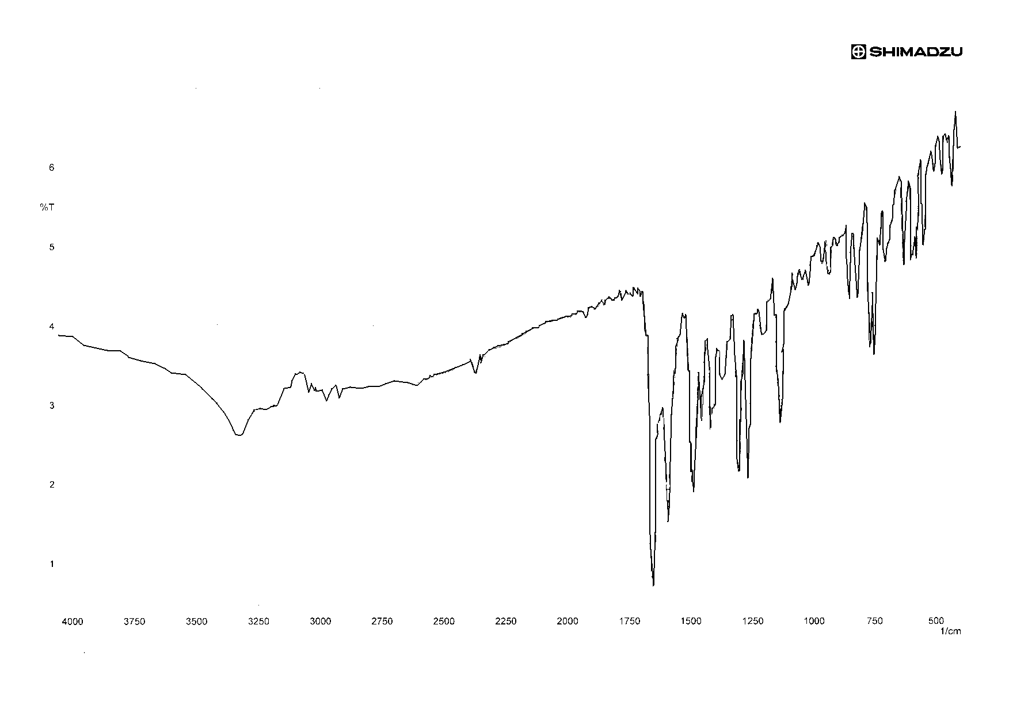

Fig. (1): FTIR spectrum of 2,3-Dimethyl-1-phenyl-4-salicylidene-3-
pyrazoline-5-on (HL)
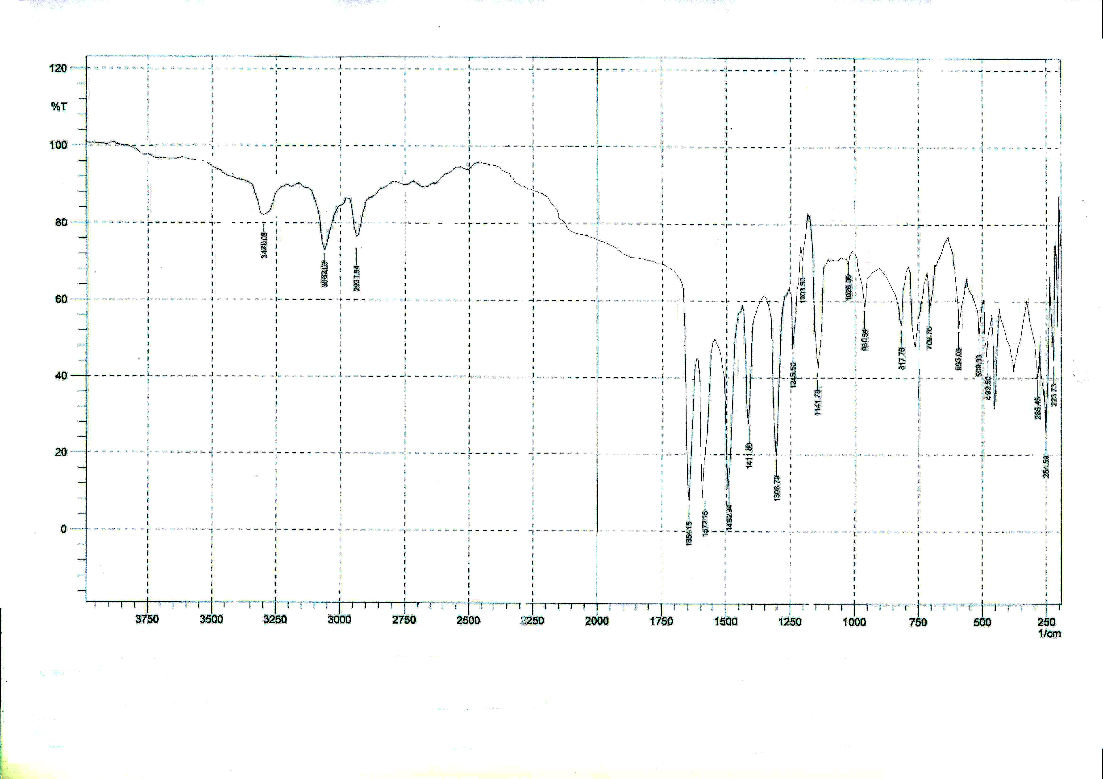

Fig. (2): FTIR spectrum of the K[(VO)₂(L)( bipy)(SO₄)₂] complex
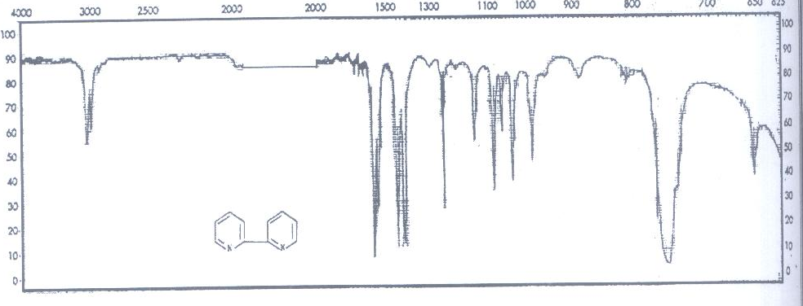

Fig. (3): FTIR spectrum of bipyridyl

Fig. (4): UV- Vis spectrum of 2,3-Dimethyl-1-phenyl-4-salicylidene-3-pyrazoline-5-on (HL)

Fig. (5): UV- Vis spectrum of bipyridyl

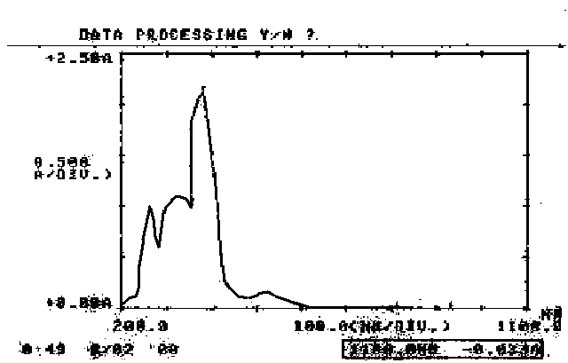

Fig. (6): UV-Vis spectrum of the K[(VO)₂(L)(bipy)(SO₄)₂] complex

تحضير وتحليل طيفي لمعقدات VO(II)، Cr(III)، Zn(II)، Cd(II)، Hg(II)، UO2(II) مع ليكاندات مختلطة للبايبريدايل وقاعدة شف جديدة

م.د.عباس علي صالح الحمداني* ،م.د.عامر جبار جراد** ، م.م.سركول عبد الغني الاطرقجي ***
*قسم الكيمياء كلية العلوم للبنات جامعة بغداد ‘ ** قسم الكيمياء كلية التربية –ابن الهيثم جامعة بغداد
*** المكتبة المركزية جامعة بغداد

الخلاصة
حضرت معقدات جديدة من تفاعل الفنادايل(П)، الكروم (Ш)، الخارصين(П)، الكادميوم (П)، الزئبق(П) واليورانيل (П) الجديدة مع الليكاندات المختلطة للبايبريدايل وقاعدة شف الجديدة 2،3-ثنائي مثيل-1-فنيل-4-سالسليدين-3- بايروزولين-5-اون. تم عزل المعقدات وتشخيصها باستخدام طيف الأشعة تحت الحمراء، طيف الأشعة فوق البنفسجية - المرئية و تقنية الامتصاص الذري اللهبي للعناصر فضلا عن التوصيلية الكهربائيــة. مــن النتائج المحصول عليهــا فـــان الشكـــل الفراغـــي المقترح هــــو هـــــرم مربعي لمعقد الفنادايــــل (II) بينمـــا اتخــذت معــقدات ( الخارصين (П)، الكادميوم (П)، الزئبق (П) ) و( الكروم (Ш)، اليورانيل (П) ) هيأة رباعي السطوح وثماني السطوح على التوالي .

