Prevalence of celiac disease in Diyala children and adolescents with short stature
Dr. Adel Hessen Al-Husseiny
Dr. Ali Moussa Al-Teemimi
Department of medicine
College of medicine
University of Diyala

Abstract
The aim of the present study was to determine the prevalence of celiac disease (CD) in children and adolescences of short stature in diyala governorate. A total of 80 short stature patients (65% males) their ages were between 4-17 years of with or without gastrointestinal symptoms were studied over three years (2003-2006). Routine physical and laboratory examinations performed to exclude other causes of short stature and those with negative workup were studied with endoscopic intestinal biopsy. Seventeen 17 (21.25%) of them showed histological abnormalities compatible with CD,70.58% of them were males. There was no statistically significant difference in anthropometric characters between patients with CD and short stature and those with short stature of undetermined cause .82% of patients with CD showed abnormal duodenal mucosa endoscopically and 82.35% of them they have marsh's grade three histopathological changes. Those with normal histopathological results are referred for endocrinological studies.
Conclusions: There was high prevalence of celiac disease among short stature children and adolescents in diyala governorate.
الخلاصه
ان هدف الدراسه الحاليه هو لتبيان شيوع مرض سلياك فى الاطفال واليافعين المصابين بقصر القامه فى محافظه ديالى.
من مجموع 80 حالة مرضية بقصر القامة تم دراستها (65% ذكور) تراوحت اعمارهم بين 4-17 عاما مع او بدون اعراض هضمية للفترة من 2003-2006، اجري الفحص السريري والمختبري الروتيني لاستبعاد الاسباب الاخرى لقصر القامة اولئك الذين كانت نتائجهم سلبية قد درسوا بواسطة خزعة ناظور المعدة والاثني عشري، 17 حالة (21،25%) منهم وجدت تغيرات نسيجية متوافقة مع مرض سيلياك 70،58% منهم كانوا ذكورا. لم تكن هنالك اختلاف احصائي ملحوظ في الصفات الانسانية بين مرضى قصر القامة مع مرض سيلياك و اولئك المصابين بقصر القامة غير محدد السبب. 82% من مرضى قصر القامة مع مرض سيلياك لديهم تغيرات ناظورية في بطانة الاثني عشري و 82,35% لديهم الدرجة الثالثة تغيرات نسيجية مرضية حسب تصنيف مارش .

الاستنتاج: كان هنالك نسبة شيوع عالية لمرض سيلياك بين الاطفال واليافعين المصابين بقصر القامة في محافظة ديالى.

Introduction
People are considered to be of short stature if they're among the shortest 3 to 5% of the population. Short stature can sometimes be normal, but sometimes it can be related to a medical problem and it's increasingly being recognized that short stature can be a symptom of celiac disease. In fact, it can sometimes be the only symptom of celiac disease.
Celiac disease is a common disorder induced by gluten present in wheat, barley, and rye, and affects up to 1% of the population of several developed countries.^{(1),(2),(3),(4).}The disease can be overt, with the classic features of diarrhea, abdominal distension, generalized malnutrition and failure to thrive, or subclinical, with isolated nutrient deficiencies such as anemia, aphthus ulcer, bone pain, etc., without gastrointestinal symptoms, particularly at a later age. Incidence of gastrointestinal carcinoma or lymphoma increases among patients with untreated CD(5)
CD symptoms and signs may be absent or very subtle.^{(6),(7)} As a result celiac disease shows
An iceberg phenomenon.
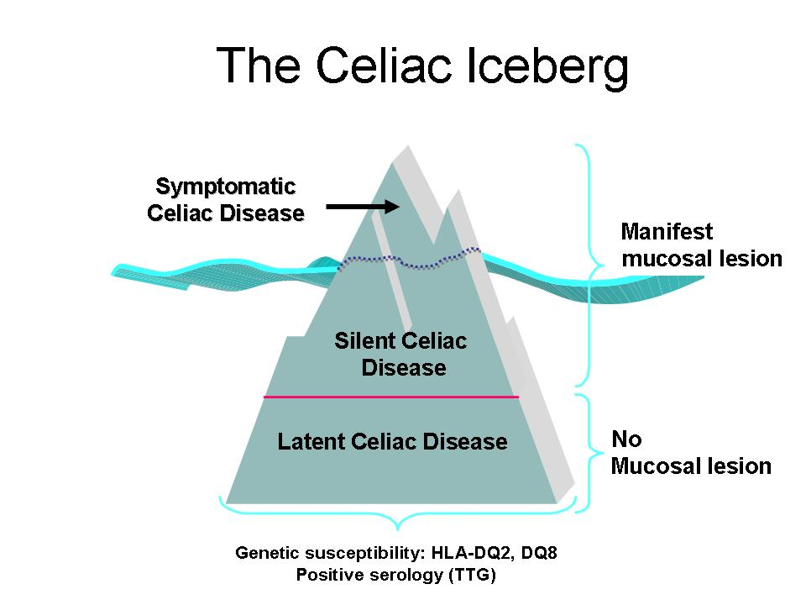

Accordingly, only a minority have the clinically recognized disease while the majority of patients have silent CD, which remains undiagnosed because the condition has no symptoms or has symptoms which are unrelated to intestinal manifestation.

CD is an inflammatory disorder of the upper small intestines, caused by an abnormal immune reaction to wheat gliadin. The striking association between HLA class II molecules, DQ2 and DQ8 and celiac disease, implicates a role for immune response in and it is not uncommon for patients with CD to have associated other autoimmune disease (table below)

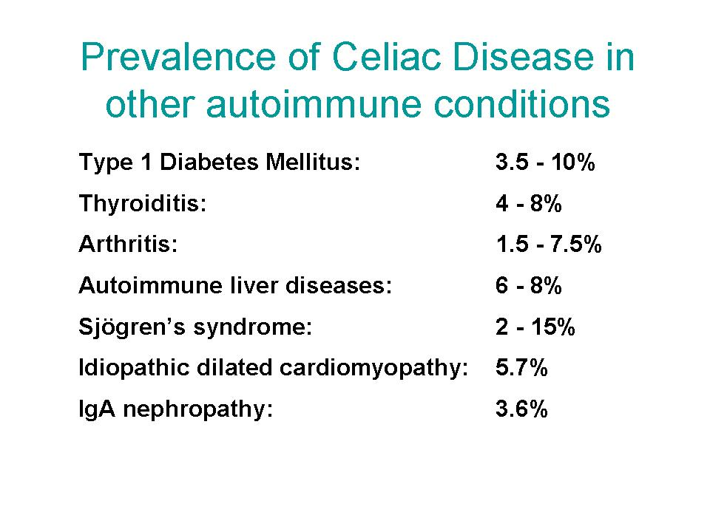
CD is systemic disease, has a wide spectrum of astrointestinal and extraintestinal manifestations (table below) atypical ymptoms or none at all. Classically, infants with celiac disease present impaired growth, diarrhea and abdominal distention between the ages of 4 and 24 months. Atypical disease is usually seen in older children or adolescents, who often have no overt features of malabsorption. In addition to recurrent abdominal pain, aphthous stomatitis, arthralgia, defects in dental enamel, short stature, and delayed puberty, affected children may show behavioral disturbances such as depression and irritability, and may perform poorly in school (8).
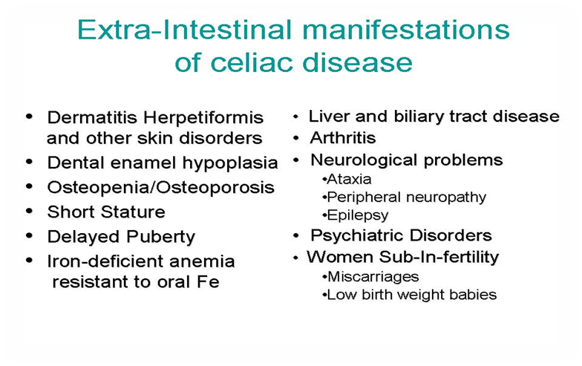

CD is familial disease and the table below shows the relative risk of developing CD among different patients populations

1 in 56 | People who have gastrointestinal symptoms yet undiagnosed as celiac
1 in 22 | People who have a first-degree relative (sibling, child, or parent) with celiac
1 in 39 | People who have a second-degree relative (grandparent, aunt, uncle, or cousin) with celiac
1 in 133 | Not at risk individuals

Histological evidence of celiac disease among patients consuming a regular (gluten-containing) diet includes small-bowel mucosal villous atrophy, crypt hyperplasia and increased numbers of intraepithelial lymphocytes. Although celiac disease is a known cause of short stature in children, its diagnosis is often difficult because of the presence of few symptoms and of biochemical parameters that fall within the normal range. Sometimes short stature could be the principal or only finding (9)) and the rate of diagnosis depends on the level of suspicion for the disease. The diagnosis is based on clinical symptoms, positive antibodies, and an intestinal biopsy, which is considered to be the Gold Standard (10,11).
The purpose of the present study was to determine the prevalence of CD among diyala children and adolescences with short stature with or without gastrointestinal symptoms

Patients and methods
A total of 80 children and adolescents, 28 girls (35%) and 52 boys (65%) with Short stature were enrolled in this prospective cross-sectional, analytical study which carried out between January 2003- to January 2006. Age ranged from 4 to 17years (mean = 10.6 years, SD = 4.3 years). Inclusion criteria for the study included: Children and adolescents between 4 and 17 years of age, height less than the 3rd percentile adjusted for age and sex, not on gluten free diet and with other etiologic factors known to produce growth failure had also been excluded, like :congenital heart disease, chronic respiratory disorder, diabetes mellitus, hematological and liver disease, renal failure, fetal growth failure, disease of bone metabolism, and chromosomal abnormalities.

Clinical features and examination ,height (Ht) .weight, body mass index (BMI), Laboratory workup including: haemoglobin, blood urea, serum creatinine, blood sugar, serum albumin, bilirubin, liver enzymes, chest radiographs, abdominal ultrasonography and echocardiography all performed to all participants to assess their general and systemic condition and to exclude other potential causes of short stature.

When no cause of the short stature was found, patients were selected for an Upper oesophageogastroduedenal endoscopy (OGD) which carried out in baquba general hospital and in private clinic.During the procedure the general appearance was observed for scalloping,attenuated folds and cobblestoning.
The grasp biopsy forceps was used to take 2-3 biopsy specimens from the second or more distal part of the duodenum and send for histopathological examination .
The Marsh classification was used to grade the mucosal changes as follow:
0 - normal histology
1 - mild increase in intraepithelial lymphocytes (IEL), crypt-villous ratio 1:1
2 - moderate villous atrophy with CV ratio more than 1
3 - flat mucosa with no recognizable villi. (12), (13).
The slides were examined and reported by a pathologists experienced in celiac disease.
Chi-square test was used for statistical analysis as applicable with P-value less than 0.05 being significant.(14)

RESULTS

The Physical examination of a total of 80 patients with short stature revealed no obvious abnormality and they were studied.
The overall characteristics of all patients are described in table 1 .
Their anthropometric assessment shows means ± SD of body weight, height and BMI, The mean (± SD) age, height, weight and BMI were: 11.1±5.3 years (range, 4-17 years), 89.0 ± 37.7 cm (41–130 cm), 16.04 ± 9.5 kg (13-45 kg) and 14.12 ±10.58 kg/cm2 respectively

Table 1: Characteristics of patients with short stature

Patients No. | ( n = 80 )
Age (years), mean ± SD | 11.1±5.3 years (range, 4-17 years)
Sex n (%)  Male  Female | 52 (65%)  28 (35%)
Weight (kg) | 16.04 ± 9.5 kg (13-45 kg)
Height (cm) | 89.0 ± 37.7 cm (41–130 cm)
BMI (kg/ m2) | 14.12 ±10.58 kg/cm 2

Among 80 patients with short stature studied, the histopathological examination reports of the biopsies revealed that 17(21.25%) participant’s biopsies showed abnormal histopathological abnormalities compatible with CD. While the rest 63 (78.75%) participants having normal results.

The differences between anthropometric means of the two groups were statistically not significant, P >0.05, table 2.

Table 2: Characteristics of patients with short stature stratified according to CD diagnosis

Variables | Patients with CD | Patients without CD | p-value
No. (total 80) | n = 17 (21.25%) | n = 63(78.75%)
Age (years) | 10 (4 - 17) | 9 (4- 17) | 0.763
Gender (male/female) | 12/5 | 44/19 | 0.629
Weight (kg) | 16 (11.50 - 29.25) | 17 (7.5 - 34.0 | 0.870
Height (cms) | 94 (81.5 - 131) | 101 (85- 125 | 0.916
Body mass index (kg/m2) | 12.1 (10.19 - 12.30) | 13.23 (12.50- 15.19 | 0.924

The OGD shows that 3 patients (17%) with CD had normal looking mucosa with 6 patients (35%) had attenuated duodenal mucosal folds and 8 (47%) had scalloped folds (table3)

Table 3: The macroscopic endoscopic features of patients with CD

Endoscopic feature | No. (%)
Normal folds | 3 (17%)
Attenuated folds | 6 (35%)
Scalloped folds | 8 (47%)

The severity of histopathological changes of patients with CD according to marsh's criteria is given in table 4 .The majority i.e. 14/17 had Marsh type 3
Table 4: classifications of patients with CD (n = 17) according to Marsh' criteria
Marsh's grade | No. (%)
1 | 2 (11.7%)
2 | 1(5.8%)
3 | 14(82.35%)

DISCUSSION
Short stature is important and not uncommon medical problem, the frequency with which it is associated with CD has not been defined in our governorate. To address this issue, the patient population endoscopically obtained histopathological diagnosis was used to assess this association.
CD was diagnosed in 17 patients(21.25%) from 80 patients screened. The present data show an expressive number of celiac disease in children with short stature, thereby justifying the search for this disease in all children with short stature. Previous studies on children with short stature have shown a variable incidence of celiac disease (0 to 59.0%) depending on the region where the study was performed (15-22). A review of the literature (23-27) led us to conclude that there is no single parameter suggesting the presence of celiac disease in children of short stature. Our data support the view that there is no single test or measurement that can identify all subjects with celiac disease nor did they differ significantly between patients diagnosed as having celiac disease and others of short stature of unknown etiology The children affected by celiac disease did not differ from those without celiac disease in any of the parameters tested. Hence, it is important to search for celiac disease in all children with short stature.

In the December 2007 issue of the Journal of Gastroenterology and Hepatology, doctors in India who studied children with short stature reported that 15% of the children had celiac disease. Indeed, the doctors discovered that celiac disease was the single most common cause of short stature in the children in this particular study (28).
In the 1990s, Italian researchers who studied a group of children with short stature found that 59% of them had celiac disease(29). Celiac disease had already been linked to short stature in Brazil (30).None of the children with celiac disease and short stature in any of these studies had any gastrointestinal symptoms of celiac disease.
The Magazzù G,et al analyze the prevalence (30,8%) of short stature in 39 coeliac patients at variable age. Height defect was especially remarkable in the subjects diagnosed after the fourth year of life. In 8 out of the studied coeliac patients, short stature was the only clinical sign at the time of diagnosis(31).
American Academy of Pediatrics studied this topic in Thirty-four patients aged 2to 17 years with short stature of undetermined cause and no gastrointestinal symptoms underwent jejunal biopsy for exclusion of CD. The conclusion was that short stature by itself, in the complete absence of gastrointestinal symptoms, is an indication for jejunal biopsy. In this study 21% of children with short stature, in whom dysmorphic or primary endocrinopathy had been ruled out, proved to have coeliac disease(32).

In our study the endoscopic intestinal mucosal folds were scalloped in 31 (69%), attenuated in 34 (76%) and normal looking in 11 (24%) of them.
Makharia GK,et al found that Intestinal mucosal folds were scalloped in 31 (69%), attenuated in 34 (76%) and normal looking in 11 (24%) of them. Mild, moderate and severe villous abnormalities on intestinal mucosal biopsies were present in 10 (22.2%), 15 (33.3%) and 19 (42.2%) patients, respectively(33).
CONCLUSIONS
Short stature can sometimes be the only symptom of celiac disease in children. Short children should be tested for celiac disease, even if they have no gastrointestinal symptoms.

REFFERENCES

1. | Fasano A, Catassi C. Current approaches to diagnosis and treatment of celiac disease: an evolving spectrum. Gastroenterology 2001;120:636-51.
2. | Rewers M. Epidemiology of celiac disease: what are the prevalence, incidence, and progression of celiac disease? Gastroenterology 2005;128 (4 Suppl 1):S47-51.
3. | Fasano A, Berti I, Gerarduzzi T, Not T, Colletti RB, Drago S, et al. Prevalence of celiac disease in at-risk and not-at-risk groups in the United States: a large multicenter study. Arch Intern Med 2003;163:286-92.
4.  5. | Cronin CC, Shanahan F. Exploring the iceberg - the spectrum of celiac disease. Am J Gastroenterol 2003;98:518-20.  Trier JS. Celiac sprue. N Engl J Med 1991;325:1709-17.
6. | United European Gastroenterology. When is a coeliac a coeliac? Report of a working group of the United European Gastroenterology Week in Amsterdam, 2001. Eur J Gastroenterol Hepatol 2001;13:1123-8.
7. | Troncone R, Bhatnagar S, Butzner D, Cameron D, Hill I, Hoffenberg E, et al. European Society for Paediatric Gastroenterology, Hepatology and Nutrition. Celiac disease and other immunologically mediated disorders of the gastrointestinal tract: Working Group report of the second World Congress of Pediatric Gastroenterology, Hepatology, and Nutrition. J Pediatr Gastroenterol Nutr 2004;39 (Suppl 2):S601-S610.
8. Farrell RJ & Kelly CP (2002). Celiac sprue. New England Journal of Medicine, 346: 180-188
9. Verkasalo M, Kuitunen P, Leisti S & Perheentupa J (1978). Growth failure from symptomless celiac disease. A study of 14 patients. Helvetica Paediatrica Acta, 33: 489-495.
10. Anonymous (2001). American Gastroenterological Association medical position statement: celiac sprue. Gastroenterology, 120: 1522-1525.
11. Anonymous (1990). Revised criteria for diagnosis of coeliac disease. Report of Working Group of European Society of Paediatric Gastroenterology and Nutrition. Archives of Disease in Childhood, 65: 909-911.
12.Marsh MN. Gluten, major histocompatibility complex and the small intestine. A molecular and immunobiologic approach to the spectrum of gluten sensitivity (celiac sprue). Gastroenterology 1992;102:330-54.
13. Marsh, MN. Mucosal pathology in gluten sensitivity. In: Coeliac disease, Marsh, MN (Ed), Blackwell Scientific, Oxford 1992. P.136.
14.Wayne W. Daniel, 983, Biostatistics: A Foundation for analysis in the health sciences, 3rd edition.
15. Bonamico M, Scire G, Mariani P, Pasquino AM, Triglione P, Scaccia S, Ballati G & Boscherini B (1992). Short stature as the primary manifestation of monosymptomatic celiac disease. Journal of Pediatric Gastroenterology and Nutrition, 14: 12-16.
16. Cacciari E, Salardi S, Lazzari R, Cicognani A, Collina A, Pirazzoli P, Tassoni P, Biasco G, Corazza GR & Cassio A (1983). Short stature and celiac disease: a relationship to consider even in patients with no gastrointestinal tract symptoms. Journal of Pediatrics, 103: 708-711.
17. de Lecea A, Ribes-Koninckx C, Polanco I & Calvete JF (1996). Serological screening (antigliadin and antiendomysium antibodies) for non-overt coeliac disease in children of short stature. Acta Paediatrica. Supplement, 412: 54-55.
18. Groll A, Candy DC, Preece MA, Tanner JM & Harries JT (1980). Short stature as the primary manifestation of coeliac disease. Lancet, 2: 1097-1099.
19. Oliveira MCLA, Reis FJC, Chagas AJ, Brasileiro-Filho G, Bahia M, Silva LD & Penna FJ (1998). Estudo de doenças de má absorção intestinal como causa de baixa estatura monossintomática. Palavras-chave. Jornal de Pediatria, 74: 213-216.
20. Rosenbach Y, Dinari G, Zahavi I & Nitzan M (1986). Short stature as the major manifestation of celiac disease in older children. Clinical Pediatrics, 25: 13-16.
21. Rossi TM, Albini CH & Kumar V (1993). Incidence of celiac disease identified by the presence of serum endomysial antibodies in children with chronic diarrhea, short stature, or insulin-dependent diabetes mellitus. Journal of Pediatrics, 123: 262-264.
22.Stenhammar L, Fallstrom SP, Jansson G, Jansson U & Lindberg T (1986). Coeliac disease in children of short stature without gastrointestinal symptoms. European Journal of Paediatrics, 145: 185-186.
23.Verkasalo M, Kuitunen P, Leisti S & Perheentupa J (1978). Growth failure from symptomless celiac disease. A study of 14 patients. Helvetica Paediatrica Acta, 33: 489-495.
24. Knudtzon J, Fluge G & Aksnes L (1991). Routine measurements of gluten antibodies in children of short stature. Journal of Pediatric Gastroenterology and Nutrition, 12: 190-194.
25.Corazza GR, Frisoni M, Treggiari EA, Valentini RA, Filipponi C, Volta U & Gasbarrini G (1993). Subclinical celiac sprue. Increasing occurrence and clues to its diagnosis. Journal of Clinical Gastroenterology, 16: 16-21.
26.Bottaro G, Cataldo F, Rotolo N, Spina M & Corazza GR (1999). The clinical pattern of subclinical/silent celiac disease: an analysis on 1026 consecutive cases. American Journal of Gastroenterology, 94: 691-696.
27.Lejarraga H, Caino S, Salvador A & De Rosa S (2000). Normal growth velocity before diagnosis of celiac disease. Journal of Pediatric Gastroenterology and Nutrition, 30: 552-556.
28.Bhadada S, Bhansali A, Kochhar R, et al. Does every short stature child need screening for celiac disease? J Gastroenterol Hepatol. 2007 Dec 13 [Epub ahead of print].
29.Bonamico M, Sciré G, Mariani P, et al. Short stature as the primary manifestation of monosymptomatic celiac disease. J Pediatr Gastroenterol Nutr. 1992;14:12-6.
30.Queiroz MS, Nery M, Cançado EL, et al. Prevalence of celiac disease in Brazilian children of short stature. Braz J Med Biol Res. 2004;37:55-60.
31.Magazzù G,et al :Celiac disease and short stature Pediatr Med Chir. 1984 Jan-Feb;6(1):115-9.
32.Pediatrics in Review. 1981;3:179-189. © 1981 American Academy of Pediatrics.
33.Makharia GK, Baba CS, Khadgawat R, Lal S, Tevatia MS, Madan K, Dattagupta S. Celiac disease: Variations of presentations in adults. Indian J Gastroenterol 2007;26:162-6.

