Calculation Mobility & Transverse, Longitudinal Diffusion Coefficients In SF₆ Gas Under The TOF Condition

Asst.Instructor.Hassan Jasim Mohammed ;
Diyala University; College Of Engineering; Dept. Of Power Engineering.

Abstract :

The electron swarm parameters in electronegative gases for the Time – Of –Flight experiments condition are calculated using a Boltzmann equation for the a range of E/N values from 140 to 1000 Td(Townsend ) , using a set of electron collision cross- sections for the SF₆ .The calculated parameters : mobility , diffusion , negative ion mobility , longitudinal and transverse diffusion coefficients. The swarm parameters for important experimental condition are deduced and the validity of the two-term a Boltzmann method checked.

1-Introduction

It is well known that sulfur hexafluoride (SF₆) is an important insulant in the field of high-voltage engineering and electric power engineering .
The extent of our understing of the dielectric behaviour of electronegative gases requires the knowledge of various electron swarm parameters . These parameters can be obtained by either experimental or theoretical methods. The experimental investigations have been mainly based on steady –state or time –resolved method [1,2, 3,4].Theoretical investigations have been made using stochastic Monte Carlo approaches or numerical solutions of the Boltzmann equation [5].
The results of swarm parameters obtained in the latter case naturally depend on the accuracy of the technique used to solve the Boltzmann equation. Most of the methods currently in use are based on the traditional two-term expansion of the energy distribution function of electrons in a series of Legendre polynomials. In many cases this approximation is sufficient, but it is now clear that at high values of the ratio electric field (E) to gas number density (N) of the background gas molecules is assumed equal to 3.54x10¹⁶ cm⁻³ (1 Torr at 0ºC), and also in the presence of inelastic processes (vibrational, rotational, attachment, etc..) [6].
The calculations in the present paper are performed for the Time-Of- Flight condition (TOF , classified in [7]) experiments. In a TOF experiment, the growth is observed as a function of both position and time. Distinguishing these observational principles from one another are important since the values of electron swarm parameters at high E/N may depend on the principles. Different sampling techniques appropriate to the respective experiments are necessary to deduce swarm parameters from the motion of electrons in the simulated avalanche correctly [5].
Our first aim in the present paper is to extend the work of [2], to the calculation of the swarm parameters measured in pulsed Townsend experiments. Our second aim is to check the validity of the two – term approximation for the calculation of the swarm parameters in electronegative gases (Mobility and Diffusion coefficients).
The electron collision cross-sections used in this paper are summarized. The momentum transfer cross-section q_{m} is taken from [1], the vibrational excitation cross-section q_{v} as a single total cross section is taken from [5 ],q_{i,} the ionization cross –section , from [8 ]. The vibrational and ionization thresholds are taken to be equal to 95 meV and 15.8eV respectively.
The electron attachment cross sections q_{a1}, q_{a2}, q_{a3}, q_{a4} and q_{a5}, for formation of SF₆ , SF₅, F, SF₄ and F₂ ions respectively are used in the calculation of [8]. The electron excitation cross section q_{ex} is determined by fitting.

2- Procedures
The Boltzmann Equation method used in this paper has been discussed previously [2,3].
The well- established two-term approximation was used to solve the Boltzmann equation . The energy distribution functions of electrons ƒ_{o} (ε) and ƒ₁ (ε ) are described by the equations:

$\begin{aligned}\frac{\left(α−η\right)\sqrt{ε}}{3}f_{1}\left(ε\right)+\frac{\text{eE}\sqrt{ε}}{3}\frac{d}{dε}\left[\sqrt{ε}f_{1}\left(ε\right)\right] \\ =2\frac{m}{M}\frac{d}{dε}\left\{ε\sqrt{ε}{\text{Nq}}_{m}f_{1}\left(ε\right)+\text{kT}ε^{2}{\text{Nq}}_{m}\frac{d}{dε}\left[\frac{1}{\sqrt{ε}}f_{o}\left(ε\right)\right]\right\} \\ +\sum_{j}{\left[\sqrt{ε+ε_{e}^{j}}{\text{Nq}}_{\text{ex}}^{j}\left(ε+ε_{e}^{j}\right)f_{o}\left(ε+ε_{e}^{j}\right)\right]} \\ +2\int_{ε}^{∞}{\frac{1}{ε}\sqrt{ε+ε_{i}}{\text{Nq}}_{i}\left(ε+ε_{i}\right)f_{o}\left(ε+ε_{i}\right)}dε \\ −\sqrt{ε}\left[\sum_{j}{{\text{Nq}}_{\text{ex}}^{j}\left(ε\right)+{\text{Nq}}_{i}\left(ε\right)+{\text{Nq}}_{a}\left(ε\right)}\right]f_{o}\left(ε\right),\end{aligned}$ (1)
and

$f_{1}\left(ε\right)=−\frac{1}{\text{NQ}\left(ε\right)}\left\{\left(α−η\right)f_{o}\left(ε\right)+\text{eE}\sqrt{ε}\frac{d}{dε}\left[\frac{1}{\sqrt{ε}}f_{o}\left(ε\right)\right]\right\},$ (2)

where e and m are the electron charge and mass , M is the mass of gas atom, ε is the energy of electrons, k is the Boltzmann constant , T is the gas temperature, and these are the final equations to solve in the present analysis.
Where ƒ₁(ε ), given by equation (2), is substituted by equation (1) , we obtain the simultaneous integro- differential equation, for ƒ_{o}(ε).
and
$\int{f_{o}\left(ε\right)dε=1}$ (3)

The total collision cross section Q is defined by:
$Q\left(ε\right)=q_{m}\left(ε\right)+\sum{q_{\text{inel}}\left(ε\right),}$

3-Properties derived from the distribution function
Important mean properties of the electron swarm may be derived from the distribution function quite easily. Thus the mean energy

$\left\langle ε\right\rangle =\int{{εf}_{o}\left(ε\right)dε}$ (4)
The electron mobility µ and the diffusion coefficient D are given by

$μ=−\frac{1}{3}{\left(\frac{2}{m}\right)}^{\frac{1}{2}}e\int{εl\left(ε\right)\frac{d}{dε}\left(ε^{−\frac{1}{2}}f_{o}\left(ε\right)\right)dε}$ (5)
where$l=\frac{1}{\text{NQ}\left(ε\right)}$, which can be written as
$μ=−\frac{1}{3}{\left(\frac{2}{m}\right)}^{\frac{1}{2}}e\int{ε^{−\frac{1}{2}}f_{o}\left(ε\right)\left(l+ε\frac{\text{dl}}{dε}\right)dε}$ (6)

and the Diffusion Coefficient is given by

$D=\frac{1}{3}{\left(\frac{2e}{m}\right)}^{\frac{1}{2}}\int{ε^{\frac{1}{2}}l\left(ε\right)f_{o}\left(ε\right)dε\text{.}}$ (7)
The diffusion coefficient for transverse and longitudinal calculated from :
$∞D_{T}=\frac{1}{3}{\left(\frac{2}{m}\right)}^{12}\int_{0}^{∞}{\frac{{εf}_{o}\left(ε\right)dε}{Q_{m}\left(ε\right)}}$ (8)
From Eq,s (1) and (2) the Einstein relationship may be determined and by using the Townsend Coefficients may be evaluated from the definition[ 9] :

$T\text{.}C=\frac{f_{i}}{\frac{W}{2}+\sqrt{{\left(\frac{W}{2}\right)}^{2}−\left(f_{i}−f_{a}\right)D}}$

(9)

where W is the Drift velocity is given by

$W=−\frac{1}{3}\sqrt{\frac{2}{m}}\text{eE}\int{\frac{ε}{\text{NQ}\left(ε\right)}}\frac{d}{dε}\left[\frac{1}{\sqrt{ε}}f_{o}\left(ε\right)\right]dε$ (10)

and the ionization and attachment frequencies ƒ_{i}, ƒ_{a} are given by:

$\begin{aligned}f_{i}=\sqrt{\frac{2}{m}}\int{\sqrt{ε}}f_{o}\left(ε\right){\text{Nq}}_{i}\left(ε\right)dε \\ \\ f_{a}=\sqrt{\frac{2}{m}}\int{\sqrt{ε}}f_{o}\left(ε\right){\text{Nq}}_{a}\left(ε\right)dε\end{aligned}$ (11)

4-Numerical Calculations

We treat the situation that the magnitudes of ƒ_{o} and ƒ₁are nearly the same because of the anisotropy of the energy distribution function. The preliminary order estimation of each term of equations (1), (2), (3) makes it possible to simplify the equations at the upper limits of energy. And so, if ƒ_{o} and d ƒ_{o}/dε are arbitrarily provided for the initial conditions at the energy ε = ε_{max} , the rest of the conditions are determined from equations (1) and (2) .In this work a numerical integral technique is adopted with the above initial condition mentioned, and the computation is started from ε_{max} and continued to ε =0 in steps of Δε. In each of E/N , ε_{max} and Δε are chosen to fulfill the conditions of ƒ_{o} (ε)_{max}/ ƒ_{o}(ε_{max} ) ≈10⁵ and ε_{max}/ Δε= 1000 in order to keep the consistency of a chain of numerical calculations.
The Townsend first ionization coefficient α and the energy distribution ƒ_{TOF}
for TOF are obtained by a relaxation technique using equation ( 1 ). A guess for α is first put into equation and ƒ_{TOF} is obtained.

5-Results And Discussion
The present study has resulted in a set of cross-sections for SF₆ which is consistent with measured swarm parameters for pure SF₆ . The reliability of these cross- sections and the Boltzmann Code procedure has been further tested by the comparison of measured and predicted values.
The energy distribution function of electrons in electronegative gases are computed from present work in a range of E/N from 140 to 1000Td (1Td=10⁻²¹ V.m² or 1Td=10⁻¹⁷ Vcm²), (for two – term approximations of Boltzmann equation as a parameter of E/N) , under a Time Of-Flight swarm condition. All the isotropic parts of the distribution, ƒ_{o}(ε) are normalized to unity.
In figure (1) , we have plotted the mobility coefficient μ, obtained with our method of solution using the cross-sections .The Time –Of-Flight measurements of [10,11] are represented in the same figure .

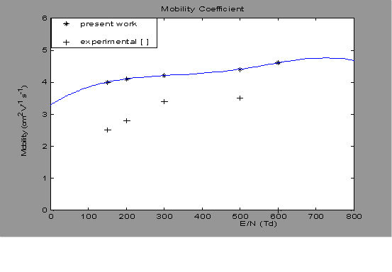
μ x 10 cm².V⁻¹.S⁻¹
Fig.(1): The Mobility coefficient μ as a function of E/N, ( * * ) present
work; ( + )experimental measurements [10,11].

In the case of the diffusion coefficient-to- mobility ratio as shown in figure (2) , the theoretical values in the present work are in poor agreement with the experimental values .

/ μ D ( eV )
Fig.(2): Diffusion /Mobility coefficients (D /μ)as function of E/N ; ( )
present work ; (+) experimental measurements [8 ].

Figure (3), gives values of the negative ion mobility μ₋ of SF₆ , and the present values compared with the experimental data of Aschwanden [10].
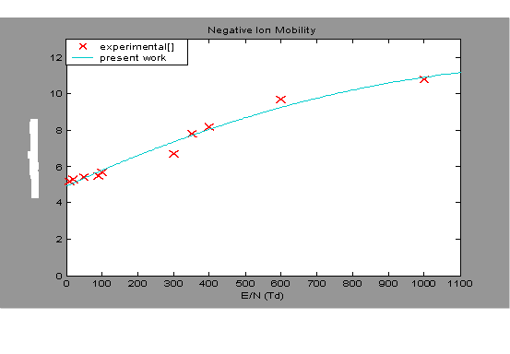
μ⁻ x 10⁻⁵ m².V⁻¹.S⁻¹
Fig.(3):Represent of the relation between Negative Ion Mobility μ⁻ as function
of E/N , ( ) ; ( x )experimental measurements [10].

Figure (4), (5) , represent the longitudinal diffusion D_{L} and Transverse diffusion D_{T} coefficients. The calculations are compared with measurements of Novak and Frechette [12], and Aschwanden [7] , for the Transverse diffusion coefficients D_{T} .The influence of anisotropy seems and the disagreement between the values of D_{T} obtains from the results of the sets cross- section data, this suggests that non-uniformity of the electron energy distribution exists across an isolated group of electrons in the SF₆ in the field direction. However, this agreement cannot be confirmed fully for D_{L} or D_{T} , since this work used only the two term approximation method of Boltzmann equation.

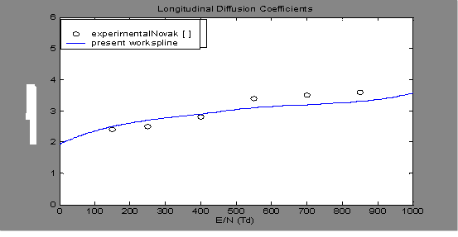
^{D}_{L} x 10²² cm⁻¹.S⁻¹
Fig.(4): Longitudinal diffusion coefficient D_{L} as a function of E/N : ( )
present work ; (o )experimental measurements [7,12 ].

^{D}_{T} x 10²² cm⁻¹.S⁻¹
Fig.(5) :Transverse diffusion coefficient D_{T} as a function of E/N :( )
present work ; ( Δ )experimental measurements [ 7,12 ].
6- Conclusions
The available data on the electron diffusion coefficient, longitudinal D_{L} to the electron mobility is plotted in Fig. (6), figure show that the increasing values of D_{L}/μ with increases E/N, we suggest that increases due to the large value of ionization coefficient.

D_{L} /μ x 10²¹ (V)

Fig.(6): Longitudinal diffusion coefficient-to –mobility ratio for SF₆ as function to E/N.

6-Conclusion
In this paper the method which was developed by some of the authors in previous papers has been applied to the calculation of swarm parameters in electronegative SF₆ gas.
The electron swarm parameters in SF₆ for the Time- Of-Flight experiments are calculated for a wide range of E/N from 140 to 1000 Td. The results confirm the validity of electron –molecule collision cross section in SF₆ determined previously by the authors,
It is clear that the use of a two-term approximation in this case involves the errors, mainly in the calculations of mobility coefficient or transverse diffusion coefficient.

حساب التنقلية ومعاملات الانتشار الطولية والمستعرضة في غاز SF₆
تحت تأثير الشرط التجريبي (Time –Of –Flight)

م.م.حسن جاسم محمد
جامعة ديالى/ كلية الهندسة / قسم هندسة القدرة والمكائن
مستخلص البحث

في هذا البحث تم توسيع مدى دراسة معلمات حشد الإلكترون بالنسبة للغازات الكهروسالبية لمدى (E/N ) (النسبة بين شدة المجال الكهربائي والكثافة العددية لجزيئات الغاز ) من 140 إلى 1000 تاونزيند , باستخدام المقاطع العرضية لتصادمات الإلكترون مع جزيئات الغاز.
الحسابات انجرت تحت الشرط التجريبي (Time -Of –Flight ) . وتم دراسة المعلمات التالية : (التنقلية μ, نسبة التنقلية إلى معامل الانتشار D/μ , ومعاملي الانتشار الطولي والمــــــستعرض D_{L},D_{T} ), وتم مقارنة النتائج التي تم الحصول عليها مع النتائج العملية وكان هناك توافق بين النتائج إلى درجة جيدة .

References

- H.Itoh, Miura Y. Ikuta, N. Nakao and H. Tagashira " Electron swarm development in SF₆:I Boltzmann equation analysis" . J. Phys D:Appl.phys,21:922 (1988).
- A.S.Hasaani, R.R. Abdulla, and H. J. Mohammed," The dynamic process in the electrical discharges of SF₆" . Diyala Journal :For Applied Researches Vol.2 No.2 (2006).
- M. Yousfi, P. Segure and T.Vassiliadis," Solution of the Boltzmann equation with ionization and attachment : application to SF₆". J.Phys.D:Appl.Phys ;18:359.(1985)
- Raju. Properties of N-SF₆ gas mixtures and optical investigation of a non-uniform (Internet) file://Jahresbericht(1999).
- H. Itoh, M. Kawaguchi, K. Satoh, Y. Miura," Development of electron swarm in SF₆". J. Phys.D: Appl. Phys. 23:299 (1990).
- M.Yousfi, A. Chatwiti, XVII, Int. Conf. phen .on Ionized Gases, PP:8, (Swanea) 1987.
- Aschwanden, Gaseous Dilectric 1V, ed: L.G.Chrhstophorou, and M.O.Pace (New York :Pergamon ):24 (1985).
- A. V. Phelps, R.J. Van Brunt ," Electron –transport ,ionization , attachment , and dissociation coefficients in SF₆ and its mixtures". J.Appl. phys. 64(9) , 1988.
- M.Hayashi , and T. Nimura. " Calculation of electron swarm parameters in fluorine" . J. Appl. Phys. 54 (9),p:4879-4882(1983).
- T.Aschwanden , in proc. 4th symp. On Gases Dielectric ( knox ville. TN),p:24-32 ,(1984).
- L. E. Kline, D.K. Davies, C.L. Chen, and P.J. Chantry," Dielectric properties for SF₆ and SF₆ mixtures predicted from basic data" J.Appl.Phys.50, 6789(1979).
- J.P. Novak and M.F. Frechette," Transport coefficients of SF₆ and SF₆-N₂ mixtures from revised data". J. Appl. Phys., vol.55, no.1,p.107.1984.

