قياس زمن النهوض والاستجابة الطيفية للكاشف مصنع مختبرياً

م.م.عواطف صابر جاسم
قسم الفيزياء - كلية العلوم - جامعة تكريت

الخلاصة
تم في هذا العمل ترسيب غشاء رقيق من مادة (PbS) بالتبخير الفراغي الحراري ودراسة خصائصه لتصنيع كاشف ضوئي . حيث وجد خلال هذه الدراسة إن الغشاء متعدد البلورات وله معامل امتصاص يتزايد عند الأطوال الموجية الأقل من طول موجة القطع . وكذلك تم التوصل على أن معامل الامتصاص يزداد عندما تصبح طاقة الفوتون الساقط (0.42eV). ولوحظ إن التيار يزداد بزيادة شدة الضوء الساقط عليه.
من المعلمات المهمة التي يجب دراستها الاستجابة الطيفية وزمن استجابة الكاشف المصنع مختبريا"، تم التوصل عمليا" إن الاستجابة الطيفية له بحدود (2.3µm). كما تم دراسة العلاقة بين زمن الاستجابة ودرجة الحرارة حيث تم التوصل إن زمن استجابة الكاشف يزداد مع انخفاض درجة الحرارة.

Measurement of rise time and respectively spectral for detector fabrication experimentally

Asst.Instructor.Awatif S. Jassim
Dept. of Physics, College of Science, Tikrit University, Tikrit, Iraq

Abstract

In this work thin film (PbS) will be preparation by the thermal vacuum evaporation technique and study the properties to fabrication photoconductive detector.
We found the thin film is polycrystalline and absorption coefficients increased with wave length decrease from cut off wave length .The absorption coefficient increased when incident photon energy (0.42eV). Ether wais the current increased with incident light Some of important parameters must be study are spectral response and rise time for the detector which fabricate experimentally. We found the intensity spectral response at (2.3µm). Also has been study the relation between the rise time and temperature. The results illustrated the rise time increased with decrease temperature.
Introduction:
The thin film occupied very important place in theoretical and application for sold state physics, the results of continued researches on the physical properties of material during last years and development a new branch of physics thin film grow on which is the part of material science. This science interested on the study of material system especially thin films markets simply preparation and can preparation with different method, suitable distance and low coast [1,2].We can definition as one layer or multi layer from atoms of material with thickness about one micrometer, also may be including physical and chemical properties for material which could not study in the volume stat [3].
Recently the wide varieties of semiconductors applications , they need to high sensitive material that are easy to fabricate at the same time we have abroad range of optoelectronic properties .During the last years, the major volume users of detectors have continued to be primarily military.
The lead sulfide process developed for this application produces detectors with high responsive and detectives at specific wavelength.
The increasing study in this field which used in many application such as solar cell, detectors,applifiers,transistors,rectifiers,integrated devices, magnetic memory devices. In other application of optical field, we can use in interference experiment. Also widely used as filters of some wavelength which more interested in photo-cells [4].Some significant improvement in detection have been taken place this period.
(PbS) photoconductive detector is among the earliest to be used in high performance photoconductive detector and is still widely used because performance and cheep fabrication method [5].Load sulfide has widespread application in guidance system for air to air missiles ,with spectral response to (3µm) and it exhibits excellent performance at room temperature and better performance when cooled to liquid nitrogen temperature [6 ].Load sulfide is one of most important infrared detectors which is extremely available in very form of infrared work over the range (1-3)µm [ 7 ].
Semiconductor in pure state are perfect insulators at near absolute zero of temperature, but the raising of temperature leads to thermal excitation of electrons from the valence band to the conduction band and according this, the conductivity of semiconductors increases .The increasing of temperature or give some of impurity atoms or made defect of crystalline, these lead to the sensitive of semiconductor toward thus effects are more important in electronic application.
Infrared detectors become more available to a large range of application needs [8 ].

Theoretical part:

The detector operation on the basic converted of photon signal to the electrical signal which intensity depended on the intensity of incident radiation. We can classification of optical detector to photo and thermal detectors depend on the type of effect which occurs from interaction radiation with detector material .In photo-detector,the process of absorbed incident light will be produce emission of electrons from the surface [ 9 ].
The development in material science lead to produce different types of detectors which operate in the suitable spectroscopy range for many used that need in sincere, also many detectors have been covered wide range from wavelength extended from ultraviolet to infrared rays [10 ]. And these are suitable in scientific application field of optoelectronic.
The detector which made experimentally from load sulfide (PbS), research subject is one of photo- conductive type which used in detection light ray include infrared ray (1-3) µm.Also marked small volume and simply structure and could operation with low potentional braise, and response toward high current because the gain is greeter than one [11], this reason used in detection light were operate in infrared range with high intensity

(PbS) photoconductors detector are the most devices which at present time in greatest use in near infrared and in comprehensive work has been and still being carried out , because it is the most sensitive and the most rapid infrared detectors. When suitably prepared it will respond to light radiation in the wavelength region (1-3) µm [12 ]. These advantages open the way for a number of application in infrared spectroscopy techniques.
The lead sulphide photoconductive cell was the first to be developed as a useful quantum detector which consists a thin sensitive microcrystalline lead sulphide film about thick (1µm) deposited on a glass substrate [13 ].
Two method of preparing (PbS) infrared detectors, chemical deposition method and evaporation by vacuum method. Both methods the layer deposited are a polycrystalline film [14 ].

Type of Detectors:
Two fundamental types of infrared detectors are:
1- Thermal detectors: This employs materials possessing some thermal detectors response only to the intensity of absorbed radiant energy which the response equally to radiant energy of all wavelength.In this detectors, the radiation is absorbed by the lattice of material causing heating of the lattice. The change in the temperature of the lattice by the absorption causes a change in the electrical properties [15 ].
2- The photon detectors: The photon detector essentially measure the rate at which quanta are absorbed, thus they responding only to those photons of short wavelength, therefore their response at any wavelength is proportional to the rate at which photons of that wavelength are absorbed.
Most of photon detector have a directivity that is one or two orders of magnitude greater than thermal detector, and response time of photon detectors is very short due to direct interaction between the incident photons and the electrons of the detector material, this called photo effect .
Photon detectors include three types: photoconductive, photovoltaic and photo-electromagnetic. This research taken (PbS) photoconductive detector.
The photoconductive detectors consist of a piece of semiconductor material of two homic contacts, when avoltage applied between them .The semiconductor is conducting and some current flowing even without light shining on material which called (dark current).
There are three types of electronic transition in photoconductive devices:
- intrinsic, b- impurity absorption, c- p-n junction.

The photoconductive detectors divided into three types depended on the method of absorption incident light ,these are:
1- Interesting photo conductive.
2- Extrinsic photo conductive.
3- Conductive detector which absorption light by carrier free charge.

In the first type, the incident photon absorption by basic process inside the material. The incident photon make to produce pair (electron-hole) during traveling from valance band to conductive band under the condition (energy of incident photon is greater than energy gap) for semiconductor material or equal to energy gap. The shorter wavelength for incident photon can be determined from the following equation which could produce pair(electron-hole):
$λ\left(μm\right)=\frac{1\text{.}\text{24}}{E_{g}}\left(−−−−−1\right)$

The absorption of light in intrinsic lead to produced two types of carrier charge (hole-electron), both include in photo conductive process. While the extrinsic semiconductor, the absorption of light occurs through impurity founded in material .To according absorption process, the condition must be occur (incident photon is greater than energy of impurity ionization) [ 16 ].
In the second type, generation one type of carrier charge (free electron and restricted hole) for n-type semiconductor or generation (free hole and restricted electron) for p-type semiconductor. For both the concentration of carrier charge increased because absorbed of incident light, thus increases electrical conduction for semiconductor material.
In third type, the process lead to increase in moving of carrier charge which generation increased of electrical conductive.
One of operator which determined amount of absorption light in the material is absorption coefficient.
The fundamental absorption refers to transfer band-to-band or the transitions in which an electron from valence band transfer to the conduction band with absorption of photon energy equal to the energy of the forbidden gap. The absorption coefficient in the semiconductor is a very strong function of photon energy and band gap energy.
There are several possible photon-semiconductor interaction mechanisms; the photon energy is converting into heat. Photons interact with impurity atoms either donors or acceptors, or photons interact with defects within semiconductors. The basic photon interact process of greater interest is the interaction with the valance electron [17 ].

Experimental part:

Two methods have been used widely to prepare of (PbS) either evaporation in vacuum of PbS powder or by chemical deposition. The thermal evaporation technique employed in this study using Blazers coating unit model (BAE370) under lower pressure of about (10⁻⁶mbar) .The system is shown in figure (1):


Water cooled unit
Vacuum chamber
Rotary pump
Bell jet vent
Roughing valve
Pump vent
Foreline valve
Diffusion pump
Ionization gauge
Ionization gauge
Pirani gauge
Pirani gauge
H.vacnum
valve

Figure (1) the typical coating system

The system consists of four parts are:

1- The vacuum chamber.

2- The rotary pump which operate in two stages ,first stage called roughing stage ,and second stage provide an initial pressure to about ( 10⁻³mbar)using pirani gauge.

3- The diffusion pump represent the second stage which is called the backing high vacuum and produce pressure about to ( 6x10⁻⁶)mbar using penning gauges.

4- The water-cooled unit for cooling process of the system.

(PbS) used from (BDH) company with purity material (99.99%), we consider the cleaning process is very important. The chamber and all the installation inside it have been cleaned by using cleaner solution and washing by distilled water and then in (CH₃COOH) solution for five min., then dried using a blowing air.

The cleaning of the substrate is very important, the cleaned of glass slide occur by using detergent and cleaner solution to remove any oil or dust that might be on the substrate of the surface for (15min.).And then cleaned using alcohol off (10min.), and then they are placed under tap water for (10 min.).

The glass slides were placed in a clean beaker containing distilled water and then rinsed in ultrasonic unit for (15min.) .Eventually the slides are dried and exposed to blowing air and wiped with soft paper.

The evaporated source (Boat) was made from Molybdenum for (PbS) material and on the distance (17Cm.) from the glass slide.

The coating system used is made from (Edwards), when the system still under vacuum, the current passes through the boat. Then produce thin film of PBS with (300nm) thickness. The simple put in oven under vacuum type (Momort) roof (1 hour) in (200 ºC).

Aluminum sheets are used in order to make the masks to get the desired shape of electrodes .Figure (2) shows kind of mask that is used in the evaporation steps .these masks have the same size of the substrate were exactly attached and fixed over the substrate after being cleaned .The distance between electrodes about (1mm).

The simple of (PbS) inter inside coating system type (Blazer) for coating the electrodes by (Ag) material with (1000 nm) thickness.

Figure (2) the Aluminum mask

After coating the electrodes and put there on maika piece for purpose of conduction process using (Sliver bats), then interred in oven for (15min.) under (100 ºC).

The (PbS) used as detector using the following circuit as shown in figure (3).

The incident power to the (PbS) was obtained from a standard detector. The spectral responsively in the region (1-3) µm.

Copper Wire
Copper Wire

Active materials PbS
Aluminum Electrode
Silver Best

Figure (3) the detector fabrication from PbS material.

Results and Discussion:

The structure properties cover the study of x-ray diffraction for (PbS) films at room temperature. Figure (4) shows the patterns obtained for PbS thin film deposited by thermal evaporation method with (300nm) thickness. The structure of thin film showed a polycrystalline cubic structure. This figure illustrated number of peak were found, thus explained that material is single crystalline places on the plane basic no crystalline (amorphous) .The reason of different orientation angles and different peaks is the difference of the number atoms which composition thin film from place to another. Also found the films have crystallized with a strong peak at (200) directions, this means that plane is suitable for crystal growth. The increases of temperature (250oC) lead to increase in crystalline grain size.

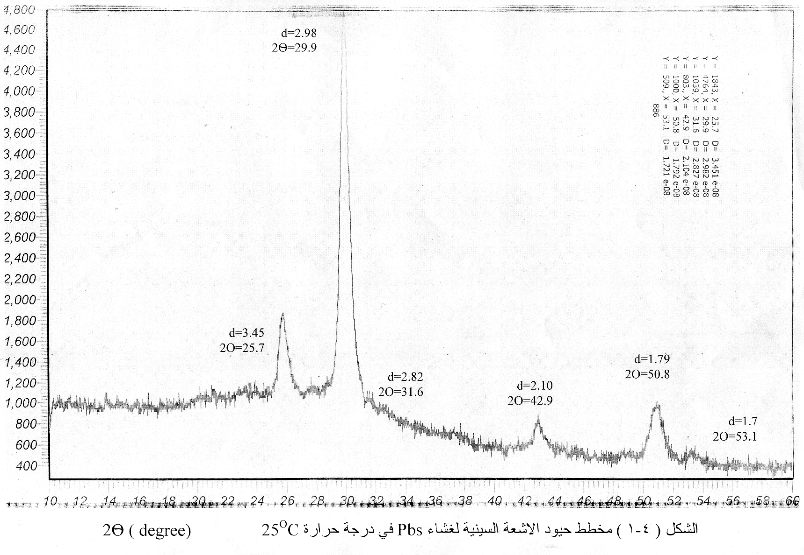
(311)
(200)
(111)
(220)
Figure (4) shows the patterns of x-ray diffraction for (PbS) films at room temperature

Figure (5) shows the relation between the photon energy and absorption coefficient for thin film, where the absorption coefficient calculated from equation:
$$α=2\text{.}\text{303}\frac{A}{t}$$

A represent the absorptions and it is the logarithm inverse of T given by:
$$A=\text{log}\frac{1}{T}$$
T is transmittance.
Absorption Coefficient * 10⁴ cm⁻¹
Photon Energy (eV)
(Fig 5): Relation between Absorption Coefficient and Photon Energy
Figure ( 6 ) showed the absorption coefficient increasing with decreased in incident photon energy. This coefficient increases when the photon energy greater than (0.42 eV).Also we can observe that from figure the absorption coefficient decreases with the increasing of wavelength. The explanation of the shift in the absorption edge to shorter wavelength is attributed to the disappearance of the subsidiary band which suggests from the dispersion theory that confirms the breading of the absorption edge by growth in grain size that causes a decrease in the thermal excitation of electrons lying in the levels associated with this band at room temperature and an increase in the energy gap between valance band and conductor band leading to decrease in the absorption coefficient and shift to longer photon energy.
Absorption Coefficient * 10⁴ cm⁻¹
Photon Energy (eV)
(Fig 6): Relation between Absorption Coefficient and Photon Energy
To study of parameter for detector designed , the characteristic of (I-V) show in figure (7), thus relation is leaner in illumines state .When the characteristic in dark current is different from first state ,the dark current decrease with increase temperature annealing which produce local levels inside energy gap ,represent center capture and re companions inside the energy gap.

Figure(7) The current-voltage in the dark stat .

The characteristic of (I-V) in the illuminated state also studied which represent in figure (8 ) .It also found the relation is leaner, the illuminated current increase with increased incident illuminated intensity on the detector preparation as the same photoconductive detector . The value of gain operator is small ,reason for thus to produce small center generation and re-compunction which sensitive during energy gap lead to increases number of carrier travel to conductive band compared to number of capture carrier ,then the current increased slightly .

Figure (8) the current-voltage in lumen's stat.

Another results that increased of annealing temperature, photo conductivity decreased when the size of gain crystalline decreased which lead to increased the resistance ,also found that photo conductive increased with increased in incident intensity forced on two detector terminal for PbS detector[ 18 ].
The most important parameters of photoconductive PbS detector is the spectral responsively. Figure (9 ) shows the spectral responsively as function of wavelength. It is found that detector operated through range (1-3) µm .And it is abvious that highest peak of responsivity is achieved at (2.3) µm.The highest absorption to detector material. When occurred cooling, the result shifted toward shorter wavelength because re compunction inside the material.

Figure (9 ) shows the spectral responsively as function of wavelength.

Another important parameter studied is the rise time , when the system is cooling ,the rise time shifted,and resistance increased with decreased temperature as shown in figures (10 and 11).this result we consider the detector is one of detectors operates efficiency with higher cooled ,thus is one of thermal detector.
Relative rise time
Temperature ○C
(Fig 10): Relation between relative rise time and Temperature ○C

Relative Dark Resistance
Temperature ○C
(Fig 11): Relation between relative dark resistance and Temperature ○C

Conclusion:
The film is polycrystalline and had cubic structure .The crystalline orientation of PbS film was effected by heat treatment and is strong (200) orientation.
The spectral investigation of the transmittance of PbS are affected by heat treatment, and noticed that the spectral curve shifted to shorter wavelengths with increasing of temperature.
The absorption coefficient is shifted to shorter wavelength.
The energy gap increases with increasing of temperature.

The sensitivity of PbS films is relevant as photoconductive detector in the range (1-3) µm

References:

- K.L.Chopra, "Thin film phenomena" ,MC- Graw-Hill",p:14,(1969).
- E.Pentia, L.Pintitie ," journal of optoelectronics", vol.3, no.2 , 525,(2001).
- M. Alexe ,M.Lisca," Applied physics latter",vol.86,no.19,192,(2005).
- L.Eckertova, "Physics of thin film" , plenum press , NewYork and London ,(1977).
- E.M.Larramendi, O.Calzadilla,E.Hernandez,"Journal of electroanalytical chemistry", vol.3,no.1,301,(2001).
- D.B.Adolf,A.V.Lyulin, G.R.Davies,"Applied physics",vol.22,no.8,381,(2001)
- L.J.Selen,F.J.Jannssen,and P.J.Smulders,"physics Rev.B",vol.64,no.24,(2006).
- A.Gonzalez,E.Hernandez ,"Chem.phys.Lett.", vol.3,no.5,443,(2007).
- A.John,T.Jack,"Journal of Electroanalytical Chemistry",vol.164,no.2,369,(1984).
- J.Ruiz and M.Garcia,"Talanta",vol.6,no.5,1055,(2004).
- J.Ebothe,A.Hichou, M.Troyon,"Thin Solid Film",vol.48,no.1,54(2005).
- M.Donald,G.Konstantates,E.Sargent,"Applied Optics",vol.46,no.2,6497,(2007).
- S.Zhangs,W.Cyrpw,E.Klem,"Optical Society of America",vol.4,no.3,355,(2007).
- G.Iordache and M.Buda,"IEEE",vol.1,199,(2007).
- V.Stancu and T.Botila ,"Materials Science and Engineering ",vol.25.no.4,496,(2005).
- L.Hao ,J.Lawrence ,"Applied Surface Science",vol.2,no.1,453,(2005).
- R.J.Cashman,vol.4,p.147,(1995).
- D.B.Adolf,G.R.Davies,"Talanta",vol.71,no.3,1110,(2007).

