The effect of a weak axial magnetic field on a He-Cd laser

Assit.Instructor /Gailan Asad Kazem, (College of science, Diyala University)

Abstract
By experimenting on a He-Cd laser in a weak axial magnetic field (WAMF), some new phenomena was observed. the polarization characteristics of the laser beam varied, the main polarization axis of the laser beam rotated and the laser output was modulated with the strength of the WAMF varied. Calculations according to Lamb's theory are in good agreement with experimental results obtained .
الملخص
تم اختبار خواص ليزر He-Cd في المجال المغناطيسي المحوري الضعيف WAMFوتم ملاحظة بعض الظواهر الجديدة و منها ان خواص الاستقطاب لحزمة الليزر قد تغيرت وان محور الاستقطاب الرئيسي لحزمة الليزر قد تم تدويره وكذلك حدوث تعديل في القدرة الخارجة مع تغير شدة WAMF.الحسابات التي تم الحصول عليها باستخدام نظرية لامب كانت قريبة و متطابقة مع النتائج العملية التي تم الحصول عليها.
Introduction
Hanle effect refers to the depolarization of the resonance radiation in a weak axial magnetic field (WAMF) [l].Culshaw investigated the Hanle effect in a He-Ne laser [2]. Brown found the output of a He-Cd laser to be increased in a WAMF where he found that The drastic effect that a weak axial magnetic field can have upon the output of an He-Cd⁺ metal vapor laser is 37 percent increase in output power for a tube current of 55 mA and magnetic field strength of 70G. Also described the parametric and spectroscopic studies performed to elucidate the cause of the large power output change [3]. Boyarskii et al also studied the cascade hanle effect in cadmium d measured some transitions lifetimes in cadmium [4]. Cristescu et al found in their research about the effect of axial magnetic field on the laser gain in hollow cathode He-Cd laser system that there has been some decrease in the laser intensity due to the action of the magnetic field both on the atomic transition and on the plasma inside the hollow cathode [5]. Gonchukov studied the use of magnetic field in enhancing gain produced by a cataphoretic He-Cd lasers [6]. Angelov observed some new results obtained by using the magnetic field in a new helical cathode for He-Cd lasers [7]. this effort was made toward stabilizing the laser output by means of Hanle effect. However, above phenomena have not been reasonably explained yet in the He-Cd laser theory, wang etal in 1995 found a new technique to dispose the Cd impurities that has been observed after each switching by using the auxiliary anode construction [8]. Novoselov studied also the effect of a fixed magnetic field on pulsed He-Cd laser [9]. In this research, the effect of WAMF on the He-Cd 4416Å laser line is reported.
Theory and experiment
Both the upper level 5s² ²D_{5/2} and the lower level 5p ²p_{3/2} of He-Cd 4416 Å laser transition are split in a magnetic field (fig.1.) and their frequency spacing is:
_{B}gH/ ħ…………….. (1) μ=υΔ
Where g is the Lande factor .g_{D} = 1.20.g_{P} = 1.33. all the possible transitions of this pair of levels in an axial magnetic field are shown in fig.( 1).
The transitions for magnetic quantum number Δm = ±1 correspond to clockwise and counterclockwise polarizations respectively. In the experiments, some new phenomena were observed in the WAMF: the rotation of the main axis of laser polarization and the variation of both the elipticity of polarization and the output power of the laser beam.
Generally speaking, such phenomena cannot be explained by the theory of spontaneous single atom radiation. Because the laser is an oscillator of stimulated radiation accordingly ,our calculations with Lamb's theory have been made with a computer and the results are close to those obtained in the experiments.

5s² ²D_{5/2}

5p ²p_{3/2}
m=-1
m=+1
σ+ σ-

Laser transition in magnetic fieldÅ4416Fig(1)energy levels of the He-Cd

In this research , we used an internal cavity He-Cd laser which was 2. 81 cm internal diameter and 72 cm in discharge lengths, as is shown in fig. 2. so that the polarization effects mentioned above could be observed. The optical resonator, which was 136 cm in length, was composed of a mirror with a curvature radius of 3m and a reflectivity of 99% and an output coupling plane mirror with reflectivity of 98%.Mounted on a non-magnetic support, the laser tube was placed in a coaxial glass tube of larger diameter so that electrical leakage from the discharge capillary could be prevented to ensure the accuracy of measurement [10] .
A coil was wound around the coaxial glass tube (8.5 C/cm) and was supplied by an adjustable D.C. power set so that the strength of the WAMF could be changed [11].

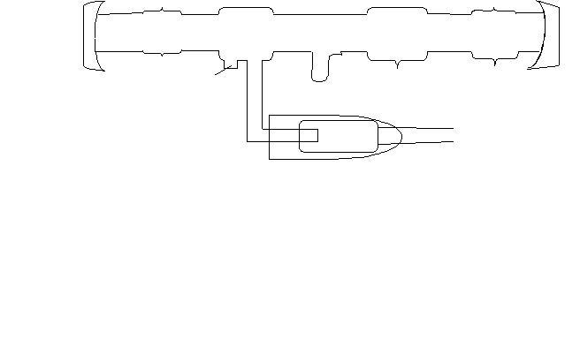
5
7
6
1
4
2
3
Fig(2) structure of laser tube,1-cathode,2-cd oven,3-anode,4-active bore 5-mirror,6-auxiliary anode,7-bellows.

Results and conclusions

Fig.3. and table(1) shows that the main polarization axis of the laser output rotated with the WAMF. Here the squares denotes the observed values. When the WAMF was augmented, the angle Ψ/2 between the main polarization axis of the laser beam and the abscissa became maximum. Then, if the WAMF was further strengthened, the main polarization axis rotated in the inverse direction and the angle Ψ/2 became smaller.

Table(1) angle of the polarization axis( Ψ/2) versus strength of WAMF, for experimental values and calculated values.
Angle of the polarization axis( Ψ/2)in (degree) | Axial magnetic field(Gauss)  calculated values | Axial magnetic field(Gauss) experimental values
0 | 0 | 0
1 | 5 | 5
2 | 11 | 13
3 | 18 | 20
4 | 26 | 35
5 | 40 | 38
6 | 12 | 31
7 | 0 | 0

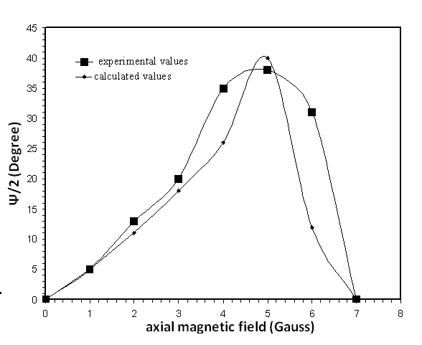
Fig(3) angle of the polarization axis Ψ/2 versus strength of WAMF.

The relation between the polarization characteristics of He-Cd 4416Å laser line and the WAMF is indicated in fig. 4, The polarization of the laser beam is circular without the WAMF, and it gradually became an ellipse with strength of WAMF the maximal eccentricity being at the
maximum angle of Ψ/2. Following that, the further increase of the WAMF reduces the eccentricity of the elliptic polarization of the laser beam, as well as the angle Ψ. With P-3 Model Computer and Algol language, the calculations were made on one pair and 7 pairs of modes by means of the laser amplitude -and frequency-determining equations in an axial magnetic field, according to Lamb's theory [12]. The frequency interval of the longitudinal modes was measured to be 103 MHz with the Trpol 360 Model Scanning Interferometer.

Penning excitation cross section σ_{p}was1.7 × 10⁻¹⁵cm²and the de excitation rates of upper and lower levels for the 4416Å laser transition are γ_{a} = 12×10⁶ s⁻¹ and γ_{b} = 2 × 10⁹ s⁻¹. In the calculations an approximation was adopted in the case of multimode laser-that each pair of modes was only coupled with two neighboring pairs of modes, and the effects of cross gain saturation and cross frequency pushing from the other modes were neglected. The calculated WAMF dependence of laser polarization in multimode is shown in fig. 5. which is similar to fig. 4.

3
1

4
2

Fig (4) polarization characteristics of the He-Cd 4416 Å lase liner in WAMF, 1:H=0 Gauss , 2:H=2 Gauss, 3:H=5Gauss, 4:H=6 Gauss.

2
3

4

1

Fig (5) calculated field dependence of the laser polarization in multimode when 1:H=0 Gauss, 2:H=2 Gauss , 3:H=5 Gauss, 4:H=6 Gauss.

The rotation of the main polarization axis of the laser beam in the WAMF is caused by the anisotropy of the cavity quality factor Q in the plane perpendicular to the laser axis. The calculated results are shown by solid rhombus in fig. 3 and they agree fairly well with the experimental values. The phenomenon of the rotation of the polarization axis during the change of the WAMF is different from that of the resonant spontaneous radiation and, therefore, may be regarded as "Quasi-Hanle Effect". The relation between laser output and the WAMF recorded by JD3 Model X-Y Recorder is shown in figs.6a and 6b, and table (2) where the ordinate is the laser output and the abscissa is the WAMF.

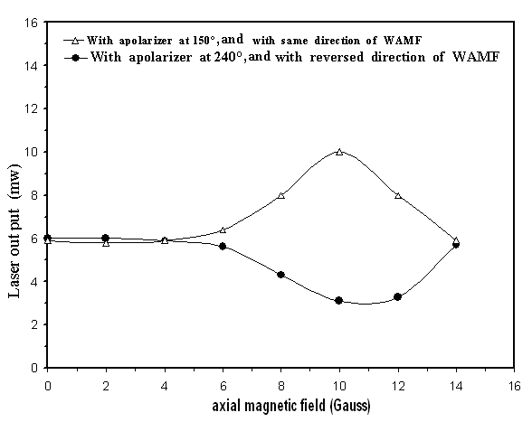
Fig.(6a).laser output as a function of the WAMF strength,( ) with a polarizer at 150° with same direction of WAMF, and( ) with a polarizer at 240° with reversed direction of WAMF.

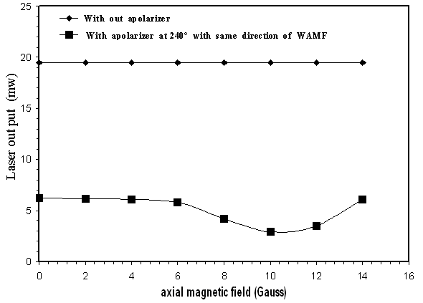
Fig.(6b).laser output as a function of the WAMF strength,( ) with a polarizer at 240° with same direction of WAMF, ( ) with out polarized .

Table(2) laser output as a function of the WAMF strength with a polarizer at 150° , 240°with same direction of WAMF ,and 240° with reversed direction of WAMF,and also without polarizer.
Axial magnetic field (Gauss) | Laser output(mw) with polarized at 240° with reverser direction of WAMF | Laser output(mw) with polarized at 240° with same direction of WAMF | Laser output(mw) with polarized at 150° with same direction of WAMF | Laser output(mw)with out polarized
0 | 6 | 6.2 | 5.9 | 19.5
2 | 6 | 6.18 | 5.8 | 19.5
4 | 5.9 | 6.12 | 5.9 | 19.5
6 | 5.6 | 5.8 | 6.4 | 19.5
8 | 4.3 | 4.18 | 8 | 19.5
10 | 3.1 | 2.9 | 10 | 19.5
12 | 3.3 | 3.5 | 8 | 19.5
14 | 5.7 | 6.1 | 5.9 | 19.5
The total output of the laser remained unchanged without the polarizer in front of the detector. It can be concluded that the WAMF only changed the polarization of the laser rather than the gain of the laser. When a polarizer was inserted, however, the laser power varied with the WAMF. the WAMF causes The anisotropy of the laser gain, the rotation of the main polarization axis of the laser, and the change the laser output which is a function of the polarization direction of the polarizer. In figs. 6a and 6b. the Lines marked with(Δ )and( ) refer to cases in which the polarization axis of the polarizer are at angles of 150°and 240° respectively with the abscissa, and there is difference of 90° between these two cases. The curves showing the laser output versus the WAMF for these two cases in figs.6a and 6b. vary in opposite direction. When the WAMF was stronger than 10 Gauss, the laser output was modulated by more than 80% of its amplitude.

The above results are quite different from these given by Brown with the laser of an external cavity [13]. The external cavity He-Cd laser has a linear polarization output beam for which the stimulated radiation process depleted the population inversion to produce the same linear polarization of laser without any polarization perpendicular to it. In our results, however, the population inversion could simultaneously devote to two linear polarizations perpendicular to each ether. After passing through the polarizer, the output of the laser was partly lost. He-Cd lasers of external cavity were also measured with the output of one of them was raised by 15% in the WAMF and the other one remained unchanged. These phenomena can be explained by minute asymmetry thin the cavity according to Lamb's theory, too.
The laser tube was parallel to the direction of the earth's magnetic field, In fig. 6 the circles show the laser output when the direction of WAMF was inverted. The displacement of the curve is about 0.6 Gauss, so that the strength of the earth's magnetic field is estimated to be 0.3 Gauss.
In our investigation the effect of the isotope of Cd was not taken into account in the calculations, because it has very little effects on the results.

References

1-Resonance radiation and exited atoms, A.C.G.Mitchill and M.W.Zemansky, Cambridge at the university press,1961, p262.
2-Hanle effect in he-Ne lasers, W.Culsha and J.Kannelaud, phys.Rev.133A, 1964,p1209.
3-An investigation of the effect of an axial magnetic field on the He-Cd⁺laser, D.C.Brown and T.M.Swift, IEEE J.quantum Electronics, 1973, p94-95.

4-Cascade Hanle effect in the 5³D₃-5³P₂ transition in cadmium, K .K. Boyarskii et al, Sov. J. Quantum Electron, 1975, p 10-12 .
5-He-Cd hollow-cathode oscillations in an axial magnetic field, C P Cristescu et al , J. Phys. D: Appl. Phys 12, 1979, p845-851.
6-Gain measurements in cataphoretic helium–cadmium lasers,
S. A .Gonchukov, E. V. Kurbatov and E. D. Protsenko,
Sov. J. Quantum Electron. v18 No 9, 1988, p 1062-1065 .
7-He-Cd laser with a new helical cathode, I.Angelov,M.Grozeva and N.Sabotinov, meas.sci.technol v4 no 6, june 1993, p 682-684.

8-New methods for out gassing in He-Cd laser, YU.Wang, Proceeding of SPIE2987, 1995, p367-369.
9-Limitation of the pulse length in a high-pressure UV He-Cd laser, Yu. N. Novoselov, V.V. Uvarin, Inst. of Electrophysics, Ekaterinburg, june 1995. p 343-347.

10-Design and construction of He-cd laser, A.D.Raouf, M.Sc Thesis, Al-mustansiria university, 2001, p 45.

11-He-Cd lasers in transverse magnetic fields, C.C.Chou and Q.Fu, laser journal of china v5, 1974, p 16-20.

12-laser physics, M.Sargent, M.O.Scully and W.E.Lamb.jr, Addison wesely,1974, p 212.

